Table of Contents
UNITED STATES
SECURITIES AND EXCHANGE COMMISSION
Washington, D.C. 20549
SCHEDULE 14A
Proxy Statement Pursuant to Section 14(a) of
the Securities Exchange Act of 1934 (Amendment No. )

Filed by the Registrant
☒
Filed by a Party other than the Registrant
☐
Check the appropriate box:
☐ |  | Preliminary Proxy Statement
☐ |  | Confidential, for Use of the Commission Only (as permitted by Rule  14a-6(e)(2))
☒ |  | Definitive Proxy Statement
☐ |  | Definitive Additional Materials
☐ |  | Soliciting Material under  §240.14a-12

Gaming and Leisure Properties, Inc.
(Name of Registrant as Specified In Its Charter)
(Name of Person(s) Filing Proxy Statement, if other than the Registrant)
Payment of Filing Fee (Check the appropriate box):
☒ |  | No fee required.
☐ |  | Fee computed on table in exhibit required by Item 25(b) per Exchange Act Rules  14a-6(i)(1)  and 0-11.
☐ |  | Fee paid previously with preliminary materials.

Table of Contents
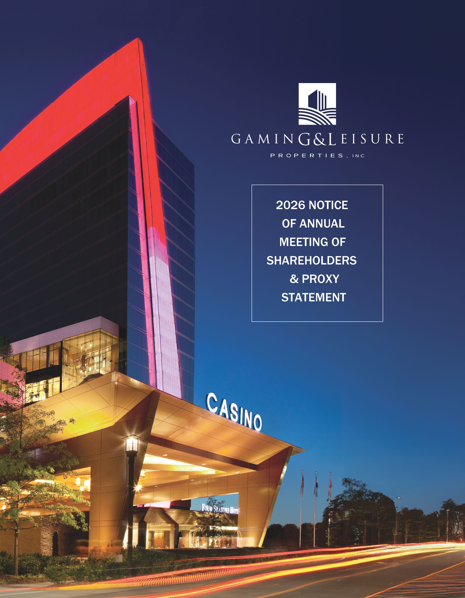

Table of Contents


 |  |  |  | To Our Shareholders,  The Board of Directors of Gaming and Leisure Properties, Inc. cordially invites you to attend the 2026 Annual Meeting of Shareholders on June 4, 2026 at 10:00 a.m. EDT. Details regarding the Annual Meeting and the matters to be voted on by Company shareholders of record are included in the Notice of Annual Meeting of Shareholders found in the Company’s 2026 Proxy Statement.  2025 marked another year of macroeconomic volatility that translated into challenges and uncertainty for market participants. Despite these challenges, we closed out the year by delivering solid operating results and record revenue, along with accretive transactions and increased dividends for our valued shareholders.  At the end of 2025, our diversified portfolio of 69 properties spanning 20 jurisdictions nationwide was representative of the $13+ billion in aggregate transaction value since the Company was formed only 13 years ago. The continued growth and stability of our portfolio demonstrate management’s deep knowledge of the gaming sector, coupled with its thoughtful and targeted execution of our business strategy to deliver long-term value to our shareholders.
Our robust pipeline, which includes the ongoing development funding for Bally’s Chicago, Live! Casino Virginia, multiple projects for PENN Entertainment, Inc., and our tribal partnerships, totaled approximately $2.6 billion of committed future capital outlays as of year-end, setting us up for continued growth in 2026 and 2027.

Our solid balance sheet, with leverage at year-end below the low end of our 5.0x - 5.5x net debt to EBITDA range, positions us to fulfill our financial commitments without the need to raise equity and remain at the low end of our target range, while driving AFFO and dividend growth.

In December 2025, the Company also appointed Michael Borofsky to complement its diverse and distinguished slate of best-in-class directors, who have extensive public company and industry experience and have proven to be thoughtful stewards of shareholder value. Michael brings an impressive array of capabilities and experience that we are confident will be invaluable as we continue to execute our growth strategy.

I am grateful to our shareholders for their continued support and wish to express my gratitude and appreciation to our dedicated management team and employees for making these results possible. We believe we are well-positioned for growth in 2026 and beyond.

Sincerely,

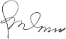

PETER M. CARLINO
Chairman and Chief Executive Officer

Table of Contents


NOTICE OF ANNUAL MEETING OF SHAREHOLDERS OF
GAMING AND LEISURE PROPERTIES, INC.

NOTICE OF ANNUAL MEETING OF SHAREHOLDERS ON JUNE 4, 2026
Gaming and Leisure Properties, Inc. (the “Company” or “GLPI”) will meet in person this year to conduct the required annual business of GLPI. The Company’s 2026 annual meeting of shareholders (the “Annual Meeting”) will be held on Thursday, June 4, 2026 at 10:00 a.m. (EDT) in person at the Company’s offices located at 845 Berkshire Blvd., Suite 200, Wyomissing, Pennsylvania 19610 for the purpose of considering and acting on the following proposals:

1. |  | To elect Peter M. Carlino, Michael C. Borofsky, Debra Martin Chase, Carol “Lili” Lynton, Joseph W. Marshall, III, James B. Perry, Earl C. Shanks and E. Scott Urdang as directors to hold office until the Company’s 2027 Annual Meeting of Shareholders and until their respective successors have been duly elected and qualified.
2. |  | To ratify the appointment of Deloitte & Touche LLP as the Company’s independent registered public accounting firm for the current fiscal year.
3. |  | To approve, on a non-binding advisory basis, the Company’s executive compensation.
4. |  | To transact such other business as may properly come before the Annual Meeting or any adjournments or postponements thereof.
Shareholders of record of the Company’s common stock (Nasdaq: GLPI) as of the close of business on April 2, 2026 are entitled to vote at the Annual Meeting and any postponements or adjournments of the meeting.
By order of the Board of Directors,
Peter M. Carlino
Chairman of the Board of Directors
Wyomissing, Pennsylvania
April 24, 2026
Your Vote is Important
Please vote as promptly as possible by using the Internet or by telephone or by signing, dating and returning the Proxy Card mailed to those who receive paper copies of this Proxy Statement. You may also vote at the Annual Meeting by following the instructions in this Proxy Statement. This Notice of Annual Meeting and accompanying Proxy Statement are first being made available to our shareholders on or about April 24, 2026.

Important Notice Regarding the Availability of Proxy Materials for the Annual Meeting of Shareholders
to be Held on June 4, 2026: The Notice of Annual Meeting, Proxy Statement, and Annual Report to
Shareholders for the year ended December 31, 2025 are available at www.proxydocs.com/GLPI.

Table of Contents
TABLE OF CONTENTS

Proxy Summary |  |  | 1
Proposal 1 — Election of Directors |  |  | 10
Executive Compensation |  |  | 26
Executive Summary |  |  | 27
Compensation Philosophy and Objectives |  |  | 31
GLPI’s Annual Executive Compensation Review and Approval Process |  |  | 31
Overview of 2025 Compensation |  |  | 35
Overview of 2026 Compensation Program |  |  | 40
Deferred Compensation |  |  | 40
Benefits and Perquisites |  |  | 40
Employment Agreements and Severance Plan |  |  | 40
Other Compensation and Compliance Policies |  |  | 42
Tax Considerations |  |  | 43
Compensation Committee Report |  |  | 44
Summary Compensation Table |  |  | 45
All Other Compensation Table |  |  | 46
Pay vs Performance Table |  |  | 47
Compensation Actually Paid (CAP) vs. Cumulative TSR |  |  | 49
Compensation Actually Paid (CAP) vs. Net Income |  |  | 49
Compensation Actually Paid (CAP) vs. AFFO Per Diluted Share |  |  | 50
2025 Grants of Plan-Based Awards |  |  | 51
Outstanding 2025 Restricted Stock Awards at Fiscal Year-End |  |  | 52
2025 Restricted Stock Awards Vested |  |  | 53

2025 Nonqualified Deferred Compensation |  |  | 53
Potential Payments Upon Termination or Change-in-Control |  |  | 55
CEO Pay Ratio |  |  | 56
Audit and Compliance Committee Report |  |  | 57
Certain Relationships and Related Person Transactions |  |  | 58
Security Ownership of Certain Beneficial Owners and Management |  |  | 59
Equity Compensation Plan Information |  |  | 61
Delinquent Section 16(a) Report |  |  | 62
Proposal 2 — Ratification of Independent Registered Public Accounting Firm |  |  | 63
Proposal 3 — Advisory (Non-Binding) Vote to Approve the Company’s Executive Compensation |  |  | 64
Frequently Asked Questions |  |  | 65
Other Matters |  |  | 69
Shareholder Proposals and Director Nominations for 2027 Annual Meeting of Shareholders |  |  | 69
Annual Report to Shareholders |  |  | 69
Delivery of Documents to Shareholders Sharing an Address |  |  | 69

Table of Contents

Proxy  Summary |  | Board of  Directors |  | Executive  Compensation |  | Audit Committee  Matters |  | Voting  Proposals |  | Other  Matters

PROXY SUMMARY
This Proxy Statement is furnished to you in connection with the solicitation of proxies by the Board of Directors (the “Board”) of Gaming and Leisure Properties, Inc. (“GLPI”, the “Company”, “we”, “us” and “our”) for the Annual Meeting of Shareholders of the Company to be held in person at the Company’s offices located at 845 Berkshire Blvd. Suite 200, Wyomissing, Pennsylvania 19610 on June 4, 2026 (the “Annual Meeting”), and any postponements or adjournments of the meeting.
This summary highlights information contained elsewhere in this Proxy Statement. This summary does not contain all of the information that you should consider and you should read the entire Proxy Statement before voting. For more complete information regarding the Company’s 2025 performance, please review the Company’s Annual Report to Shareholders for the year ended December 31, 2025.
2026 Annual Meeting Of Shareholders

Time and Date  10:00 a.m. EDT  June 4, 2026 |  | Record Date  April 2, 2026 |  | Number of Common Shares Eligible to Vote at the Meeting  as of the Record Date: 283,420,826
Place
845 Berkshire Blvd., Suite 200
Wyomissing, Pennsylvania 19610

On or about April 24, 2026, we will mail to each of our shareholders (other than those who previously requested electronic delivery or to whom we are mailing a paper copy) a Notice of Internet Availability of Proxy Materials containing instructions on how to access and review the proxy materials via the Internet and how to submit a proxy electronically using the Internet.
Voting Matters

Matter |  | Board  Recommendation |  | Page Reference  (for more detail)
Election of Directors |  | FOR each director nominee |  |  | 10
Ratification of Independent Registered Public Accounting Firm |  | FOR |  |  | 63
Non-Binding Advisory Vote to Approve Executive Compensation |  | FOR |  |  | 64

Gaming and Leisure Properties, Inc. |  | 2026 Proxy Statement | 1

Table of Contents

Proxy  Summary |  | Board of  Directors |  | Executive  Compensation |  | Audit Committee  Matters |  | Voting  Proposals |  | Other  Matters

BOARD NOMINEES

  Peter M. Carlino  Chairman and Chief  Executive Officer of  Gaming and  Leisure Properties, Inc. |  |   Michael C. Borofsky  Founder and President  of Mithrandir Ventures |  |   Debra Martin Chase  Founder and Chief  Executive Officer of  Martin Chase Productions |  |   Carol “Lili” Lynton  Co-founder of The Dinex Group,  and Chief Investment Officer, HD American Trust
  Joseph W. Marshall, III  Of Counsel, Stevens & Lee, PC, and Former Vice Chairman of Stevens & Lee, PC and Griffin Holdings, LLC |  |   James B. Perry  Retired. Former Chairman  and Chief Executive  Officer of Isle of Capri  Casinos, Inc. |  |   Earl C. Shanks  Retired. Former Chief  Financial Officer of  Essendant, Inc. |  |   E. Scott Urdang  Retired. Founder,  Former Chairman, and  Chief Executive Officer of  CenterSquare Capital  Management, Inc.

Our slate of Board nominees is balanced with a range of tenure, diversity and age.

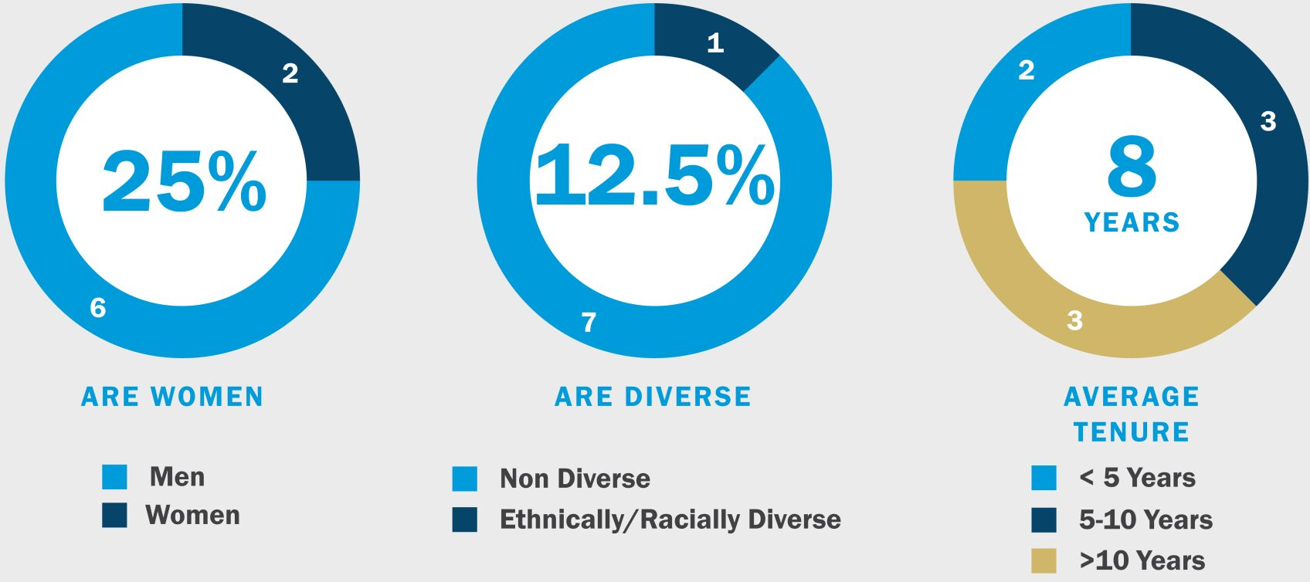

2 | 2026 Proxy Statement |  | Gaming and Leisure Properties, Inc.

Table of Contents

Proxy  Summary |  | Board of  Directors |  | Executive  Compensation |  | Audit Committee  Matters |  | Voting  Proposals |  | Other  Matters

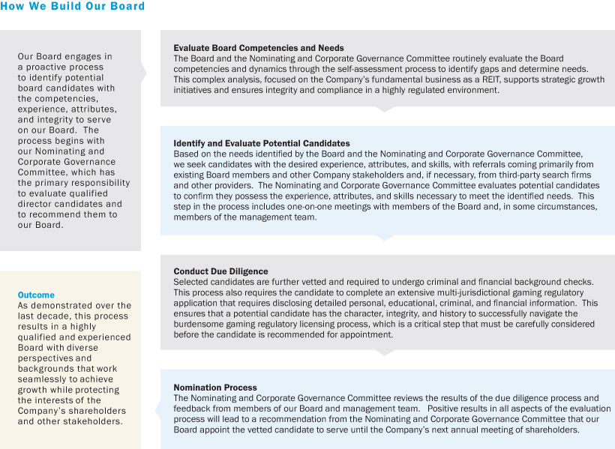

Gaming and Leisure Properties, Inc. |  | 2026 Proxy Statement | 3

Table of Contents

Proxy  Summary |  | Board of  Directors |  | Executive  Compensation |  | Audit Committee  Matters |  | Voting  Proposals |  | Other  Matters

The following matrix summarizes the expertise and experience of our Board nominees:

Board Expertise and Experience |  |  |  |  |  |  |  |  |  |  |  |  |  |  |  | 
Strategic Planning and Leadership |  | ● |  | ● |  | ● |  | ● |  | ● |  | ● |  | ● |  | ●
Accounting/Finance |  |  |  | ● |  |  |  | ● |  | ● |  |  |  | ● |  | ●
Risk Management |  | ● |  | ● |  | ● |  | ● |  | ● |  | ● |  | ● |  | ●
Legal/Regulatory/Compliance |  |  |  | ● |  | ● |  |  |  | ●
Information Technology/Cybersecurity |  |  |  | ● |  |  |  |  |  |  |  |  |  | ●
Gaming Industry Experience |  | ● |  | ● |  |  |  |  |  | ● |  | ●
CEO/Executive Management Experience |  | ● |  | ● |  | ● |  | ● |  | ● |  | ● |  | ● |  | ●
Mergers and Acquisitions |  | ● |  | ● |  |  |  | ● |  | ● |  | ● |  | ● |  | ●
Real Estate Industry Experience/REIT |  | ● |  |  |  |  |  |  |  | ● |  |  |  |  |  | ●
Community Engagement/Non-Profit |  | ● |  | ● |  | ● |  | ● |  | ● |  |  |  | ●
Board Age
Age |  | 79 |  | 53 |  | 69 |  | 64 |  | 73 |  | 76 |  | 69 |  | 76
Director Tenure
Director Since |  | 2013 |  | 2025 |  | 2024 |  | 2019 |  | 2013 |  | 2017 |  | 2017 |  | 2013

4 | 2026 Proxy Statement |  | Gaming and Leisure Properties, Inc.

Table of Contents

Proxy  Summary |  | Board of  Directors |  | Executive  Compensation |  | Audit Committee  Matters |  | Voting  Proposals |  | Other  Matters

2025 PERFORMANCE HIGHLIGHTS

Balance Sheet Discipline  Maintained a strong balance sheet with leverage below 5.0x and capacity to fund existing capital commitments through 2027 |  | Track Record of Accretive Transactions  Since 2024, committed to transactions totaling $3.7 billion at a blended capitalization rate of 8.6%, which adds $315 million in annual income |  | Significant New Transaction Activity  Entered into transactions with new and existing tenants committing an additional $876 million in capital at a blended capitalization rate of 9.2%
Steady Dividend Growth  Continued proven track record of increasing dividends with 16.4% growth from 4th quarter 2021 to 4th quarter 2025, with a compounded annual growth rate of approximately 3.9% |  | Strong Investment Pipeline  Robust investment pipeline with capital deployments anticipated through 2027, leading to predictable AFFO growth |  | Expanded Tribal Gaming Projects  Expanded investment in our new long-term leasing structure for application on tribal land held in trust by the U.S. Government
Increased Development Funding
Deployed development capital for seven projects, spanning five states and four tenants, including initial funding for Bally’s Chicago

FOCUS ON STABILITY

Gaming Properties Critical for State Budgets  State and local governments have a vested interest in property success through tax revenue |  | Over 80% of Properties in Master Leases  Master leases provide cross-collateralization of properties and reduce risk of isolated poor performance |  | High Barriers to Entry  Casino properties are highly regulated with, in many cases, a limited number of licenses available
Long-Term Leases  The remaining terms of our leases, including renewals, range from 22 years to 96 years |  | Investment-Grade Ratings  We hold investment-grade ratings from S&P Global Ratings and Fitch Ratings Inc. |  | Durable Underlying Business  100% occupancy and collected 100% of rent due under our leases since the Company’s inception
Coverage Stability
Rent coverage across the portfolio remains strong with a majority of our leases covered at 1.80x or greater at year end

Gaming and Leisure Properties, Inc. |  | 2026 Proxy Statement | 5

Table of Contents

Proxy  Summary |  | Board of  Directors |  | Executive  Compensation |  | Audit Committee  Matters |  | Voting  Proposals |  | Other  Matters

Executive Compensation
The overall objective of the Company’s executive compensation program is to compensate executive officers in a manner that most effectively incentivizes them to maximize long-term shareholder value, while taking into consideration the interests of other stakeholders and not taking undue financial risks. At the same time, the Compensation Committee believes that the executive compensation program should enable the Company to attract and retain the executive talent needed to grow and further its strategic initiatives. To achieve this goal, the compensation program is heavily weighted toward performance-based pay that is tied to several different categories, including total shareholder return (“TSR”), adjusted funds from operations (“AFFO”), dividends per share, and strategic and operational goals. The compensation program is structured on a foundation that includes the following principles:

 |  | Key Compensation Practices
✓ |  | Annual incentives aligned with strategic business plan |  |  |  | No uncapped cash bonus or equity award opportunities
✓ |  | Majority of executive compensation tied to rigorous performance goals |  |  |  | No single-trigger change of control benefits
✓ |  | Performance-based equity payouts capped if absolute TSR is negative |  |  |  | Anti-hedging policy prohibiting officers and directors from engaging in derivative or other hedging transactions
✓ |  | Significant stock ownership requirements for directors and executive officers |  |  |  | No agreements or arrangements containing tax gross-ups or similar tax indemnification
✓ |  | Appropriate balance between short-term and long-term performance measures |  |  |  | Anti-pledging policy prohibiting pledging of securities except under extremely limited circumstances approved by the Audit and Compliance Committee
✓ |  | Transparency with our shareholders on our compensation program, decisions and practices |  |  |  | No dividends on unearned performance-based awards. Recipients of LTIP Units receive a 10% distribution to support the units’ characterization as profits interests for federal tax purposes
✓ |  | Compensation Committee comprised solely of independent directors
✓ |  | Engage independent compensation consultant

6 | 2026 Proxy Statement |  | Gaming and Leisure Properties, Inc.

Table of Contents

Proxy  Summary |  | Board of  Directors |  | Executive  Compensation |  | Audit Committee  Matters |  | Voting  Proposals |  | Other  Matters

Majority of Compensation “At-Risk”
Our executive compensation program is designed to motivate and reward executives to execute our business strategy tied to rigorous performance goals. The majority of our named executive officers’ (“NEOs”) compensation is variable and primarily in the form of “at-risk” compensation. The breakdown of our NEO compensation as a group is as follows:

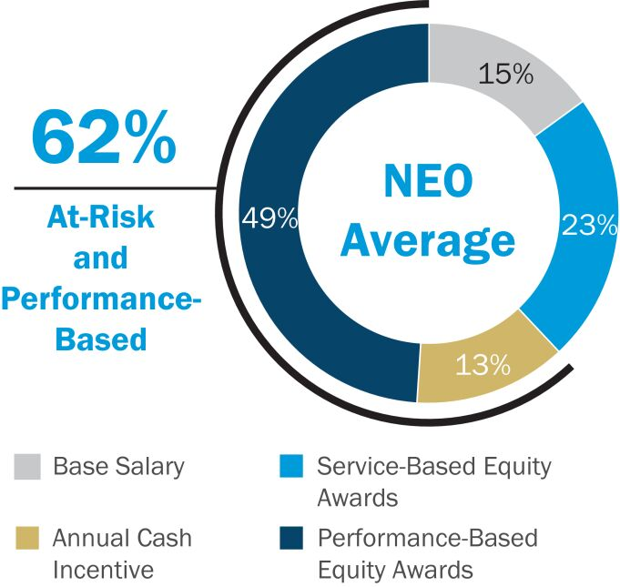

(1) | Service-Based Equity Awards compensation includes the value of long-term fixed equity awards subject to continued employment.

(2) | “At-Risk and Performance-Based” compensation includes the target annual performance cash bonus awards and the target value of the long-term performance-based equity awards.
Key 2025 Compensation Decisions
Below are certain key compensation decisions made by the Compensation Committee for our NEOs in 2025:

 | ● |  | 90% of cash bonus tied to pre-established performance goals

 | ● |  | 20% of cash bonus contingent on achieving specific goals, including goals related to balance sheet management, growth initiatives, shareholder engagement and other strategic initiatives
Responsive to Shareholder Feedback
Our Board of Directors and its committees value the opinions of our shareholders, and we routinely request the opportunity to engage with them to better understand their views, policies and voting guidelines. We have continued to listen and promptly address shareholder concerns and suggestions. We value the relationships we have with our shareholders and encourage them to reach out with questions, concerns or other opportunities to engage.
We continued our proactive engagement efforts with investors in 2025. We spoke at length with our investors during these outreach efforts and engaged in meaningful dialogue with various members of our investors’ capital markets and corporate governance teams, covering a wide range of topics, including capital markets strategy, capital allocation process and strategy, our unique competitive advantages, balance sheet management, gaming industry perspective, tenant relationships, regional gaming, real estate’s unique investment merits, succession planning, board composition and executive compensation.

Gaming and Leisure Properties, Inc. |  | 2026 Proxy Statement | 7

Table of Contents

Proxy  Summary |  | Board of  Directors |  | Executive  Compensation |  | Audit Committee  Matters |  | Voting  Proposals |  | Other  Matters

Corporate Responsibility
Our Approach
Our primary business as a publicly-traded, self-administered, and self-managed real estate investment trust consists of owning, acquiring, developing, expanding, and leasing gaming and leisure properties and related facilities to tenants under triple-net leases whereby the Company’s tenants are responsible for business operations, maintenance, insurance, taxes, utilities and other property-related expenses.
Although we do not control or oversee our tenants’ operational decisions, sustainability strategies, or related initiatives, we recognize the importance of our responsibilities as a landlord, employer, community partner, and responsible corporate citizen. With this in mind, we take a thoughtful and deliberate approach to Corporate Responsibility by assessing the environmental and social risks most material to our business and integrating these considerations into our broader business strategy. These efforts are intended to support long-term value creation for our shareholders, employees, and other stakeholders.
Oversight of our Corporate Responsibility policies, strategies, and initiatives is provided by the Nominating and Corporate Governance Committee of the Board of Directors. Our Nominating and Corporate Governance Committee’s responsibilities include oversight of Corporate Responsibility matters relating to, among other things, human capital management, corporate culture, leadership development, employee engagement, and community involvement, which are thoughtfully discussed with the Company’s ESG Steering Committee Chair, and reported to the Company’s Board of Directors on a quarterly basis and more frequently, as needed.

 |  | Environmental Stewardship
As part of our considerate approach to environmental sustainability, GLPI is committed to responsible environmental practices that include conservation of natural resources, pollution prevention, and waste reduction. We foster environmental responsibility with our employees and other partners by encouraging them to reduce consumption while applying an ethical approach to disposal efforts.

We are committed to betterment around environmental sustainability and employ a thoughtful approach in the allocation of our resources. We will continue to explore potential opportunities and partnerships that promote and integrate practical sustainability strategies into our day-to-day business decisions and socialize those opportunities with our tenants and other stakeholders, when applicable, through meaningful engagement.

 |  | Social Responsibility
Our most important asset is our talent. We strive to create long-term, responsible economic value for our stakeholders, including our employees, tenants, partners, and community members. We aim to maintain a corporate environment that fosters a sense of community and well-being and encourages our employees to focus on their long-term success along with the long-term success of the Company.

We endeavor to foster a culture of inclusion, so all team members feel respected and valued. Our culture was built to promote positive attitudes, strong work ethics and individual authenticity. We strive to create a rewarding and supportive environment that empowers our employees to thrive. We are committed to pay equity and regularly review our compensation model to ensure fair and inclusive pay practices.

We take an active role in supporting our communities by partnering with local and national organizations to administer charitable contributions, provide community service, and organize the donation of goods to assist local causes as well as those in need. The Company proudly continues to expand its community outreach efforts and impact year over year.

8 | 2026 Proxy Statement |  | Gaming and Leisure Properties, Inc.

Table of Contents

Proxy  Summary |  | Board of  Directors |  | Executive  Compensation |  | Audit Committee  Matters |  | Voting  Proposals |  | Other  Matters

 |  | Culture Of Governance
We emphasize a culture of accountability and conduct our business in a manner that is fair, ethical, and responsible. We maintain governance, compliance, and risk management practices to ensure compliance with applicable laws and regulations governing our business. We believe that good corporate governance is integral to ensure continued growth and stability for the Company and its shareholders.

Our Board is responsible for the oversight of the management of the Company and its business for the long-term benefit of our shareholders. Its members set the tone for GLPI and operate under a set of published Corporate Governance Guidelines, which are based on best practices that meet or exceed the existing standards of the U.S. Securities and Exchange Commission (“SEC”). We feature an experienced and diverse Board with expertise in a broad set of areas relevant to our business including deep governance expertise with proven oversight capabilities.

Through our Code of Business Conduct and employee handbook, we communicate our workplace non-discrimination and anti-harassment policies that embrace the highest ethical and moral standards. We maintain strong and confidential reporting processes and procedures that foster an open, honest environment in an effort to ensure that the highest principles of ethics and integrity are maintained.

We routinely engage with our stakeholders to better understand their views on sustainability and matters related to corporate responsibility, carefully considering the feedback we receive and, when appropriate, incorporating certain changes based on this feedback and/or best practices.

For more information regarding the Company’s approach to Corporate Responsibility, including its sustainability, social and governance strategies, initiatives and achievements, please refer to our most recent Corporate Sustainability Report available on our website, www.glpropinc.com, under the “Investors” section. The information on our website shall not be deemed incorporated by reference in this Proxy Statement.

Gaming and Leisure Properties, Inc. |  | 2026 Proxy Statement | 9

Table of Contents

Proxy  Summary |  | Board of  Directors |  | Executive  Compensation |  | Audit Committee  Matters |  | Voting  Proposals |  | Other  Matters

PROPOSAL 1 – ELECTION OF DIRECTORS
At our Annual Meeting, shareholders will be asked to elect eight (8) directors to hold office until our 2027 Annual Meeting of Shareholders. The nominees were recommended and approved for nomination by our Nominating and Corporate Governance Committee. Elected directors will serve until their successors have been duly elected and qualified or until such director’s earlier resignation or removal. Proxies cannot be voted for a greater number of persons than the number of nominees named. If you sign and return the accompanying proxy, your shares will be voted for the election of each nominee in accordance with your instruction and, if no instructions are provided, then your shares will be voted as recommended by our Board of Directors. If any of the nominees for any reason are unable or unwilling to serve, the proxies may be voted for such substitute nominees as the proxy holder may determine. We are not aware of any reason that any of the nominees will be unable to serve as a director.
Peter M. Carlino, Michael C. Borofsky, Debra Martin Chase, Carol “Lili” Lynton, Joseph W. Marshall, III, James B. Perry, Earl C. Shanks and E. Scott Urdang have been nominated for election to our Board of Directors to serve for a term through the 2027 Annual Meeting of Shareholders.
REQUIRED VOTE
The Company’s Articles of Incorporation provide for a majority voting standard with a resignation policy. Under a majority voting standard, once a quorum has been established, in an uncontested director election, a candidate must receive the affirmative vote of a majority of the votes cast with respect to the election of that candidate. Abstentions and broker non-votes will not be considered votes cast on any candidate’s election. The resignation policy set forth in our Corporate Governance Guidelines requires any director nominee who fails to receive the requisite majority vote to promptly, following certification of the shareholder vote, tender his or her resignation from the Board and all committees upon which he or she serves. Our Board will then assess the appropriateness of such nominee continuing to serve as a director and decide whether to accept or reject the resignation, or whether other action should be taken. The policy further provides that any director who tenders his or her resignation shall not participate in the Board action regarding whether to accept the resignation offer. Our Board will act upon the tendered resignation and publicly disclose its decision and rationale within ninety (90) days following certification of the shareholder vote.
In a contested director election, a plurality voting standard will apply. Under the plurality voting standard, each of the nominees receiving the highest number of affirmative votes of the shares entitled to be voted for him or her will be elected.
The election of directors at the Annual Meeting is uncontested and the majority voting standard will determine the directors that will serve until the 2027 Annual Meeting of Shareholders and until his or her successor is duly elected and qualified. Brokers are not permitted to vote your shares for the election of directors absent instruction from you. Therefore, we urge you to give voting instructions to your broker on the proposal so that your votes may be counted on this important matter.
OUR DIRECTORS
Our directors serve subject to the requirements of our charter and bylaws, including the requirement that directors not be “unsuitable persons,” within the meaning of our charter (“Unsuitable Person(s)”). In addition, certain jurisdictions in which we own properties require, either by statute or discretion of the applicable gaming or racing regulatory authority, our directors to acquire and maintain gaming licenses. Licenses typically require a determination from the applicable gaming or racing regulatory authority that the applicant qualifies or is suitable to hold such a license. Our charter requires that our directors maintain all required licenses. If one of our directors were to be determined to be an Unsuitable Person by virtue of failure to obtain or maintain such a license or otherwise, he or she would be subject to removal for cause by affirmative vote of the remaining members of our Board of Directors or by shareholders with an affirmative vote of 75% of the votes cast at a shareholder meeting.
There are no family relationships among any of our directors or executive officers.

10 | 2026 Proxy Statement |  | Gaming and Leisure Properties, Inc.

Table of Contents

Proxy  Summary |  | Board of  Directors |  | Executive  Compensation |  | Audit Committee  Matters |  | Voting  Proposals |  | Other  Matters

NOMINEES FOR ELECTION TO THE BOARD OF DIRECTORS FOR A ONE-YEAR TERM EXPIRING AT THE 2027 ANNUAL MEETING
The following biographical information is furnished as to the nominees for election as a director:

 |  | Peter M.  Carlino  Age: 79  Director Since: 2013  Other Current Public Boards:  PENN Entertainment, Inc. (Emeritus) |  |  |  |  |  | Michael C.  Borofsky  Age: 53  Director Since: 2025
Peter M. Carlino has been the Chairman of our Board of Directors and our CEO since our inception in February 2013. Mr. Carlino was the founder of PENN Entertainment, Inc. (Nasdaq: PENN) (“PENN”) and served as the Chief Executive Officer of PENN from 1994 through October 2013. Mr. Carlino also served as the Chairman of the Board of Directors of PENN from 1994 through May 2019 and is currently Chairman Emeritus. Since 1976, Mr. Carlino has served in an executive capacity for Carlino Capital Management Corp., a holding company that owns and operates various Carlino family businesses and is currently the Chairman of the Board and Chief Executive Officer. Mr. Carlino has been continuously active in its strategic planning and in the monitoring of its operations. Mr. Carlino also serves on the Board of Directors of Penn State Health/St. Joseph Regional Health Network.  Mr. Carlino brings to our Board of Directors extensive leadership and management experience, including over forty (40) years of collective executive management and board service, critical knowledge of our properties and an extensive knowledge and understanding of the gaming industry, real estate assets and real estate development in general. Moreover, as one of the largest beneficial owners of our common stock, his interests are significantly aligned with our efforts to enhance long-term shareholder value. |  |  |  |  |  | Michael C. Borofsky was appointed to our Board of Directors in December 2025. Mr. Borofsky is the founding principal of Mithrandir Ventures, a diversified growth equity platform with investments in healthcare, software, and gaming, and has also served as President since November 2023. Mr. Borofsky also serves as Vice Chairman of Key Benefit Administrators, a large, independent third party administrator and population health administrator that specializes in managing self-funded employer health plans. Mr. Borofsky’s primary focus is on building high cash flow businesses with leading market positions and helping companies innovate and evolve through emerging technologies. From July 2020 to March 2024, Mr. Borofsky served as general counsel and member of the Management and Investment Committees at Gryphon Investors, a middle market private equity fund with $10 billion in assets under management and 34 controlled portfolio companies across five industry sectors: consumer, healthcare, software, industrial growth and business services. He also served as Chief Operating and Strategy Officer of the Pohlad Companies, a holding company with a diverse group of operating businesses, including the Minnesota Twins, Par Systems, United Properties, Carousel Motors and Northmarq Capital. Mr. Borofsky also spent 16 years as a senior executive at MacAndrews & Forbes, Ronald O. Perelman’s investment vehicle, with interests in consumer products, defense, media and entertainment, gaming, financial services, biotechnology and food products. Prior to MacAndrews & Forbes, Mr. Borofsky worked for Skadden, Arps, Slate, Meagher & Flom LLP, where he specialized in mergers and acquisitions, and was an analyst at Goldman Sachs. He earned a B.A. with honors from Yale University and a J.D. from Columbia University School of Law where he was a Harlan Fiske Stone Scholar.  Mr. Borofsky was recommended to the Nominating and Corporate Governance Committee by one of the Company’s directors. He brings to our Board of Directors extensive knowledge and experience in mergers and acquisitions along with building and scaling innovative, high-growth companies. Through his experience and knowledge of diverse platforms, he brings strategic investment insight and substantial knowledge of capital markets and finance.

Gaming and Leisure Properties, Inc. |  | 2026 Proxy Statement | 11

Table of Contents

Proxy  Summary |  | Board of  Directors |  | Executive  Compensation |  | Audit Committee  Matters |  | Voting  Proposals |  | Other  Matters

 |  | Debra Martin  Chase  Age: 69  Director Since: 2024  Other Current Public Boards:  B&G Foods, Inc. |  |  |  |  |  | Carol “Lili”  Lynton  Age: 64  Director Since: 2019  Other Current Public Boards:  CIM RACR (Trustee)
Debra Martin Chase was appointed to our Board of Directors in April 2024. Ms. Chase, a Tony and Peabody Award-winning and Emmy-nominated television, motion picture and Broadway producer, is the first African American female producer to have a production deal at a major studio. Ms. Chase is the founder and has served as Chief Executive Officer of Hampstead Heath Productions, Inc. (d/b/a Martin Chase Productions), a California production company, since its formation in 2000. Ms. Chase has been a member of the board of directors and currently serves as Chair on the Corporate Social Responsibility Committee and sits on the Risk and Nominating and Governance Committees of B&G Foods, Inc. (NYSE: BGS) since July 2020. From July 2021 through September 2025, Ms. Chase served as a member of the board of directors of Bridge Investment Group Holdings Inc. (NYSE: BRDG), where she also served as an Audit Committee member. Prior to forming Martin Chase Productions, Ms. Chase served as Executive Vice President of Brown House Productions, the late Whitney Houston’s production company, from 1995 to 2000, and Vice President of Mundy Lane Entertainment, Denzel Washington’s production company, from 1992 to 1995. Ms. Chase formerly served as an in-house attorney and subsequently as a participant in the executive training program at Columbia Pictures. Prior to entering the entertainment industry, Ms. Chase practiced corporate law in New York and Houston. She also serves on the board of the Second Stage Theater in Manhattan, where she chairs the board’s Artistic Committee. She previously served on the board of the New York City Ballet until 2024, where she founded and chaired its Diversity and Inclusion Committee. She is a member of the Academy of Motion Picture Arts and Sciences, where she serves on the Producers Executive Committee; the Academy of Television Arts and Sciences; and the Broadway League, where she is a member of the Tony Management Committee.  Ms. Chase brings to our Board of Directors extensive leadership skills, business acumen and legal expertise. She has extensive experience in advocating diversity, inclusion and philanthropic efforts throughout her professional career. |  |  |  |  |  | Lili Lynton has served as a member of our Board of Directors since December 2019. Ms. Lynton is the co-founder of The Dinex Group, which operates 21 Daniel Boulud branded restaurants. Prior to forming Dinex, she co-founded Telebank, an internet banking pioneer that was acquired by E*Trade in 1999. Since 1987, she has also served as Chief Investment Officer of HD American Trust, a family investment office formed in 1987 that invests actively across a broad range of asset classes. At HD American Trust, Ms. Lynton is responsible for selection of asset managers, asset allocation, liquidity and leverage parameters with direct management responsibility for the firm’s venture capital and real estate portfolio. From 1987 through 1990, Ms. Lynton was an investment analyst at financial services company, Sanford C. Bernstein, and from 1983 through 1985, she was a mergers and acquisitions analyst at Lehman Brothers. Ms. Lynton served as a Director of El Pollo Loco Holdings, Inc. (Nasdaq: LOCO) from 2016 to 2024. Ms. Lynton also serves as a Trustee, Audit Committee Chair of CIM RACR (a Securities and Exchange Commission-registered Interval Fund). She also serves on the Advisory Board of The Hamilton Project, a division of the Brookings Institution, which develops proposals for a more equitable and robust U.S. economy; as a board member of The Center on Budget Policy and Priorities (a non-profit research institute focused on federal and state budgets); as Trustee of the Guggenheim Foundation (awards 175 annual Guggenheim Fellowships); as Trustee of Vera Institute for Justice (criminal justice reform organization); and as Trustee for the Bail Project (funds and operates 27 charitable bail funds across the nation).  Ms. Lynton brings to our Board of Directors experience and expertise in investment analysis, mergers and acquisitions and business operations as well as a diverse perspective resulting from her vast knowledge and business experience as well as her advocacy initiatives and non-profit board service.

12 | 2026 Proxy Statement |  | Gaming and Leisure Properties, Inc.

Table of Contents

Proxy  Summary |  | Board of  Directors |  | Executive  Compensation |  | Audit Committee  Matters |  | Voting  Proposals |  | Other  Matters

 |  | Joseph W.  Marshall, III  Age: 73  Director Since: 2013  Other Current Public Boards:  SIGA Technologies, Inc. |  |  |  |  |  | James B.  Perry  Age: 76  Director Since: 2017  Other Current Public Boards:  Fortress Credit Realty Income Trust
Joseph W. Marshall, III, has served as a member of our Board of Directors since October 2013. Mr. Marshall served as Vice Chairman of Stevens & Lee, PC and Griffin Holdings, LLC from February 2010 until December 2023, and currently serves as Of Counsel of Stevens & Lee. Mr. Marshall has served on the Board of Directors of SIGA Technologies, Inc. since 2009, as well as the Board of Directors of Maxim Healthcare Services, Inc. since 2017. He has served on several boards in the past, including the Cancer Treatment Centers of America – Eastern Regional Medical Center, First Bank of Delaware, and Health Partners, a provider-owned Medicaid/Medicare HMO operating in Greater Philadelphia from 2003-2008. From 2001 to 2008, Mr. Marshall was the CEO of Temple University Health System (“TUHS”), one of the largest healthcare organizations in Pennsylvania, and served as Chairman from 1999-2007, and from 2018-2025. He is currently a member of the board of TUHS and chairs its Audit and Compliance Committee. In addition, he chairs the boards of Temple University Hospital, Chestnut Hill Hospital, and is the Vice Chairman of Fox Chase Comprehensive Cancer Center. Mr. Marshall has also served on the Pennsylvania Gaming Control Board, the Pennsylvania State Ethics Commission (where he held positions as Vice Chairman and Chairman), and the Medicaid Commission, which was created by Congress and established by the Honorable Michael O. Leavitt, Secretary of the U.S. Department of Health & Human Services. Mr. Marshall has been a member of the Board of Trustees of Temple University since 1992.  Mr. Marshall brings to our Board of Directors extensive experience and expertise in law and compliance, with an in-depth knowledge of regulated industries, including gaming regulation, as well as significant experience as a director and an executive in both the private and public sectors. |  |  |  |  |  | James B. Perry was appointed to our Board of Directors in March 2017. Mr. Perry served on the Board of Directors of Isle of Capri Casinos, Inc. (“Isle”) from 2007 to 2014 and was named Chairman of the Board of Directors and Executive Chairman of the Board of Directors in 2009 and 2011, respectively. From March 2008 to April 2011, he served as Isle’s Chief Executive Officer. Prior to being named Chairman, Mr. Perry was Executive Vice Chairman from March 2008 to August 2009 and Vice Chairman from July 2007 to March 2008. Mr. Perry has served on the Board of Trustees of Fortress Credit Realty Income Trust since June 2024 and presently serves as a member of its Audit Committee. Mr. Perry served as a Class III Director on the board of Trump Entertainment Resorts, Inc. from May 2005 until July 2007. From July 2005 to July 2007, Mr. Perry served as Chief Executive Officer and President of Trump Entertainment Resorts, Inc., which filed for Chapter 11 bankruptcy in February 2009. Mr. Perry was President of Argosy Gaming Company from April 1997 through July 2002 and Chief Executive Officer of Argosy Gaming Company from April 1997 through May 2003. Mr. Perry also served as a member of the Board of Directors of Argosy Gaming Company from 2000 to July 2005.  Mr. Perry brings to our Board of Directors over thirty (30) years of gaming industry experience complemented by extensive operational, executive management and leadership expertise.

Gaming and Leisure Properties, Inc. |  | 2026 Proxy Statement | 13

Table of Contents

Proxy  Summary |  | Board of  Directors |  | Executive  Compensation |  | Audit Committee  Matters |  | Voting  Proposals |  | Other  Matters

 |  | Earl C.  Shanks  Age: 69  Director Since: 2017  Other Current Public Boards:  Cognyte Software Ltd. |  |  |  |  |  | E. Scott  Urdang  Age: 76  Director Since: 2013
Earl C. Shanks was appointed to our Board of Directors in March 2017. Mr. Shanks served as Chief Financial Officer of Essendant Inc., a leading supplier of workplace essentials, from November 2015 through May 2017. Previously, Mr. Shanks served as the Chief Financial Officer at Convergys Corporation from 2003 until 2012. Prior to that, Mr. Shanks held various financial leadership roles with NCR Corporation, ultimately serving as the Chief Financial Officer, where he oversaw treasury, finance, real estate and tax. Mr. Shanks served as a director of Verint Systems Inc. (Nasdaq: VRNT) from July 2012 until January 2021. Additionally, Mr. Shanks has served as a director of Cognyte Software Ltd. (Nasdaq: CGNT) since January 2021 and Chairman since September 2023.  Mr. Shanks brings to our Board of Directors expertise and knowledge in the areas of accounting, finance, capital markets, tax, risk, information technology and cybersecurity through his various executive management leadership roles as well as his significant public company service as a director. |  |  |  |  |  | E. Scott Urdang has served as a member of our Board of Directors since October 2013. Mr. Urdang, who retired in 2012, was the founder, Chief Executive Officer and Chairman of Urdang Capital Management (now CenterSquare Investment Management, Inc.). CenterSquare Investment Management, Inc. is a Philadelphia-based global asset manager that specializes in real estate investment strategies. Mr. Urdang founded the company in 1987, and at the time of his retirement, it had in excess of $5 billion under management. From 1984 to 1987, Mr. Urdang was a Partner at Laventhol and Horwath, a national consulting and accounting firm, where he served as regional partner in charge of real estate consulting with national responsibility for its pension consulting practice. Mr. Urdang also served as Vice President of Finance of a large regional development company that was involved in residential subdivisions, office buildings, apartments and shopping centers. Mr. Urdang has twenty (20) years of experience teaching both undergraduate and graduate courses in economics, corporate finance, real estate finance, and investment analysis at the Wharton School of the University of Pennsylvania.  Mr. Urdang brings to our Board of Directors extensive leadership experience in strategic planning, economics and finance as well as his comprehensive knowledge and proven record of success in the real estate industry as an investor, developer, entrepreneur and professor.

Our Board of Directors unanimously recommends a vote FOR the election of each of the nominated directors.

14 | 2026 Proxy Statement |  | Gaming and Leisure Properties, Inc.

Table of Contents

Proxy  Summary |  | Board of  Directors |  | Executive  Compensation |  | Audit Committee  Matters |  | Voting  Proposals |  | Other  Matters

BOARD COMPOSITION
Our business and affairs are managed under the direction of our Board of Directors, which currently consists of eight (8) members.
Each director’s term continues until the election and qualification of his or her successor, or his or her earlier death, resignation or removal. Newly created directorships resulting from any increase in the number of directors and any vacancies resulting from death, resignation or removal from office or other cause will be filled generally by the majority vote of the remaining directors in office, even if less than a quorum is present. A director may be removed by the Board of Directors only for cause or by the shareholders only for cause and only by the vote of 75% of the votes cast by the holders of shares entitled to vote at a shareholder meeting.
DIRECTOR INDEPENDENCE
Our Board of Directors observes all applicable criteria for independence established by The Nasdaq Stock Market LLC (“Nasdaq”) and other governing laws and applicable regulations. No director will be deemed to be independent unless our Board of Directors determines that the director has no relationship that would interfere with the exercise of independent judgment in carrying out the responsibilities of a director. Our Nominating and Corporate Governance Committee has determined that each of our directors, other than Mr. Carlino, is independent as defined under the corporate governance rules of Nasdaq and, with respect to the committees on which they serve, the applicable rules and regulations of the SEC and Nasdaq.
BOARD LEADERSHIP STRUCTURE AND ITS ROLE IN RISK OVERSIGHT
Our Board of Directors has no policy with respect to the separation of the offices of CEO and Chairman of the Board of Directors (the “Chairman”). It is the Board’s view that rather than having a rigid policy, it, with the advice and assistance of the Nominating and Corporate Governance Committee, and upon consideration of all relevant factors and circumstances, will determine, as and when appropriate, whether the two offices should be separate. Currently, our CEO also serves as the Chairman. Our Board believes this is appropriate because of the Chairman’s role in leading the Company and his long-standing track record of generating significant shareholder return for the companies for which he has served. Moreover, our Board believes that the Chairman’s substantial beneficial ownership of the Company’s equity has strongly aligned his interests with the interests of shareholders. Because we have selected to have Mr. Carlino serve in both the roles of Chairman and CEO, we have appointed Mr. Marshall to serve as Lead Independent Director. As Lead Independent Director, Mr. Marshall’s responsibilities include:

 | ● |  | consulting with the Chairman, as appropriate, regarding the information, agendas and schedules of Board and Board committee meetings, including the ability to add items to the agendas for any meeting

 | ● |  | scheduling, setting the agenda for and serving as chair of meetings of independent directors

 | ● |  | serving as principal liaison between the independent directors and the Chairman and between the independent directors and the management team

 | ● |  | presiding at all meetings of the Board at which the Chairman is not present, including executive sessions of the independent directors

 | ● |  | becoming the acting Chairman until a new Chairman is selected, in the event of the death, incapacity, resignation or removal of the Chairman

 | ● |  | ensuring availability for consultation and direct communications on behalf of the independent directors with major shareholders, as appropriate
Our Board of Directors plays an active role in the oversight of risks impacting our Company, and the management team is charged with managing such risks. Our Board of Directors works closely with the management team to ensure that integrity, security and accountability are integrated into our operations. Our Compensation Committee is responsible for overseeing the management of risks relating to our executive compensation plans and arrangements. Our Audit and Compliance Committee oversees the management of compliance and financial risks and is tasked with focusing on, analyzing, and assessing steps taken by the management team to mitigate risks related to cybersecurity and, for that purpose, receiving reports from the management team regarding cybersecurity risks and countermeasures being undertaken or considered by the Company to prevent cyber incidents, detect unusual activity, and respond appropriately should an incident occur. The Nominating and Corporate Governance Committee is responsible for overseeing the risks associated with the Company’s policies relating to sustainability and corporate responsibility as well as the independence of the Board of Directors. While each committee is responsible for evaluating certain risks and overseeing the management of such risks, our full Board of Directors is regularly informed regarding such risks through committee reports and otherwise.

Gaming and Leisure Properties, Inc. |  | 2026 Proxy Statement | 15

Table of Contents

Proxy  Summary |  | Board of  Directors |  | Executive  Compensation |  | Audit Committee  Matters |  | Voting  Proposals |  | Other  Matters

COMMITTEES OF THE BOARD OF DIRECTORS
Our Board of Directors has established the following committees: the Audit and Compliance Committee; the Compensation Committee; and the Nominating and Corporate Governance Committee. The composition of each committee satisfies the independence requirements and current standards of the SEC and the rules of Nasdaq (as applicable). Current copies of the charters for each of the committees are available on our website, www.glpropinc.com, under the “Investors” section. The information on our website shall not be deemed incorporated by reference in this Proxy Statement.
2025 Committee Membership

Name |  | Audit and  Compliance |  | Compensation |  | Nominating and  Corporate  Governance
Peter M. Carlino
Michael C. Borofsky
Debra Martin Chase |  |  |  |  |  | ●
Carol “Lili” Lynton |  | Chair |  | ●
Joseph W. Marshall, III |  |  |  | ●
James B. Perry |  |  |  | Chair |  | ●
Barry F. Schwartz |  |  |  |  |  | Chair (1)
Earl C. Shanks |  | ●
E. Scott Urdang |  | ● |  |  |  | Chair (2)
Number of Committee Meetings Held in 2025 |  | 5 |  | 6 |  | 3

(1) | Barry F. Schwartz retired from the Company’s Board effective June 12, 2025.

(2) | E. Scott Urdang was appointed as Chair of the Board’s Nominating and Corporate Governance Committee following Mr. Schwartz’s retirement.
During 2025, the Board held 8 meetings. Each director, other than Mr. Borofsky who joined our Board in December 2025, attended 75% or more of the aggregate of all meetings held by our Board and the Board committees on which he or she served in 2025 and also attended last year’s Annual Meeting of Shareholders. Our Board of Directors generally expects its members to attend the Annual Meeting of Shareholders and we believe that all of our directors will attend this year’s Annual Meeting.
Audit and Compliance Committee
The duties and responsibilities of the Audit and Compliance Committee are set forth in its charter and include, among other things, the following:

 | ● |  | to oversee the quality and integrity of our financial statements and our accounting and financial reporting processes

 | ● |  | to prepare the Audit and Compliance Committee report required by the SEC to be included in our annual proxy statement

 | ● |  | to review and discuss with the management team and the independent registered public accounting firm our annual and quarterly financial statements

 | ● |  | to review and discuss with the management team and the independent registered public accounting firm our earnings press releases prior to disclosure

 | ● |  | to appoint, compensate and oversee our independent registered public accounting firm, and pre-approve all auditing services and non-audit services to be provided to us by our independent registered public accounting firm

 | ● |  | to review the qualifications, performance and independence of our independent registered public accounting firm

 | ● |  | to establish procedures for the receipt, retention and treatment of complaints received by us regarding accounting, internal accounting controls or auditing matters and the confidential, anonymous submission by our employees of concerns regarding questionable accounting or auditing matters

 | ● |  | to discuss with the internal auditors any major issues as to the adequacy of the Company’s internal controls

16 | 2026 Proxy Statement |  | Gaming and Leisure Properties, Inc.

Table of Contents

Proxy  Summary |  | Board of  Directors |  | Executive  Compensation |  | Audit Committee  Matters |  | Voting  Proposals |  | Other  Matters

 | ● |  | to review and approve related person transactions that would be required to be disclosed in our SEC reports

 | ● |  | to review the Company’s policies and guidelines to assess and manage risk, including cybersecurity risk, and to assess steps taken by the management team to mitigate exposure to risk

 | ● |  | to review the Company’s Code of Business Conduct on an annual basis

 | ● |  | to oversee the Company’s compliance program

 | ● |  | to conduct an annual self-assessment and present the results to the Board with oversight by the Nominating and Corporate Governance Committee
Our current Audit and Compliance Committee is comprised of Carol “Lili” Lynton (Chair), Earl C. Shanks, and E. Scott Urdang. Our Board of Directors has determined that each member meets the heightened independence standards for service on the Audit and Compliance Committee and satisfies the financial literacy and other requirements for “audit committee” members under applicable Nasdaq rules and that each of Ms. Lynton, Mr. Shanks, and Mr. Urdang is an “audit committee financial expert” as that term is defined in Item 407(d)(5) of Regulation S-K of the Securities Act of 1933, as amended (the “Securities Act”). The Audit and Compliance Committee has the authority to delegate any of its responsibilities, along with the authority to take action in relation to such responsibilities, to one or more subcommittees as the Audit and Compliance Committee may deem appropriate in its sole discretion.
Compensation Committee
The duties and responsibilities of the Compensation Committee are set forth in its charter and include, among other things, the following:

 | ● |  | to evaluate the performance and determine the compensation of our CEO and other executive officers of the Company

 | ● |  | to establish, review and evaluate, and amend, as necessary, employee compensation programs and policies and procedures for executive officers and employees generally

 | ● |  | to review and approve any employment contracts, severance agreements or similar arrangements between the Company and any executive officer of the Company

 | ● |  | to review and discuss with the management team the relationship between the Company’s policies and practices for compensating employees, risk-taking incentives and risk management

 | ● |  | to review, monitor, and make recommendations concerning incentive compensation plans

 | ● |  | to oversee shareholder engagement with respect to executive compensation matters

 | ● |  | to recommend the compensation of directors

 | ● |  | to review and approve revisions and oversee compliance with the Company’s Policy Regarding the Mandatory Recovery of Compensation

 | ● |  | to conduct an annual self-assessment and present the results to the Board with oversight by the Nominating and Corporate Governance Committee
During 2025, our Compensation Committee was comprised of James B. Perry (Chair), Carol “Lili” Lynton, and Joseph W. Marshall, III. Michael C. Borofsky replaced Ms. Lynton on the Compensation Committee effective March 2026. The Compensation Committee has the authority to delegate any of its responsibilities, along with the authority to take action in relation to such responsibilities, to one or more subcommittees as the Compensation Committee may deem appropriate in its sole discretion.
Nominating and Corporate Governance Committee
The duties and responsibilities of the Nominating and Corporate Governance Committee are set forth in its charter and include, among other things, the following:

 | ● |  | to review the structure, composition, eligibility and size of the Board of Directors and its committees, including the suitability of candidates and current directors, and make recommendations to the Board of Directors based on its review and analysis

Gaming and Leisure Properties, Inc. |  | 2026 Proxy Statement | 17

Table of Contents

Proxy  Summary |  | Board of  Directors |  | Executive  Compensation |  | Audit Committee  Matters |  | Voting  Proposals |  | Other  Matters

 | ● |  | to identify and recommend to our Board of Directors potential candidates, including any candidates recommended by our shareholders, for election to the Board of Directors by the shareholders at annual meetings, including an annual review as to the renominations of incumbents and proposed nominees for election by the Board of Directors to fill vacancies that occur between shareholder meetings

 | ● |  | to determine whether a candidate recommended for membership on the Company’s Audit and Compliance Committee is financially literate and is able to read and understand fundamental financial statements and meets the standards of “an audit committee financial expert” as defined by Nasdaq and the Securities Act

 | ● |  | to oversee and review the Company’s strategies, activities, policies and communications regarding sustainability, corporate responsibility, human capital management, talent recruitment, development, retention and employee engagement and corporate culture and make recommendations to the Board regarding material guidelines, documents or policies, or any changes related thereto

 | ● |  | to oversee shareholder engagement with respect to matters relating to environmental sustainability, corporate responsibility and governance

 | ● |  | to review and assess succession planning

 | ● |  | to conduct an annual self-assessment and oversee the annual Board and committee self-assessment process and evaluation

 | ● |  | to recommend members for each committee of the Board of Directors

 | ● |  | to engage third parties, if and when the Committee deems appropriate, to identify potential director nominee candidates, which shall include instructing such parties of the criteria to be considered to ensure the Committee’s commitment to maintaining an appropriate balance of tenure, diversity, skills and experience on the Company’s Board

 | ● |  | to oversee the Company’s corporate governance policies

 | ● |  | to evaluate and make recommendations to the Board regarding shareholder proposals
Our current Nominating and Corporate Governance Committee is comprised of E. Scott Urdang (Chair), Debra Martin Chase, and James B. Perry. Former Nominating and Corporate Governance Committee Chair, Barry F. Schwartz, retired from our Board effective June 12, 2025. Mr. Urdang was subsequently appointed as Chair of the Nominating and Corporate Governance Committee. The Nominating and Corporate Governance Committee has the authority to delegate any of its responsibilities, along with the authority to take action in relation to such responsibilities, to one or more subcommittees as the Nominating and Corporate Governance Committee may deem appropriate in its sole discretion.
Compensation Committee Interlocks and Insider Participation
No member of the Compensation Committee is or was formerly an officer or employee of the Company or has or had any relationships requiring disclosure by the Company under applicable SEC rules requiring disclosure of certain relationships and related party transactions. None of our executive officers currently serve, or in 2025 served, as a member of the board of directors or compensation committee of any entity that has one or more executive officers serving on our Board of Directors or our Compensation Committee.
DIRECTOR COMPENSATION
Our non-employee directors receive both cash and equity compensation for service on our Board of Directors. The compensation of our non-employee directors is reviewed annually by the Compensation Committee with the assistance of the Compensation Committee’s independent compensation consultant, Ferguson Partners Consulting, L.P. Our Board’s compensation program for non-employee directors is designed to meet the following objectives:

 | ● |  | to provide fair compensation to directors commensurate with the time commitments, responsibilities and strict gaming licensing requirements that must be maintained for service on our Board,

 | ● |  | to attract and retain experienced, highly-qualified individuals to serve on our Board, and

 | ● |  | to provide a compensation program that aligns the interests of directors with shareholders by providing a significant portion of annual compensation in the form of equity.

18 | 2026 Proxy Statement |  | Gaming and Leisure Properties, Inc.

Table of Contents

Proxy  Summary |  | Board of  Directors |  | Executive  Compensation |  | Audit Committee  Matters |  | Voting  Proposals |  | Other  Matters

Annual Review Process
The Compensation Committee assesses the non-employee director compensation program on an annual basis. With the assistance of the independent compensation consultant, the Compensation Committee recommends to our Board the form and amount of compensation to be paid for service as a non-employee director on our Board and its committees.
2025 Director Compensation
The Company paid director compensation in 2025 to each non-employee director as shown in the table below.

 |  | Schedule of Non-Employee Director Compensation for 2025
Annual Cash Retainer |  | $130,000
Annual Restricted Stock Award |  | Restricted Stock valued at $200,000
Committee Chair Retainer |  | $40,000 for the Audit and Compliance Committee
 |  | $30,000 for the Compensation Committee
 |  | $25,000 for the Nominating and Corporate Governance Committee
 |  | $50,000 for the Lead Independent Director
Committee Member Retainer |  | $20,000 for the Audit and Compliance Committee
 |  | $15,000 for the Compensation Committee
 |  | $15,000 for the Nominating and Corporate Governance Committee
The following table sets forth information on the compensation of all our non-employee directors for 2025:

 |  | 2025 Compensation(1)
Name |  | Fees  Earned or  Paid in  Cash ($)(2) |  |  |  |  | Stock  Awards (#)(3) |  |  |  |  | Stock  Awards  ($)(3) |  |  |  |  | Total  Compensation  ($)
Joseph W. Marshall, III |  |  |  | — |  |  |  |  | 8,203 |  |  |  |  | 395,056 |  |  |  |  | 395,056
E. Scott Urdang |  |  |  | 156,250 |  |  |  |  | 4,153 |  |  |  |  | 200,008 |  |  |  |  | 356,258
Earl C. Shanks |  |  |  | 150,000 |  |  |  |  | 4,153 |  |  |  |  | 200,008 |  |  |  |  | 350,008
James B. Perry |  |  |  | 175,000 |  |  |  |  | 4,153 |  |  |  |  | 200,008 |  |  |  |  | 375,008
Barry F. Schwartz(4) |  |  |  | 64,583 |  |  |  |  | 4,153 |  |  |  |  | 200,008 |  |  |  |  | 264,591
Carol “Lili” Lynton |  |  |  | 185,000 |  |  |  |  | 4,153 |  |  |  |  | 200,008 |  |  |  |  | 385,008
Debra Martin Chase |  |  |  | 145,000 |  |  |  |  | 4,153 |  |  |  |  | 200,008 |  |  |  |  | 345,008
Michael Borofsky(5) |  |  |  | 10,833 |  |  |  |  | — |  |  |  |  | — |  |  |  |  | 10,833

(1) | There were no unvested stock awards outstanding as of December 31, 2025.

(2) | Cash fees include annual board retainer and, where applicable, committee retainers. Mr. Marshall elected to receive his annual cash retainer and committee fees in the form of restricted stock in 2025.

(3) | The amounts listed above are calculated based on the closing price on the day prior to grant date and vest on December 1st of the year of the grant, with the exception of Mr. Schwartz whose shares vested in June 2025 in conjunction with his retirement from the Board of Directors, as noted below.

(4) | Mr. Schwartz retired from the Board of Directors effective June 12, 2025.

(5) | Mr. Borofsky was appointed to the Board of Directors on December 4, 2025. Fees referenced above were prorated for service provided during 2025.
Director Stock Ownership Guidelines
Our Board of Directors believes that it is important for non-employee directors to have a financial stake in the Company such that their interests are more closely aligned with those of our shareholders. Accordingly, the Board has established stock ownership guidelines for our non-employee directors. Each non-employee director is expected to acquire, and continue to hold during the term of his or her service on the Board, equity with a value equal to five times the annual cash retainer. The deadline to satisfy these guidelines is the fifth anniversary of the applicable non-employee director’s appointment or election. As of December 31, 2025, all

Gaming and Leisure Properties, Inc. |  | 2026 Proxy Statement | 19

Table of Contents

Proxy  Summary |  | Board of  Directors |  | Executive  Compensation |  | Audit Committee  Matters |  | Voting  Proposals |  | Other  Matters

of our directors, with the exception of Ms. Chase and Mr. Borofsky, were in compliance with the ownership guidelines. Ms. Chase has until April 22, 2029 to achieve compliance. Mr. Borofsky has until December 4, 2030 to achieve compliance.
COMMUNICATIONS WITH THE BOARD OF DIRECTORS
The Board of Directors believes it is important for shareholders and others to have a process to send communications to the Board. Shareholders who wish to communicate with directors should do so by writing to Gaming and Leisure Properties, Inc., 845 Berkshire Blvd., Suite 200, Wyomissing, PA 19610, Attention: Secretary. The Secretary of the Company reviews all such correspondence and forwards to the Board of Directors a summary of all such correspondence and copies of all correspondence that, in the opinion of the Secretary, deals with the functions of the Board of Directors or its committees or that he otherwise determines requires their attention. Directors may at any time review a log of all correspondence received by the Company that is addressed to members of the Board of Directors and request copies of any such correspondence. Concerns relating to accounting, internal controls or auditing matters will be brought to the attention of the Company’s Audit and Compliance Committee.
DIRECTOR NOMINATION PROCESS
Minimum Qualifications of Directors
The Nominating and Corporate Governance Committee is responsible for evaluating and recommending eligible candidates for membership on our Board of Directors, including director nominees suggested by, among others, other Board members, the management team and shareholders. The Nominating and Corporate Governance Committee is also responsible for examining the composition of the Board of Directors to ensure that the current and anticipated future needs of the Board and the Company are being met. Our Nominating and Corporate Governance Committee may also retain professional search firms to identify candidates.
The Nominating and Corporate Governance Committee seeks to identify, as candidates for director, persons with gaming and/or real estate industry knowledge, senior management experience, diversity of views, skill sets, backgrounds and demographics, analytical ability, business acumen, strength of character, integrity, and mature judgment. The Nominating and Corporate Governance Committee’s focus on diversity is evidenced by its commitment to include qualified candidates who identify as women and minorities in board candidate searches, including any searches conducted by third-party consultants. The Nominating and Corporate Governance Committee will also consider the following (among other considerations set forth in the Company’s Corporate Governance Guidelines):

 | ● |  | a candidate’s background and skills, including financial literacy, independence, and the contribution he or she would make in connection with developing and furthering the Company’s business strategy

 | ● |  | a candidate’s ability to meet the suitability requirements of all applicable regulatory authorities

 | ● |  | a candidate’s ability to represent the interests of the shareholders

 | ● |  | a candidate’s ability to work constructively with the Company’s management team and other directors

 | ● |  | a candidate’s availability, including the number of other boards on which the candidate serves, and his or her ability to dedicate sufficient time and energy to his or her board duties

 | ● |  | changes to a candidate’s affiliations that could create potential conflicts of interest or result in the candidate not being able to serve in a manner that is consistent with the Company’s policies and/or values
The Nominating and Corporate Governance Committee Charter and the Corporate Governance Guidelines are made available on the “Investors” section of our website, www.glpropinc.com. The information on our website shall not be deemed incorporated by reference in this Proxy Statement.
Holistic Approach to Board Composition
The Board of Directors is focused on ensuring that it is composed of individuals with an appropriate balance of diverse backgrounds, experiences, skill sets, perspectives, demographics (including gender, race, ethnicity and age), tenure, analytical ability and viewpoints. The Board confirms that the Company’s policy of non-discrimination applies in the selection of its directors. The Board believes that Board diversity is critical to thoroughly assess risk, anticipate challenges and scrutinize the complex and dynamic issues that impact the Company and its industry, its shareholders, stakeholders and the broader society. The current Nominating and Corporate Governance Committee Charter outlines the characteristics and qualifications sought by the Nominating and Corporate Governance Committee when considering potential director candidates.
The Nominating and Corporate Governance Committee’s view on the topic of diversity is multifaceted and aligned with our Board of Directors. Creating a board of diverse, but also complementary, individuals requires the Nominating and Corporate Governance

20 | 2026 Proxy Statement |  | Gaming and Leisure Properties, Inc.

Table of Contents

Proxy  Summary |  | Board of  Directors |  | Executive  Compensation |  | Audit Committee  Matters |  | Voting  Proposals |  | Other  Matters

Committee to balance each factor through a holistic approach. Such an approach enables the Nominating and Corporate Governance Committee to identify and recommend, for the selection by a majority of the Board, the best director candidates.
Shareholder Nominations of Directors and Other Business
Shareholders who (a) are not “Unsuitable Persons,” as that term is defined in our charter, (b) have beneficially owned at least 1% of the Company’s common stock for a continuous period of not less than 12 months before making such recommendation and (c) are entitled to vote at the Annual Meeting, may submit director nominations and proposals for other business for consideration by the Board of Directors and the Nominating and Corporate Governance Committee, as applicable, to be raised from the “floor” at our Annual Meeting, provided that such recommendations comply with the notice requirements under the Company’s Second Amended and Restated Bylaws and are timely received by the Secretary of the Company. To be timely, a shareholder’s notice to the Secretary must be delivered to or mailed and received at the principal executive offices of the Company not less than 120 days and not more than 150 days prior to the anniversary date of the immediately preceding annual meeting of shareholders.
The Company’s Second Amended and Restated Bylaws were amended in December 2023 to reflect certain procedural requirements related to proxy access and the SEC’s “universal proxy” rules, as well as certain technical, conforming and clarifying changes in connection therewith, which are reflected below. The requirements set forth in this section do not relate to shareholder proposals intended to be included in our Proxy Statement and submitted pursuant to Rule 14a-8 promulgated under the Securities Exchange Act of 1934, as amended (the “Exchange Act”).
Advance Notice Provisions and Universal Proxy Rules
With respect to the shareholder giving the notice and the beneficial owner, if any, on whose behalf the recommendation for nomination or proposal is made, all notices must include the following information as further outlined in our Second Amended and Restated Bylaws and must comply with all applicable requirements under Rule 14a-19 under the Exchange Act:

 | ● |  | the name and address of such shareholder, as they appear on the Company’s records, the telephone number of such shareholder, and the name, address and telephone number of such beneficial owner, if any

 | ● |  | a statement or SEC filing from the record holder of the shares, derivative instruments or other interests verifying the holdings of the beneficial owner and indicating the length of time the shares, derivative instruments or other interests have been held by such beneficial owner and any other information and representations relating to such shareholder and beneficial owner, if any, that would be required to be disclosed in a proxy statement or other filings required to be made in connection with solicitations of proxies for, as applicable, the proposal and/or the election of directors in a contested election pursuant to Section 14 of the Exchange Act (or any successor provision) and the rules and regulations promulgated thereunder, including, but not limited to, voting arrangements, rights to dividends or performance related fees associated with any securities held, material legal proceedings involving the Company, its directors, officers or affiliates, and any material interest in any material contract or agreement with the Company, its affiliates or any principal competitors

 | ● |  | a representation that such shareholder and beneficial owner, if any, intend to be present in person at the meeting

 | ● |  | a representation that such shareholder and such beneficial owner, if any, intend to continue to hold the reported shares, derivative instruments or other interests through the date of the Company’s next annual meeting of shareholders

 | ● |  | a (a) signed directors’ and officers’ questionnaire, (b) multi-jurisdictional personal history disclosure form, representations, agreement and consent to provide additional information and to submit to a background check prepared with respect to and signed by such shareholder and beneficial owner, and (c) such additional information, certificates, documents, instruments, agreements and consents as may be deemed useful to the Board of Directors to evaluate whether such shareholder or beneficial owner is an Unsuitable Person (as set forth in the Company’s charter)

 | ● |  | a representation as to whether the shareholder, proposed nominee or any Shareholder Associated Person intends to engage in a solicitation in support of director nominees other than the Board’s nominees in accordance with Rule 14a-19 promulgated under the Exchange Act (and if so, (a) including a statement that any such person intends to solicit the holders of shares representing at least 67% of the voting power of shares entitled to vote on the election of directors in support of director nominees other than the Board’s nominees), and, if so, (b) confirming the names of the participants (as defined in Item 4 of Schedule 14A under the Exchange Act) in the solicitation. The term “Shareholder Associated Person” means any person acting in concert with such shareholder or another Shareholder Associated Person or who is otherwise a participant (as defined in Item 4 of Schedule 14A under the Exchange Act) in the solicitation
Any notice pertaining to a shareholder recommendation for nomination for election or re-election as a director, must also include the following information:

 | ● |  | all information and representations relating to the recommended nominee that is required to be disclosed in a proxy statement or other filings required to be made in connection with solicitations of proxies for election of directors in an election contest, or

Gaming and Leisure Properties, Inc. |  | 2026 Proxy Statement | 21

Table of Contents

Proxy  Summary |  | Board of  Directors |  | Executive  Compensation |  | Audit Committee  Matters |  | Voting  Proposals |  | Other  Matters

is otherwise required, in each case pursuant to Section 14 of the Exchange Act, and the rules and regulations promulgated thereunder (including such person’s written consent to being named in the proxy statement as a nominee and to serving as a director, if elected)

 | ● |  | a description in reasonable detail of all direct and indirect compensation, economic interests and other material monetary agreements, arrangements and understandings during the past three years between or among such shareholder and beneficial owner, if any, and their respective affiliates and associates, or others acting in concert therewith, on the one hand, and each recommended nominee, and his or her respective affiliates and associates, or others acting in concert therewith, on the other hand, including, without limitation, all information that would be required to be disclosed pursuant to Rule 404 promulgated under Regulation S-K if the shareholder making the nomination and any beneficial owner on whose behalf the nomination is made, if any, or any affiliate or associate thereof or person acting in concert therewith, were the “registrant” for purposes of such rule and the recommended nominee were a director or executive officer of such registrant

 | ● |  | a description in reasonable detail of all other material relationships between the proposed nominee and the recommending shareholder and the beneficial owner, if any, including any agreements, arrangements and understandings between the recommending shareholder and the beneficial owner, if any, and the recommended nominee regarding the nomination

 | ● |  | a description in reasonable detail of all relationships between the recommended nominee and any of the Company’s competitors, customers, suppliers, labor unions (if applicable) and any other persons with special interests regarding the Company

 | ● |  | a (a) signed directors’ and officers’ questionnaire, (b) multi-jurisdictional personal history disclosure form, representations, agreement and consent to provide additional information and to submit to a background check prepared with respect to and signed by the recommended nominee, and (c) such additional information, documents, instruments, agreements and consents as may be deemed useful to the Board of Directors to evaluate whether such nominee is an Unsuitable Person

 | ● |  | the written representation and agreement (in the form provided by the Secretary upon written request) of the recommended nominee that he or she (a) is not and will not become a party to a voting commitment that has not been disclosed to the Company or that could limit or interfere with such person’s ability to comply, if elected as a director of the Company, with such person’s fiduciary duties under applicable law, (b) is not and will not become a party to any compensation arrangement with any person or entity in connection with service or action as a director that has not been disclosed, (c) in such person’s individual capacity, and on behalf of any person or entity on whose behalf the nomination is being made, would be in compliance, if elected as a director of the Company, and will comply with all applicable publicly disclosed corporate governance and other policies and guidelines of the Company, (d) currently intends to serve as a director for the full term for which he or she is standing for election and will notify the Company simultaneously with the notification to the shareholder of his or her actual or potential unwillingness or inability to serve as a director, and (e) does not need any permission or consent from any third party to serve as a director of the Company, if elected, that has not been obtained, including any employer or any other board or governing body on which he or she serves, attaching copies of any and all requisite permissions or consents

 | ● |  | a certificate executed by the shareholder certifying that such shareholder will (a) comply with Rule 14a-19 promulgated under the Exchange Act in connection with such shareholder’s solicitation of proxies in support of any proposed nominee, (b) notify the Company as promptly as practicable of any determination by the shareholder to no longer solicit proxies for the election of any proposed nominee as a director at the meeting, and (c) furnish such other or additional information as the Company may request for the purpose of determining whether the requirements set forth in Section 7.04 of the Second Amended and Restated Bylaws have been complied with and of the evaluation of any nomination or other business described in the shareholder’s notice
Any notice as to any business other than a recommendation for nomination of a director or directors that the shareholder proposes to bring before an annual meeting of shareholders must also set forth (a) a brief description of the business desired to be brought before such meeting, the reasons for conducting such business at the annual meeting of shareholders and any material interest of such shareholder and beneficial owner, if any, in such business, (b) a description in reasonable detail of all contracts, arrangements, understandings and relationships between such shareholder and beneficial owner, if any, on the one hand, and any other person or persons (including their names), on the other hand, in connection with the proposal of such business by such shareholder, and (c) the text of the proposal or business (including the text of any resolutions proposed for consideration).
A shareholder proposing a nominee shall have no right to (a) nominate a number of proposed nominees that exceed the number of directors to be elected at the meeting or (b) substitute or replace any proposed nominee unless such substitute or replacement is nominated in accordance with the advance notice provisions described above and as more fully set forth in the Second Amended and Restated Bylaws (including the timely provision of all information and representations with respect to such substitute or replacement proposed nominee in accordance with the deadlines set forth in such advance notice provisions). If the Company provides notice to a shareholder that the number of proposed nominees proposed by such shareholder exceeds the number of directors to be elected at a meeting, the shareholder must provide written notice to the Company within five (5) business days stating the names of the proposed nominees that have been withdrawn so that the number of proposed nominees proposed by

22 | 2026 Proxy Statement |  | Gaming and Leisure Properties, Inc.

Table of Contents

Proxy  Summary |  | Board of  Directors |  | Executive  Compensation |  | Audit Committee  Matters |  | Voting  Proposals |  | Other  Matters

such shareholder no longer exceeds the number of directors to be elected at a meeting. If any individual who is nominated in accordance with the advance notice provisions becomes unwilling or unable to serve on the Board, then the nomination with respect to such individual shall no longer be valid and no votes may validly be cast for such individual.
A shareholder shall also comply with all applicable requirements of state and federal law, including, without limitation, the requirements of Rule 14a-19 under the Exchange Act, with respect to the matters set forth in the advance notice provisions. Without limiting the generality of the foregoing, and in addition to the other requirements in the Second Amended and Restated Bylaws, unless otherwise required by law, if any shareholder, proposed nominee or shareholder associated person provides notice pursuant to Rule 14a-19(b) under the Exchange Act or includes the information and certification required by Rule 14a-19 under the Exchange Act or any other rules and regulations thereunder and subsequently fails to comply with the requirements of Rule 14a-19(a)(2) and Rule 14a-19(a)(3) under the Exchange Act, then the Company shall disregard any proxies or votes solicited for the proposed nominees. Upon request by the Company, if a shareholder or shareholder associated person provides notice pursuant to Rule 14a-19(b) under the Exchange Act, such shareholder or shareholder associated person shall deliver to the Company, no later than five (5) business days prior to the applicable meeting of shareholders, reasonable evidence that it has met the requirements of Rule 14a-19(a)(3) under the Exchange Act.
Proxy Access
The Company’s Second Amended and Restated Bylaws also permit a shareholder (or a group of up to twenty (20) shareholders) owning 3% or more of the Company’s outstanding common stock continuously for at least three years to nominate director candidates constituting up to the greater of, subject to certain exceptions set forth in the Second Amended and Restated Bylaws, two or 20% of the number of directors in office as of the last day on which a notice may be delivered, for inclusion in the Company’s proxy materials for election at any annual meeting of the shareholders, provided that such nominations comply with the notice requirements under the Company’s Second Amended and Restated Bylaws and are timely received by the Secretary of the Company. To be timely, a shareholder’s notice to the Secretary must be delivered to or mailed and received at the principal executive offices of the Company not less than 120 and not more than 150 days prior to the anniversary date of the immediately preceding annual meeting of shareholders.
The Company shall include in its proxy statement for the annual meeting (a) the name of the proxy access shareholder nominee, (b) the information concerning the proxy access shareholder nominee and the eligible shareholder that is required to be disclosed pursuant to the Exchange Act, and the rules and regulations promulgated thereunder, and (c) if the eligible shareholder so elects, a written statement of the eligible shareholder or group, not to exceed 500 words, in support of each proxy access shareholder nominee, which must be provided at the same time as the proxy access nomination notice; provided, that the Company may omit from its proxy materials any information or supporting statement that it, in good faith, believes is untrue in any material respect (or omits a material fact necessary in order to make the statements made, in light of the circumstances under which they are made, not misleading) or would violate any applicable law, rule, regulation, or listing standard. Additionally, proxy access provisions in the Second Amended and Restated Bylaws do not limit the Company’s ability to solicit against and include in its proxy statement its own statements relating to any proxy access shareholder nominee.
With respect to the eligible shareholder giving the notice, all notices must include the following information as further outlined in the Company’s Second Amended and Restated Bylaws:

 | ● |  | one or more written statements from the record holder of the shares (and from each intermediary through which the shares are or have been held during the requisite three-year holding period) verifying that, as of the date the notice is delivered to or received by the Company, the eligible shareholder owns, and has owned continuously for the preceding three years, the required shares, and the eligible shareholder’s agreement to provide: (a) within five days after the record date for the meeting, written statements from the record holder and intermediaries verifying the eligible shareholder’s continuous ownership of the required shares through the record date, and (b) immediate notice if the eligible shareholder ceases to own any of the required shares prior to the date of the applicable annual meeting of shareholders

 | ● |  | the eligible shareholder’s representation and agreement that the eligible shareholder (including each member of any group of shareholders that together is an eligible shareholder) intends to continue to satisfy the eligibility requirements through the date of the annual meeting

 | ● |  | the written consent of each proxy access shareholder nominee to be named in the Company’s proxy statement as a nominee and serve as a director if elected, together with the information and representations that would be required to be set forth in, or accompanied with, a shareholder’s notice of a nomination pursuant to the advance notice provisions, and any additional information that may be requested by the Board pursuant to the advance notice provisions as is necessary for the Board to determine if (a) the proxy access shareholder nominee is an independent director and (b) the proxy access shareholder nominee is eligible to be found suitable or licensed or otherwise qualified by the applicable gaming and regulatory authorities for the jurisdictions in which the Company operates

Gaming and Leisure Properties, Inc. |  | 2026 Proxy Statement | 23

Table of Contents

Proxy  Summary |  | Board of  Directors |  | Executive  Compensation |  | Audit Committee  Matters |  | Voting  Proposals |  | Other  Matters

 | ● |  | a copy of the Schedule 14N that has been filed with the SEC as required by Rule 14a-18 under the Exchange Act, as such rule may be amended

 | ● |  | a representation that the eligible shareholder, including each member of any group of shareholders that together is an eligible shareholder, (a) acquired the required shares in the ordinary course of business and not with the intent to change or influence control at the Company, and does not presently have such intent, (b) has not nominated and will not nominate for election to the Board at the annual meeting of shareholders any person other than the proxy access shareholder nominee(s) being nominated, (c) has not engaged and will not engage in, and has not and will not be a “participant” in another person’s, “solicitation” within the meaning of Rule 14a-1(l) under the Exchange Act in support of the election of any individual as a director at the annual meeting other than its proxy access shareholder nominee or a nominee of the Board, (d) will not distribute to any shareholder any form of proxy for the annual meeting other than the form distributed by the Company, and (e) in the case of a nomination by a group of shareholders that together is an eligible shareholder, the designation by all group members of one group member that is authorized to act on behalf of all such members with respect to the nomination and matters related thereto, including any withdrawal of the nomination

 | ● |  | an undertaking that the eligible shareholder agrees to (a) assume all liability stemming from any legal or regulatory violation arising out of the eligible shareholder’s communications with the shareholders of the Company or out of the information that the eligible shareholder provided to the Company, (b) indemnify and hold harmless the Company and each of its directors, officers and employees individually against any liability, loss or damages in connection with any threatened or pending action, suit or proceeding, whether legal, administrative or investigative, against the Company or any of its directors, officers or employees arising out of any nomination, solicitation or other activity by the eligible shareholder in connection with its efforts to elect the proxy access shareholder nominee, (c) comply with all other laws and regulations applicable to any solicitation in connection with the annual meeting, and (d) provide to the Company prior to the annual meeting such additional information as deemed necessary by the Company to comply with the foregoing
The Company shall not be required to include any proxy access shareholder nominees in its proxy materials for any meeting of shareholders (a) for which the Secretary of the Company receives a notice that a shareholder has nominated a person for election to the board of directors pursuant to the advance notice provisions and such shareholder does not expressly elect at the time of providing the notice to have its nominee included in the Company’s proxy materials pursuant to the proxy access notice provisions, (b) if the eligible shareholder who has nominated such proxy access shareholder nominee (or any member of any group of shareholders that together is such eligible shareholder) has engaged in or is currently engaged in, or has been or is a “participant” in another person’s, “solicitation” within the meaning of Rule 14a-1(l) under the Exchange Act in support of the election of any individual as a director at the meeting other than its proxy access shareholder nominee(s) or a nominee of the board of directors, (c) if another person is engaging in a “solicitation” within the meaning of Rule 14a-1(l) under the Exchange Act in support of the election of any individual as a director at the applicable annual meeting of shareholders other than a nominee of the Board, (d) who is not an independent director, as determined by the Board, (e) whose election as a member of the Board would cause the Company to be in violation of the Second Amended and Restated Bylaws, the Amended and Restated Articles of Incorporation, the listing standards of the principal exchange upon which the Company’s capital stock is traded, or any applicable law, rule or regulation, (f) who is or has been, within the past three years, an officer or director of a competitor, as defined in Section 8 of the Clayton Antitrust Act of 1914, (g) who is a named subject of a pending criminal proceeding (excluding traffic violations and other minor offenses) or has been convicted in such a criminal proceeding within the past ten (10) years, (h) who is subject to any order of the type specified in Rule 506(d) of Regulation D promulgated under the Securities Act, (i) who is an Unsuitable Person or is otherwise barred or suspended by the applicable gaming and regulatory authorities for the jurisdictions in which the Company operates, (j) if such proxy access shareholder nominee or the applicable eligible shareholder shall have provided information to the Company in respect to such nomination that was untrue in any material respect or omitted to state a material fact necessary in order to make the statement made, in light of the circumstances under which it was made, not misleading, as determined by the board of directors, or (k) if the eligible shareholder or applicable proxy access shareholder nominee otherwise contravenes any of the agreements or representations made by such eligible shareholder or proxy access shareholder nominee or fails to comply with its obligations pursuant to the proxy access provisions.
The Board or the person presiding at the annual meeting of shareholders shall declare a nomination by an eligible shareholder to be invalid, and such nomination shall be disregarded notwithstanding that proxies in respect of such vote may have been received by the Company, if (a) the information provided pursuant to the proxy access provisions to the Company by such individual or by the eligible shareholder (or any member of any group of shareholders that together is such eligible shareholder) who nominated such individual was untrue in any material respect or omitted to state a material fact necessary in order to make the statements made, in light of the circumstances under which they were made, not misleading, (b) such individual, or the eligible shareholder (or any member of any group of shareholders that together is such eligible shareholder) who nominated such individual, shall have breached or failed to comply with its agreements, representations undertakings and/or obligations pursuant to the Second Amended and Restated Bylaws, or (c) the eligible shareholder (or a qualified representative thereof) does not appear at the meeting to present any nomination pursuant to the proxy access provisions.

24 | 2026 Proxy Statement |  | Gaming and Leisure Properties, Inc.

Table of Contents

Proxy  Summary |  | Board of  Directors |  | Executive  Compensation |  | Audit Committee  Matters |  | Voting  Proposals |  | Other  Matters

The eligible shareholder (including any person who owns shares of capital stock of the Company that constitute part of the eligible shareholder’s ownership) shall file with the SEC any solicitation or other communication with the Company’s shareholders relating to the meeting at which the proxy access shareholder nominee will be nominated, regardless of whether any such filing is required under Regulation 14A of the Exchange Act or whether any exemption from filing is available for such solicitation or other communication under Regulation 14A of the Exchange Act.

Gaming and Leisure Properties, Inc. |  | 2026 Proxy Statement | 25

Table of Contents

Proxy  Summary |  | Board of  Directors |  | Executive  Compensation |  | Audit Committee  Matters |  | Voting  Proposals |  | Other  Matters

EXECUTIVE COMPENSATION
Compensation Discussion and Analysis
The Compensation Committee is responsible for the Company’s executive compensation program. For purposes of the following Compensation Discussion and Analysis (“CD&A”), the terms “Committee” or “we” or “our” refer to the Compensation Committee of the Board.
The following CD&A describes our compensation philosophy, objectives and policies and how these are reflected in the compensation program for our named executive officers (“NEOs”). Our NEOs for 2025 were:

Name |  | Title
Peter M. Carlino |  | Chairman and Chief Executive Officer
Brandon J. Moore |  | President, Chief Operating Officer and Secretary
Desiree A. Burke |  | Chief Financial Officer and Treasurer
Steven L. Ladany |  | Senior Vice President and Chief Development Officer
Matthew J. Demchyk* |  | Former Senior Vice President and Chief Investment Officer

* | As previously reported, in connection with an internal reorganization, the position of Senior Vice President and Chief Investment Officer of the Company was eliminated, resulting in the termination of Mr. Demchyk’s employment effective August 1, 2025. When we discuss in this CD&A our compensation objectives for our NEOs for 2025 and prospectively, we are addressing only those NEOs who continue to serve as executive officers: Mr. Carlino, Mr. Moore, Ms. Burke and Mr. Ladany, unless otherwise noted.
Executive Compensation Reference Guide

Executive Summary |  |  | 27
Compensation Philosophy and Objectives |  |  | 31
GLPI’s Annual Executive Compensation Review and Approval Process |  |  | 31
Overview of 2025 Compensation |  |  | 35
Overview of 2026 Compensation Program |  |  | 40
Deferred Compensation |  |  | 40
Benefits and Perquisites |  |  | 40
Employment Agreements and Severance Plan |  |  | 40
Other Compensation and Compliance Policies |  |  | 42
Tax Considerations |  |  | 43
Compensation Committee Report |  |  | 44
Summary Compensation Table |  |  | 45

All Other Compensation Table |  |  | 46
Pay vs Performance Table |  |  | 47
Compensation Actually Paid (CAP) vs. Cumulative TSR |  |  | 49
Compensation Actually Paid (CAP) vs. Net Income |  |  | 49
Compensation Actually Paid (CAP) vs. AFFO Per Diluted Share |  |  | 50
2025 Grants of Plan-Based Awards |  |  | 51
Outstanding 2025 Restricted Stock Awards at Fiscal Year-End |  |  | 52
2025 Restricted Stock Awards Vested |  |  | 53
2025 Nonqualified Deferred Compensation |  |  | 53
Potential Payments Upon Termination or Change-in-Control |  |  | 55
CEO Pay Ratio |  |  | 56

26 | 2026 Proxy Statement |  | Gaming and Leisure Properties, Inc.

Table of Contents

Proxy  Summary |  | Board of  Directors |  | Executive  Compensation |  | Audit Committee  Matters |  | Voting  Proposals |  | Other  Matters

Executive Summary
GLPI is the most geographically diversified owner of gaming assets in the country, focused on acquiring, owning, developing, and leasing real property assets to gaming operators under long-term net lease arrangements. The unique nature of the Company’s business model requires our management team to have a specialized skill set with knowledge and expertise in both the gaming and real estate industries. As the gaming landscape evolves, including through the construction of new gaming facilities, the expansion of existing gaming facilities and the introduction of new forms of legalized gaming, such as sports betting and internet-based gaming, understanding the potential impact of competition and increased supply is crucial to the continued viability of the Company’s long-term leases. The Committee is committed to designing and maintaining an executive compensation program that attracts and retains top executive talent with the necessary experience in, and understanding of, gaming assets while recognizing that the overall construct of the compensation program reflects the Company’s operation as a publicly traded triple-net REIT.
Our diversified geographic footprint spans 20 states in the United States, with a portfolio that has grown from 21 properties as of December 31, 2013, to 69 properties as of December 31, 2025, representing over $13 billion in aggregate transaction value since our inception in 2013.

Gaming and Leisure Properties, Inc. |  | 2026 Proxy Statement | 27

Table of Contents

Proxy  Summary |  | Board of  Directors |  | Executive  Compensation |  | Audit Committee  Matters |  | Voting  Proposals |  | Other  Matters

2025 Performance Highlights
The macroeconomic environment remained volatile in 2025 with new tariffs leading to increased consumer prices, a cooling labor market, and the boom of artificial intelligence (AI) driving gains in the equity markets with investor funds flowing primarily into technology and growth securities. Against this backdrop, the Company’s management team delivered another productive year marked by strong operating results, accretive transactions and increased dividends. Leveraging our knowledge of the gaming sector and successful development history, we continued to drive long-term growth, while actively managing our tenant relationships, financing activities, and capital structure. The successful execution of our strategy and business plan continues to deliver consistent, long-term value creation for our shareholders.

Strong Operating Results
 |  | Significant 2025 Achievements |  | Consistent with
✓ |  | Closed on the acquisition of Sunland Park Racetrack and Casino for $183.75 million with Strategic Gaming Management, LLC at an 8.20% capitalization rate |  | Our commitment to drive accretive growth through acquisitions
✓ |  | Entered into a $225 million commitment with the Dry Creek Rancheria Band of Pomo Indians in Sonoma, California consisting of a $180 million delayed draw term loan and $45 million term loan B, with conversion of at least $112.5 million into a long-term lease at a 9.75% capitalization rate |  | Our business plan to invest in real estate held in trust by the United States for federally recognized Indian tribes
✓ |  | Entered into an agreement to acquire the real estate assets of the new Live! Virginia Casino & Hotel development in Petersburg, Virginia with a joint venture managed by an affiliate of The Cordish Companies at an 8.00% capitalization rate |  | Our goal to leverage our gaming and development expertise to drive accretive growth
✓ |  | Funded $201.6 million for Bally’s Chicago Casino development project at an 8.50% capitalization rate |  | Our goal to leverage our gaming and development expertise to drive accretive growth
✓ |  | Funded $150 million for PENN’s M Resort hotel tower at a 7.79% capitalization rate |  | Our goal to leverage our gaming and development expertise to drive accretive growth
✓ |  | Funded $130 million for PENN’s Hollywood Casino Joliet relocation development project at a 7.75% capitalization rate |  | Our goal to leverage our gaming and development expertise to drive accretive growth
✓ |  | Completed funding of $111 million for Casino Queen’s Baton Rouge landside casino and hotel development at a 9.00% capitalization rate |  | Our goal to leverage our gaming and development expertise to drive accretive growth
✓ |  | Funded $9.6 million of the $16.5 million commitment for Bally’s Marquette landside development project at an 8.25% capitalization rate |  | Our goal to leverage our gaming and development expertise to drive accretive growth
✓ |  | Funded $56.6 million of the $110 million loan to the Ione Band of Miwok Indians for the tribe’s Acorn Ridge casino development at an 11.00% interest rate |  | Our business plan to invest in real estate held in trust by the United States for federally recognized Indian tribes
✓ |  | Expanded local and national community outreach and charitable giving initiatives and partnerships |  | Our commitment to corporate responsibility
✓ |  | Issued $1.3 billion in senior unsecured notes, including $600 million 5.25% notes maturing in February 2033 and $700 million 5.75% notes maturing in November 2037 |  | Our commitment to maintain a strong balance sheet and extend our debt maturities
✓ |  | Entered into forward sale agreements to sell 7.59 million shares of common stock through our at-the-market trading program for gross proceeds of $363.3 million, subject to certain contractual adjustments |  | Our commitment to maintain a strong balance sheet and ensure liquidity for future funding commitments
✓ |  | Net leverage at 4.6x on December 31, 2025 |  | Our commitment to maintain a strong balance sheet

28 | 2026 Proxy Statement |  | Gaming and Leisure Properties, Inc.

Table of Contents

Proxy  Summary |  | Board of  Directors |  | Executive  Compensation |  | Audit Committee  Matters |  | Voting  Proposals |  | Other  Matters

Pay-for-Performance Spotlight
Our executive compensation program is rooted in a robust pay-for-performance framework, with guaranteed compensation representing approximately 15% of our NEOs’ average total compensation opportunity. As a result, a substantial portion of executive compensation is variable and performance-based, with realized values under the annual and long-term incentive programs varying significantly from year-to-year based on GLPI’s financial results and stock price performance.

Compensation Factor |  | Performance Objectives |  | Performance Link
Annual Cash Bonus |  | ●  Tied to the achievement of annual financial objectives and the achievement of our annual business plan  ●  Aligned with annual and short-term objectives rather than stock price performance which is captured in our equity awards |  | ●  AFFO per share  ●  Dividend Growth  ●  Execution of Strategic Priorities  ●  Individual Performance
Service-Based  Equity Awards |  | ●  Value of shares granted is determined by our stock price  ●  Continued alignment with our shareholders over the vesting period |  | ●  Stock Price
Performance-  Based-Equity Awards |  | ●  Measures long-term value creation and evaluates our performance relative to a defined peer group  ●  Largest component of compensation that is fully at-risk of forfeiture if performance objectives are not achieved |  | ●  Relative TSR  ●  Stock Price
Total Realized Compensation |  | ●  Reviewed by the Compensation Committee to understand the true value of compensation earned by our NEOs |  | ●  Cumulation of all performance criteria for a given year

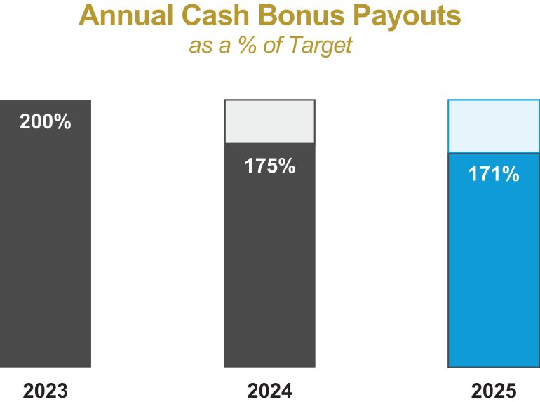 |  |  |  | 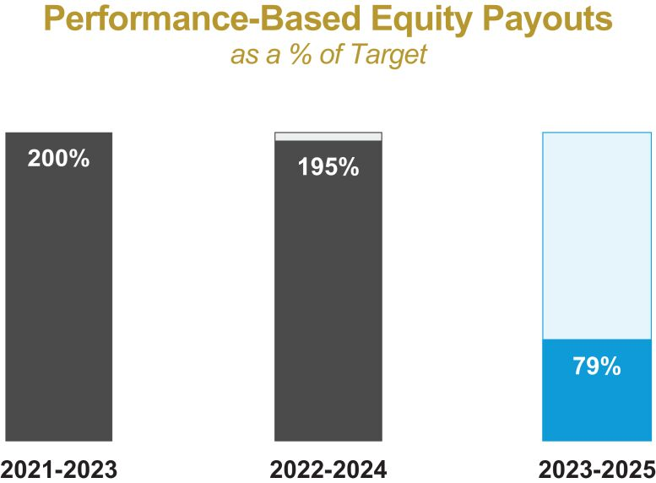
2025 payout reflects our strong financial performance including AFFO growth 3.9% and dividend growth of 2.6% |  |  |  | 3YR TSR performance ending on December 31, 2025 resulted in a significant decrease in the shares earned vs. the prior two cycles when our TSR significantly outperformed the market
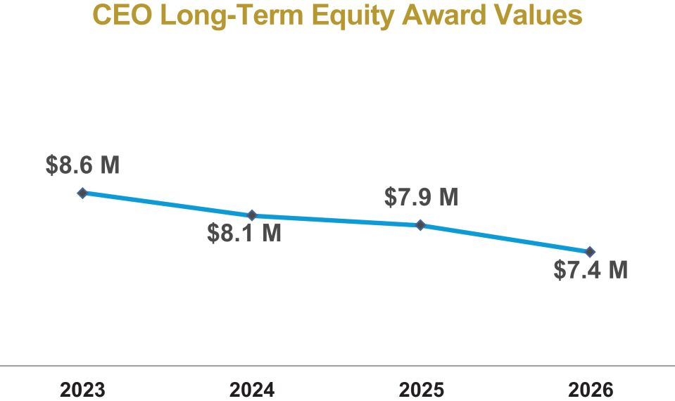 |  |  |  | 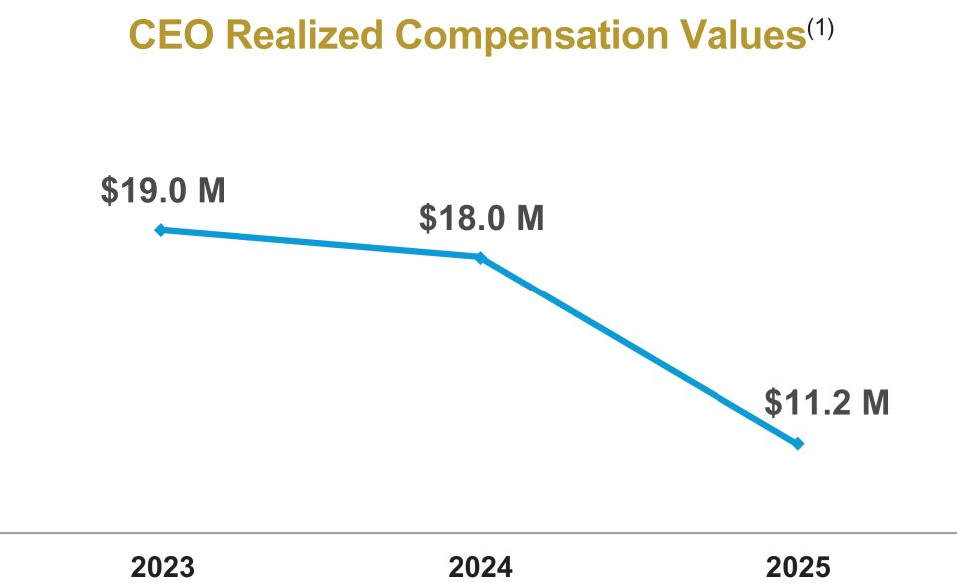
Fixed share grants tie NEO grant-date equity values directly to our stock price and resulted in a $1.2 million reduction in target LTI value |  |  |  | Our pay-for-performance alignment is demonstrated through our CEO’s realized compensation, which has resulted in an approximate $7.8 million reduction since 2023 due to lower funding under our incentive programs

(1) | CEO realized compensation includes base salary and annual bonus, the year-end value of service-based equity granted on January 1, and the value of performance-based equity earned for each completed three-year period ending December 31, multiplied by the December 31 stock price.

Gaming and Leisure Properties, Inc. |  | 2026 Proxy Statement | 29

Table of Contents

Proxy  Summary |  | Board of  Directors |  | Executive  Compensation |  | Audit Committee  Matters |  | Voting  Proposals |  | Other  Matters

Executive Compensation Core Elements
The core elements of our overall 2025 executive compensation program are outlined below, with details discussed more fully throughout CD&A:

 | ● |  | Ensured a compensation structure focused on execution of the business strategy and achieving Company goals, including the following 2025 highlights:

 | — | 90% of cash bonus tied to pre-established performance goals
 | — | 80% of maximum equity awards require the achievement of long-term TSR hurdles over a three-year performance period

 | ● |  | Rigorous performance goals for both our annual performance cash bonus program and performance-based equity awards:

 | — | Maximum payout under the cash bonus program requires out-performance across multiple metrics
 | — | Maximum payout for the performance-based equity awards requires top quartile relative TSR performance over a three-year period
 | — | Performance-based equity award payout capped at target if absolute TSR is negative over the performance period

 | ● |  | Over 60% of the pay opportunity of our NEOs is variable, performance-based compensation contingent upon the achievement of predetermined performance criteria designed to drive shareholder value

 | ● |  | The “at risk” compensation represents a significant portion of management’s total compensation opportunity

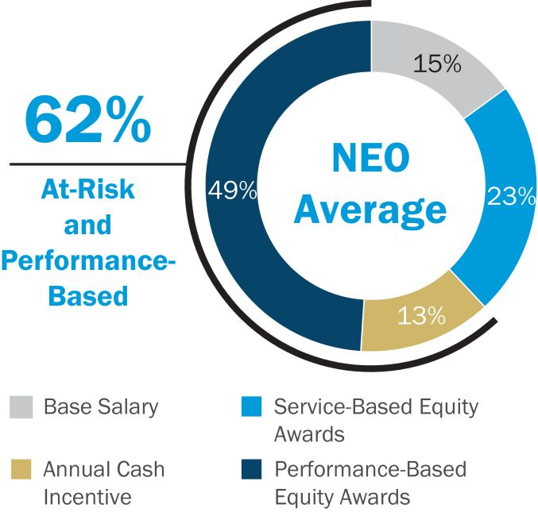

 | (1) | Service-Based Equity Award(s) compensation includes the value of the long-term equity awards subject to continued employment.

 | (2) | “At-Risk and Performance-Based” compensation includes the target annual performance cash awards and the target value of long-term performance-based equity awards.

 | ● |  | In lieu of employment agreements, we adopted the Executive Change in Control and Severance Plan in 2019 to provide members of the Company’s executive management team with compensation and benefits in the event of certain termination events.
In addition, we are committed to strong corporate governance as evidenced by the following:

 | ● |  | Stock Ownership Guidelines for our executive officers and non-employee directors
 | ● |  | Anti-hedging policy that prohibits trading in puts, calls, options or other derivative instruments derived from the value of the Company’s stock
 | ● |  | Double trigger vesting acceleration of incentive equity awards upon a change of control
 | ● |  | No agreements or arrangements containing tax gross-ups or other similar tax indemnification provisions
 | ● |  | Enhanced commitment to corporate responsibility initiatives through formalized oversight by the Nominating and Corporate Governance Committee
 | ● |  | Engaged with our shareholders to discuss our compensation program, which has resulted in numerous changes over the past several years. During 2025, the Company’s outreach efforts included participation in several gaming and REIT industry conferences. See Shareholder Outreach below for more information.

30 | 2026 Proxy Statement |  | Gaming and Leisure Properties, Inc.

Table of Contents

Proxy  Summary |  | Board of  Directors |  | Executive  Compensation |  | Audit Committee  Matters |  | Voting  Proposals |  | Other  Matters

Compensation Philosophy and Objectives
We annually review and confirm our compensation philosophy that serves as the guide for all executive compensation decisions. Our compensation philosophy is as follows:
The Company maintains an executive compensation program that will help it attract and retain the executive talent needed to grow and further the strategic interests of the business in an increasingly competitive operating environment. To this end, the Company provides a compensation and benefits program designed to retain talented executives and continue in their efforts to improve shareholder value, while carefully considering the impact of the Company’s actions on all stakeholders. The Company’s program is designed to motivate and reward executives to achieve and exceed targeted results. Pay received by our executives will be commensurate with the performance of the Company and their own individual contributions.
In order to achieve our stated compensation philosophy, our compensation program is guided by the following objectives:

 | ● |  | offer a competitive and balanced compensation program to compensate executives for the unique experience required in their roles, taking into consideration the total compensation opportunity offered by our peer companies

 | ● |  | utilize a mix of fixed and performance-based compensation designed to closely align the interests of the management team with those of the Company’s shareholders

 | ● |  | utilize rigorous performance-based metrics aligned with key strategic objectives that support long-term shareholder value
GLPI’s Annual Executive Compensation Review and Approval Process
In developing our 2025 and 2026 executive compensation program, we considered multiple perspectives and reference points to guide the design process and individual pay decisions. The Committee regularly analyzes and considers information received from its independent compensation consultant, our shareholders, individual performance assessments, and external factors impacting the REIT and gaming industries to make informed compensation decisions for our NEOs.

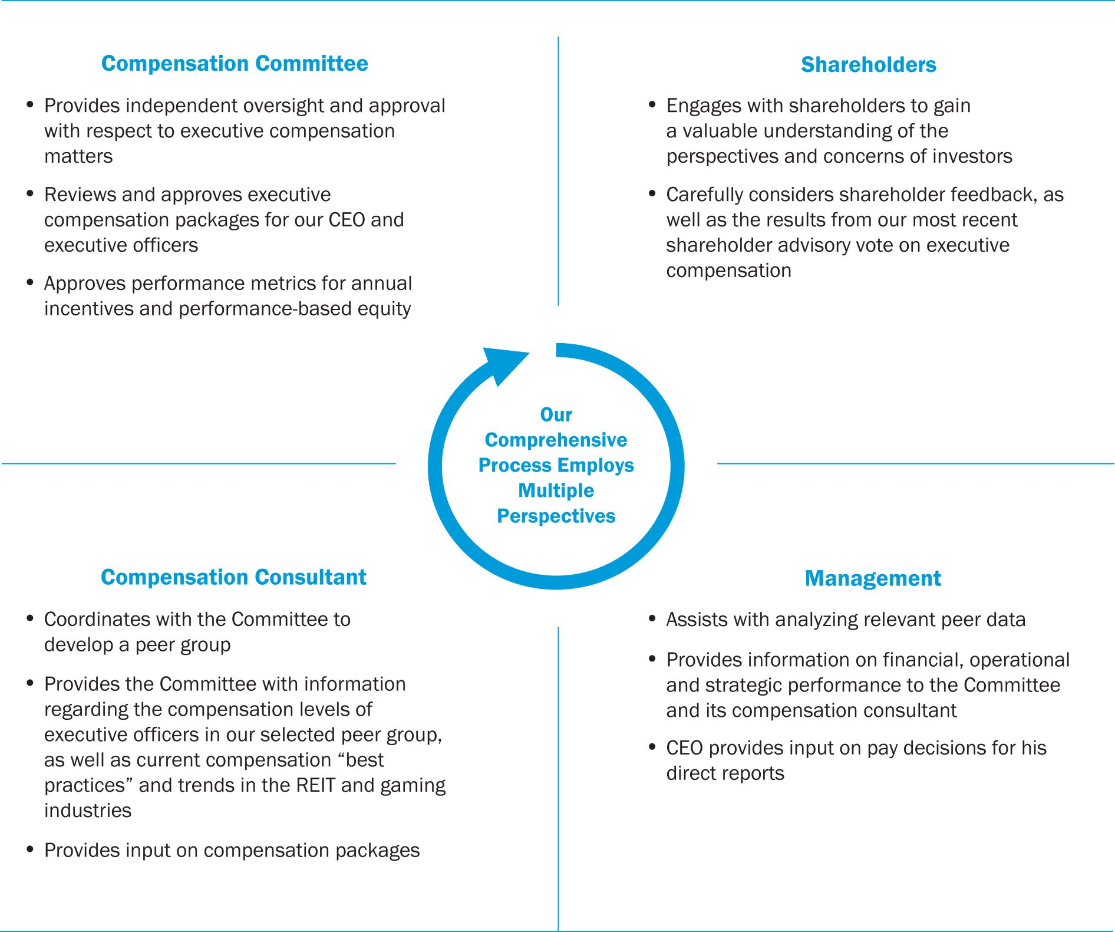

Gaming and Leisure Properties, Inc. |  | 2026 Proxy Statement | 31

Table of Contents

Proxy  Summary |  | Board of  Directors |  | Executive  Compensation |  | Audit Committee  Matters |  | Voting  Proposals |  | Other  Matters

Shareholder Outreach
Our Board and the management team recognize the importance of ongoing engagement with our shareholders to enable us to understand and respond to shareholder concerns. In response to our shareholders, the Company has made meaningful changes to its corporate governance structure, compensation programs and corporate responsibility initiatives.
Throughout the year, members of the management team engaged in routine and off-cycle investor outreach with the corporate governance teams of our top 15 shareholders as well as significant shareholders that either withheld votes or voted against the recommendations of the Board. The Board believes that it is important to understand the reasons why shareholders choose not to support certain of the Board’s recommendations and to discuss the Company’s governance structure and initiatives shareholders would like the Board to consider in the upcoming year.
Through these outreach efforts, the Board and the management team have gained a valuable understanding of the perspectives and concerns of each investor. The Board and the management team carefully consider shareholder feedback, as well as the results from our most recent shareholder advisory vote on executive compensation, when reviewing our corporate governance and executive compensation programs.
At the Company’s 2025 Annual Meeting of Shareholders, the majority of our shareholders (96% of shares voted) supported our shareholder advisory vote on executive compensation.
Consistent Support for our Say-on-Pay Proposal

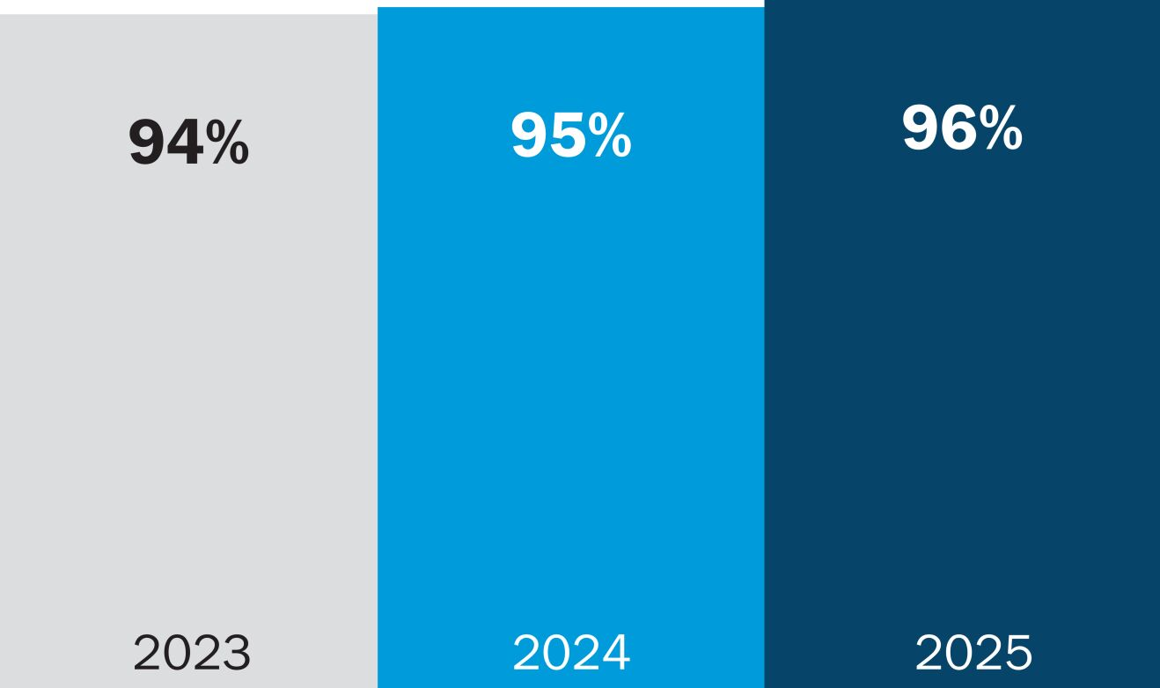
Role of the Compensation Committee
The Committee annually reviews and approves the executive compensation packages for our CEO and each of the other executive officers as well as confirms and approves performance-based awards earned for the most recently completed three-year performance period. In establishing compensation packages, the Committee considers numerous factors and data, including:

 | ● |  | the experience necessary to identify and solve the significant tax, accounting, finance, legal and regulatory complexities inherent in the types of transactions pursued by the Company as a REIT

 | ● |  | current best practices and market trends related to compensation structure

 | ● |  | the compensation packages, structure and performance goals of our REIT peers, supplemented with gaming companies with whom we compete for talent and assets

 | ● |  | the dividend payout for the previous fiscal year and projected dividends for the current year

 | ● |  | the ability to negotiate definitive acquisition agreements for properties that will be accretive to the Company

 | ● |  | the Company’s performance relative to its REIT peers

 | ● |  | the ability to satisfy state gaming licensing requirements and maintain compliance with REIT qualifications

 | ● |  | the individual performance of the executives and their total compensation relative to executive peers

32 | 2026 Proxy Statement |  | Gaming and Leisure Properties, Inc.

Table of Contents

Proxy  Summary |  | Board of  Directors |  | Executive  Compensation |  | Audit Committee  Matters |  | Voting  Proposals |  | Other  Matters

 | ● |  | a breakdown of the various components of each executive officer’s compensation package

 | ● |  | perquisites and other benefits, if any, offered to each executive

 | ● |  | the performance of previous performance-based equity incentive awards
The Committee reviews this information with its independent compensation consultant and certain executives to revise or confirm the compensation packages for each executive officer. One of our goals is to ensure that base salaries and total compensation packages are appropriate to attract and retain executives with the gaming and real estate experience necessary to create and preserve long-term shareholder value and protect the interests of our stakeholders. We will also alter performance measures and/or the mix of cash and long-term equity incentive awards as necessary to ensure that management incentives continue to be aligned with shareholder interests.
Role of Management
The Company’s CEO works closely with the Committee to analyze relevant peer data and to determine the appropriate base salary, cash bonus and incentive award levels for each member of the management team. While the Committee values the judgment of and input from the CEO and considers his recommendations, the Committee ultimately retains sole discretion to approve the compensation packages for each member of the management team.
Additionally, the management team also provides the necessary financial, operational and strategic information to determine appropriate metrics and goals that will best measure performance and results to assess actual achievement versus pre-established goals.
Role of Compensation Consultant
We retained Ferguson Partners Consulting L.P. (“FPC”) to advise us on compensation-related matters in 2025. We selected FPC because of its experience in assisting other REITs in determining the optimal type and balance of cash and incentive award components in a manner intended to align the interests of the management team and shareholders while being competitive. FPC coordinated with the Committee to develop a peer group for use in structuring the Company’s executive compensation program. We review the peer group with FPC annually to ensure that it provides an accurate representation of the Company’s structure and operations. A description of the process and rationale utilized for selecting our 2025 executive compensation peer group is described below.
FPC reviewed the current compensation of each executive officer on several levels, including consideration of (a) cash versus equity-based incentive awards, (b) fixed versus variable compensation, (c) service-based vesting versus performance-based vesting, and (d) short-term awards versus long-term incentive awards. In addition, FPC provided the Committee with information regarding the compensation levels of executive officers in our selected peer group, as well as current compensation “best practices” and trends in the REIT and gaming industries. Based on all of the available information and discussions with the CEO, FPC provided the Committee with its recommendation as to the appropriate compensation of each executive officer or confirmed for the Committee that the suggested compensation packages were reasonable.
The Committee determined that no conflict of interest existed during 2025 between FPC and the Company (including the Company’s Board of Directors and management team) pursuant to Item 407(e)(3)(iv) of SEC Regulation S-K. Neither FPC nor any affiliate provided additional services to the Company or its affiliates in excess of $120,000 during 2025.

Gaming and Leisure Properties, Inc. |  | 2026 Proxy Statement | 33

Table of Contents

Proxy  Summary |  | Board of  Directors |  | Executive  Compensation |  | Audit Committee  Matters |  | Voting  Proposals |  | Other  Matters

Executive Compensation Peer Group
Each year, the Committee reviews the executive compensation peer group to ensure the appropriateness of each peer company, as well as the peer group in totality, based on the following:

GLPI Business Factors Used to Assess Peer Group Selection
Focusing exclusively on the acquisition and development of gaming assets
Acquiring gaming assets from taxable corporations includes complex tax, accounting, legal and regulatory issues
Requiring executives that possess knowledge and expertise in both real estate and gaming operations to balance our strategic initiatives with our structure
Competing for talent and assets with not only REITs, but with companies in the highly competitive gaming industry
Based on this assessment, the Committee determined that the Company’s competitors primarily consist of two groups of companies (i) companies with whom we compete for investors, capital and gaming assets – gaming REITs, triple-net lease REITs and private equity, and (ii) companies with whom we compete with for talent and gaming assets – gaming REITs and gaming operators. Accordingly, we reviewed our executive compensation peer group based on the following selection criteria:

 | ● |  | Size – Companies with implied market capitalization or total capitalization ranging from 0.3x to 3.0x that of the Company

 | ● |  | Net Lease REITs – Primarily include REITs with revenues predominately derived from net leases or triple-net leases that are comparable to the Company in terms of the knowledge and skills required by the executive team to effectively evaluate opportunities and structure leases in complex transactions

 | ● |  | Gaming Expertise – Include a limited number of gaming companies with whom the Company competes for talent and assets and have the knowledge to navigate the highly regulated and complex gaming industry (represents 33% of our executive compensation group)
Applying these criteria, FPC recommended, and the Committee approved, the following peer group in 2025(1):

Net Lease REITs |  | Gaming Companies
Alexandria Real Estate Equities, Inc. |  | Boyd Gaming Corporation
EPR Properties |  | Caesars Entertainment Inc.
Healthpeak Properties, Inc. |  | MGM Resorts International
NNN REIT, Inc. |  | PENN Entertainment Inc.
Omega Healthcare Investors, Inc. |  | Wynn Resorts, Limited
Realty Income Corporation
Rexford Industrial Realty, Inc.
Ventas, Inc.
VICI Properties Inc.
W. P. Carey Inc.

(1) | Welltower, Inc. was removed from the peer group, and Ventas, Inc. was identified as a suitable addition to the peer group based on the selection criteria above.
While each peer is not entirely comparable to the Company, we believe that on a blended basis our current peer group provides the most accurate representation of the Company’s operations and is appropriate particularly given that:

 | ● |  | The peer group is over-weighted towards net lease REITs (represents two-thirds of the peer group)

 | ● |  | Our implied equity market capitalization and total enterprise value were above the median of the peer group
In establishing the 2025 compensation program, the Committee utilized peer group compensation data to understand the Company’s pay levels and structure as compared to the market. Although the Committee does not target a certain percentile of

34 | 2026 Proxy Statement |  | Gaming and Leisure Properties, Inc.

Table of Contents

Proxy  Summary |  | Board of  Directors |  | Executive  Compensation |  | Audit Committee  Matters |  | Voting  Proposals |  | Other  Matters

compensation, we believe it is important to understand the competitive landscape to effectively assess each executive officer’s total compensation opportunity, pay mix and our governance practices. We strive to ensure that our compensation program and opportunities remain equitable and competitive, while also considering other factors such as overall market trends, shareholder feedback, internal equity and Company performance.
Risk Assessment
In establishing and reviewing our executive compensation program, we consider, among other things, whether the program properly motivates our executives to focus on the creation of shareholder value without encouraging unnecessary or excessive risk taking. To this end, the Committee carefully reviews the principal components of executive compensation. Base salaries are reviewed annually. Annual incentive pay is focused on the achievement of certain specific overall financial performance goals and is determined using multiple criteria with established maximum payouts. The other major component of our executive officers’ compensation comprises long-term incentives provided through equity awards which we believe is important to help further align our executives’ interests with those of our shareholders and other stakeholders. The Committee believes that these cash and incentive awards, especially when combined with the stock ownership requirements and compensation clawback policy described in this Proxy Statement under the heading Other Compensation Policies, appropriately balance risk, payment for performance and alignment of executive compensation with the interests of shareholders and other stakeholders without encouraging unnecessary or excessive risk taking.
Overview of 2025 Compensation
Elements of Compensation
The 2025 compensation program was heavily weighted toward performance-based compensation utilizing several different performance metrics. The mix of cash versus equity-based incentive awards, fixed versus variable compensation, and service-based vesting versus performance-based vesting of equity incentive awards was designed to ensure that management was, and remained, appropriately incentivized across a number of different business and economic environments. In addition, our program included both internal performance measures as well as external performance metrics to ensure that our executives were focused on the Company’s goals as well as its position in the market. The following is an outline of the key elements (with a summary of each element provided below):

Component |  | Description |  | Objective |  | Strategic Rationale
Base Salary |  | Fixed cash compensation |  | Provide competitive fixed compensation considering the job responsibilities, individual performance, skills and experience |  | Designed to attract and retain executives with the experience and skills necessary to implement and execute the Company’s growth strategy
Annual Performance Cash Awards |  | Cash compensation with 90% tied to achievement of pre-determined performance goals and 10% tied to qualitative performance |  | Provide variable incentives targeting specific annual goals for the year based on prior year results and specific strategic objectives |  | Motivates the achievement of short-term corporate objectives that are aligned with our annual budget and business plan and aligns executive and shareholder interests
Long-Term Service-Based Equity Awards |  | Annual equity awards with time-based vesting equally over a three-year period |  | Supplement fixed compensation with long-term vesting to enhance retention and encourage long-term growth by subjecting recipients to the same market fluctuations as shareholders |  | Aligns executive and shareholder interests and rewards long-term stock performance
Long-Term Performance-Based Equity Awards |  | Annual equity award with three-year cliff vesting based on TSR measured against the US MSCI Index and triple-net REIT peers |  | Provide a significant portion of total potential compensation tied to superior long-term stock performance |  | Aligns executive and shareholder interests and rewards long-term stock performance with no payout for under-performance and capped payouts during periods of negative absolute TSR

Gaming and Leisure Properties, Inc. |  | 2026 Proxy Statement | 35

Table of Contents

Proxy  Summary |  | Board of  Directors |  | Executive  Compensation |  | Audit Committee  Matters |  | Voting  Proposals |  | Other  Matters

Base Salary
The base salaries of our executives are designed to compensate them for services rendered during the fiscal year and, consistent with our pay for performance philosophy, executives receive a significant portion of their overall targeted compensation in a form other than a fixed base salary. Although the Company does not generally benchmark against any particular percentile of base salaries of comparable executives within the Company’s peer group, we set salaries that are competitive with our peers so that the Company can attract and retain high-performing executives, including certain executives with experience in the gaming industry. In addition, we recognize that it is critical that executives have the experience necessary to identify and resolve the complex tax, accounting, legal and regulatory issues inherent in the type of transactions engaged in by the Company. Base salaries are then further adjusted for certain qualitative factors, including: specific position duties and responsibilities; tenure with the Company; individual contributions; value to the Company; and the overall reasonableness of an executive’s compensation.
Set forth below are the base salaries for each of the NEOs in effect as of the end of fiscal year 2025, which included a (i) $75,000 market-based increase in base salary for Ms. Burke and (ii) $30,000 market-based increase in base salary for Mr. Ladany.

Executive |  | 2025  Salary |  |  |  |  | Year-over-Year Change
Chairman and Chief Executive Officer |  |  |  | $1,808,468 |  |  | No Change Since 2012
President, Chief Operating Officer and Secretary |  |  |  | $650,000 |  |  | No Change
Chief Financial Officer and Treasurer |  |  |  | $600,000 |  |  | $75,000
Senior Vice President and Chief Development Officer |  |  |  | $460,000 |  |  | $30,000
Annual Performance Cash Awards
For 2025, the Committee adopted an annual cash bonus program designed to motivate the executive officers and other members of the management team to achieve certain Company growth objectives and near-term strategic priorities. These goals are critical to our long-term success and are designed to be challenging and rigorous to ensure that we remain focused on sustained growth and our overall business strategy. Additionally, the Committee considered best practices and governance standards in designing our cash bonus program.
The annual cash bonus program has historically been based on the achievement of a number of specific performance criteria focused on the Company’s annual strategic goals and business plan, including specific AFFO and dividend targets. The performance assessment for 2025 was based on the following structure:

Metric and Rationale for Inclusion |  | Weighting |  | Threshold |  | Target |  | Maximum |  | Actual
AFFO Growth(1)  Motivates management to responsibly deploy capital as measured by a frequently used REIT earnings metric |  | 35% |  | $3.77  per share |  | $3.84  per share |  | $3.90  per share |  | $3.88  per share
Dividend Growth(2)  Encourages management to focus on profitability and effectively increasing shareholder cash distributions |  | 35% |  | N/A |  | $3.08  per share |  | $3.16  per share |  | $3.12  per share
Achievement of Company Objectives(3)  Rewards management for the achievement of key priorities, including corporate responsibilities, balance sheet management and other relevant factors |  | 20% |  | 5 |  | 7 |  | 9 |  | 10
Qualitative/Individual  Represents indicators of the executive’s success in fulfilling his or her responsibilities and in executing the business plan |  | 10% |  | Compensation Committee’s Assessment—See Below

(1) | AFFO per diluted share and unit is a non-GAAP financial measure. For a definition and reconciliation of this non-GAAP financial measure to the most directly comparable GAAP measure, see our earnings release furnished as Exhibit 99.1 to our Current Report on Form 8-K furnished on April 23, 2026. AFFO per share is presented on a fully diluted basis assuming full conversion of limited partnership units to common shares and therefore before the income statement impact of non-controlling interests.
(2) | Based on per share dividends announced as of fourth quarter 2025 on an annualized basis.

36 | 2026 Proxy Statement |  | Gaming and Leisure Properties, Inc.

Table of Contents

Proxy  Summary |  | Board of  Directors |  | Executive  Compensation |  | Audit Committee  Matters |  | Voting  Proposals |  | Other  Matters

(3) | Based on the achievement of: (a) Balance Sheet Management: (i) Net Debt to Adjusted EBITDA (pro forma for transactions) at or less than 5.50x (Achieved),(ii) variable rate debt at year-end to not exceed 10% (Achieved), and (iii) negotiate and implement a new at-the-market trading program with increased bank participation (Achieved); (b) Growth Initiatives: (i) enter into definitive agreements to participate in a greenfield development project (Achieved), (ii) enter into definitive agreement(s) that will add at least a target amount in additional revenue (Achieved), and (iii) enter into definitive documents providing for long-term lease structure with a Native American tribe (Achieved); (c) Other Strategic Objectives: (i) expand relationships by adding at least one new partner or tenant (Achieved), and (ii) increase the geographic diversification of the Company’s portfolio (Achieved); and (d) Shareholder Engagement: (i) solicit input from top 10 institutional investors as of year-end on corporate governance and other matters (Achieved), and (ii) engage with institutional investors and sell-side analysts through at least fifteen conferences, investor meetings, property tours and non-deal roadshows (Achieved).
In establishing performance metrics and targets for our annual cash bonus program, the Committee takes into consideration (i) strategic objectives for the year, (ii) our business plan, (iii) prior-year results, and (iv) growth expectations. Performance metric targets are intended to be challenging but achievable with maximum payouts only earned for exceptional performance as demonstrated by the following:

 | ● |  | 2025 AFFO Growth Hurdles: To earn any payout under the 2025 AFFO growth metric, our earnings must be equal to or above the prior year’s results.

 | ● |  | Dividend Growth: The 2025 target goal was set $0.04 higher than 2024 results and the 2025 maximum goal was set $0.12 higher than 2024 results. To the extent our dividend did not increase by at least $0.04, no payout would be earned.
The Committee also takes into consideration more qualitative/individual factors to reward executives for non-financial achievements that are critical to the growth and success of our Company in the long-term. The 2025 qualitative/individual goals do not represent an exhaustive list of the Company’s strategic and financial goals and objectives.
We set the ranges of bonuses payable pursuant to the cash bonus measure for each executive as a percentage of annual base salary. Set forth below are the bonus ranges for each of the NEOs in effect as of the end of fiscal year 2025. In order to help manage total potential compensation payouts, annual cash bonus opportunities are capped at a maximum bonus level, regardless of the extent to which performance exceeds targeted levels.

Executive |  | Threshold |  |  |  |  | Target |  |  |  |  | Maximum
Chairman and Chief Executive Officer |  |  |  | 50 | % |  |  |  | 100 | % |  |  |  | 200 | %
President, Chief Operating Officer and Secretary |  |  |  | 50 | % |  |  |  | 100 | % |  |  |  | 200 | %
Chief Financial Officer and Treasurer |  |  |  | 37.5 | % |  |  |  | 75 | % |  |  |  | 150 | %
Senior Vice President and Chief Development Officer |  |  |  | 37.5 | % |  |  |  | 75 | % |  |  |  | 150 | %
In the first quarter of 2026, the Committee evaluated 2025 performance, as detailed above, and determined that the Company’s performance achieved (i) 75% of the maximum level established for the dividend goal, (ii) 83.3% of the maximum level for the established AFFO goals, and (iii) the maximum level established for the achievement of Company objectives. The Committee also assessed the individual performance of each NEO, which accounts for only 10% of the overall bonus. The Committee determined that the individual component was achieved at maximum level based on its assessment of the Company’s overall growth achievements and each NEO’s considerable efforts and contributions toward these achievements. Key considerations included:

 | ● |  | The successful funding of over $800 million for development projects and acquisitions in 2025.

 | ● |  | Entered into new transactions representing over $875 million in newly invested capital when fully deployed.
Based on the formula and assessment described above and each NEO’s bonus opportunities, the following illustrates the actual amount paid to each NEO for 2025:

Executive |  | Actual Bonus  Percent of  Base Salary |  | Actual  Payment
Chairman and Chief Executive Officer |  | 171% |  | $ | 3,089,466
President, Chief Operating Officer and Secretary |  | 171% |  | $ | 1,110,417
Chief Financial Officer and Treasurer |  | 128% |  | $ | 768,750
Senior Vice President and Chief Development Officer |  | 128% |  | $ | 589,375

Gaming and Leisure Properties, Inc. |  | 2026 Proxy Statement | 37

Table of Contents

Proxy  Summary |  | Board of  Directors |  | Executive  Compensation |  | Audit Committee  Matters |  | Voting  Proposals |  | Other  Matters

Long-Term Performance-Based Equity Awards
While the annual cash bonus program was designed to incentivize the Company’s management team to achieve specific near-term internal Company goals, the long-term performance equity award program was designed to focus the management team on the Company’s long-term performance in relation to the broader REIT indices. We believe that having a majority of compensation structured as equity compensation motivates executives to increase the long-term value of the Company by aligning a significant portion of their total compensation with the interests of the Company’s shareholders. We also believe that equity compensation is a critical tool in attracting and retaining executives with the type of entrepreneurial spirit that has been and will continue to be integral to the Company’s success.
In 2025, the Committee provided executive officers with the opportunity to elect to receive annual long-term based equity awards (performance-based and/or service-based) in the form of a class of units of limited partnership interest in our operating partnership, GLP Capital, L.P. (“LTIP Units”). For a description of the LTIP Units, see Tax Considerations below.
Long-term performance-based awards have three-year cliff vesting with the number of restricted shares or LTIP Units vested at the end of the three-year period determined based on the Company’s performance during such period measured against its peers. More specifically, the percentage of shares or units vesting at the end of the measurement period is based on the Company’s three-year TSR ranking among the three-year return of the companies included in (1) the MSCI US REIT index, and (2) a triple-net REIT group(1) that includes publicly-traded REITs with revenues primarily derived from triple-net leases.
The performance hurdles and levels of opportunity for performance-based restricted stock and LTIP Unit awards granted in 2025 are set forth below. The awards provide for linear vesting in between achievement levels with vesting capped at target if TSR over the three-year performance period is negative.

Level |  | Relative TSR Hurdles (%) |  | Payout Percentage
Below Threshold |  | < 25th percentile |  | 0%
Threshold |  | 25th percentile |  | 50%
Target |  | 50th percentile |  | 100%
Maximum |  | 75th percentile |  | 200%

(1) | Companies included in the triple-net REIT measurement group are Agree Realty Corporation, Alexandria Real Estate Equities, Inc., Broadstone Net Lease, Inc., CareTrust REIT, Inc., EPR Properties, Essential Properties Realty Trust, Four Corners Property Trust, Inc., Global Net Lease, Inc., LTC Properties, Inc., LXP Industrial Trust, Medical Properties Trust, Inc., NNN REIT, Inc., Omega Healthcare Investors, Inc., Realty Income Corporation, Sabra Health Care REIT, Inc., Safehold Inc., Service Properties Trust, STAG Industrial Inc., Uniti Group, Inc., VICI Properties Inc. and W.P. Carey Inc.
The following table sets forth the target number of performance-based awards granted to each NEO in 2025, which included adjustments for Mr. Moore in recognition of his promotion to President in September 2024:

Executive |  | Target Performance-Based  Equity Awards(1)
Chairman and Chief Executive Officer |  | 110,000
President, Chief Operating Officer and Secretary |  | 52,000
Chief Financial Officer and Treasurer |  | 36,000
Senior Vice President and Chief Development Officer |  | 30,000

(1) | The target number of performance-based equity awards is split equally between awards based on the MSCI REIT Index and the net lease REIT group.

38 | 2026 Proxy Statement |  | Gaming and Leisure Properties, Inc.

Table of Contents

Proxy  Summary |  | Board of  Directors |  | Executive  Compensation |  | Audit Committee  Matters |  | Voting  Proposals |  | Other  Matters

The performance awards granted in January 2023 were each earned as of December 31, 2025 with (i) 38.2% of the maximum payout as a result of the Company’s relative TSR ranking compared to the MSCI US REIT index and (ii) 40.9% of the maximum payout as a result of the Company’s relative TSR ranking compared to the net lease REIT group, each for the measurement period. The following table shows the status of the performance awards granted in each of 2023 through 2025:

Program |  | Performance  Period |  | Performance Metric |  | Actual Performance |  | Status as of 12/31/25
2025  Performance  Awards |  | January 2025-December 2027 |  | Relative TSR vs.  MSCI US REIT Index and  Select Triple-Net Lease REITs |  | Matures 12/31/2027 |  | ●  vs. MSCI US REIT Index: Tracking 60.3%  ●  vs. Select Triple-Net Lease REITs: Tracking 27.2%  ●  Absolute TSR: MSCI US REIT index payout reduced to target.
2024  Performance  Awards |  | January 2024-December 2026 |  | Relative TSR vs.  MSCI US REIT Index and  Select Triple-Net Lease REITs |  | Matures 12/31/2026 |  | ●  vs. MSCI US REIT Index: Tracking 42.9%  ●  vs. Select Triple-Net Lease REITs: Tracking 36.3%  ●  Absolute TSR: No payout reduction
2023  Performance  Awards |  | January 2023-December 2025 |  | Relative TSR vs.  MSCI US REIT Index and  Select Triple-Net Lease REITs |  | ●  vs. MSCI US REIT Index: above 25th percentile  ●  vs. Select Triple-Net Lease REITs: above 25th percentile  ●  Absolute TSR: 4.1% |  | ●  vs. MSCI US REIT Index: 38.2%  ●  vs. Select Triple-Net Lease REITs: 40.9%  ●  Absolute TSR: No payout reduction
We believe that this long-term performance-based equity incentive program complements the annual cash incentive program by providing the appropriate balance between performance-based cash and performance-based equity awards.
Long-Term Service-Based Equity Awards
In addition to the long-term performance-based equity awards, we also grant service-based awards with long-term vesting that serve as a critical retention tool and are directly correlated with the Company’s share price performance. Awards vest at a rate of 33.33% per year and are generally subject to continued employment.
Our service-based equity awards are granted as a set number of shares per year. This further aligns our executive officers with our shareholders as the value of their equity awards can only increase (or decrease) with any changes in share price year-over-year and subjects them to the same market fluctuations as our shareholders.

Gaming and Leisure Properties, Inc. |  | 2026 Proxy Statement | 39

Table of Contents

Proxy  Summary |  | Board of  Directors |  | Executive  Compensation |  | Audit Committee  Matters |  | Voting  Proposals |  | Other  Matters

The number of shares of restricted stock awarded to each NEO for 2025 was as follows, which included adjustments for Mr. Moore in recognition of his promotion to President in September 2024:

Executive |  | Number of  Shares
Chairman and Chief Executive Officer |  | 55,000
President, Chief Operating Officer and Secretary |  | 26,000
Chief Financial Officer and Treasurer |  | 18,000
Senior Vice President and Chief Development Officer |  | 15,000
Policies Relating to Grant of Certain Equity Awards
We do not have a practice of granting stock options, and therefore, do not have a policy relating to the timing of the grant of options awards. With respect to equity-based awards, we generally grant restricted stock and other full-value awards, and the grant date of such awards is typically the first trading day of the fiscal year.

Overview of 2026 Compensation Program

Following a review of peer group market data and taking into consideration the Company’s one and three-year TSR as of December 31, 2025, the Committee determined that no changes to the Company’s compensation program were warranted for 2026.

Deferred Compensation

The Company does not maintain any defined benefit pension programs for its executives. The Company maintains an elective
non-qualified
deferred compensation plan for executives. Pursuant to such plan, the Company’s contributions are equal to 50% of the participant’s deferral for the first 10% of the salary and/or bonus deferred, subject to a maximum annual Company contribution equal to 5% of the participant’s salary and/or bonus. All amounts credited to an executive’s account are notionally invested, as directed by the executive, in commonly available mutual funds, and the Company does not guarantee any minimum returns. The deferred compensation plan is unfunded and benefits are paid from the Company’s general assets. However, the Company currently contributes funds into a grantor trust on a monthly basis in respect of these deferred compensation obligations. The Company generally sets aside separately the amounts deferred by the executives and the matching contributions thereon and, to protect against excess liabilities, invests such amounts in the mutual funds selected by each executive. The deferred compensation program is described in more detail under the heading
Gaming and Leisure Properties Inc. Deferred Compensation Plan
of this Proxy Statement.

Benefits and Perquisites

We believe that executives should be offered customary benefits and perquisites that are reasonable relative to the benefits provided to all employees, are consistent with competitive practices among the Company’s peer group and, in certain circumstances, may address a particular reasonable issue or concern of an executive. The standard benefits offered to all of the Company’s employees include medical, dental and vision insurance, group life insurance, short and long-term disability and a 401(k) plan with certain contributions funded by the Company. Consistent with the objectives described above, the Company has historically provided certain executive officers with additional supplemental benefits and perquisites, including in limited instances, use of the Company’s private aircraft where individual circumstances merit. The description and value of such supplemental benefits and perquisites in 2025 can be found on the
All Other Compensation Table
of this Proxy Statement.

Employment Agreements and Severance Plan

We currently have no employment agreements in place with any of our executives. However, on January 29, 2019, the Compensation Committee of the Board adopted the Executive Change in Control and Severance Plan (the “CiC and Severance Plan”). The purpose of the CiC and Severance Plan is to provide certain of the Company’s management team designated by the Compensation Committee (the “Covered Executives”) with compensation and benefits in the event of a termination of employment by the Company without Cause or resignation by the employee for Good Reason or termination of employment due to death or Disability (as such terms and other defined terms used below are defined in the CiC and Severance Plan). Each of our NEOs is eligible to participate in the CiC and Severance Plan.
Under the CiC and Severance Plan, in the event that a Covered Executive’s employment is terminated (i) by the Company for any reason other than for Cause, death, or Disability, or (ii) by the Covered Executive for Good Reason (each such event, a “Qualified

40 |  2026 Proxy Statement |  | Gaming and Leisure Properties, Inc.

Table of Contents

Proxy  Summary |  | Board of  Directors |  | Executive  Compensation |  | Audit Committee  Matters |  | Voting  Proposals |  | Other  Matters

Termination”) such Covered Executive shall be entitled to (a) a lump sum payment equal to two times (for the Chief Executive Officer), or one and
one-half
times (for all other Covered Executives), the sum of the Covered Executive’s annual base salary and average annual cash bonuses, if any, for the three years (with respect to which bonuses are determined) prior to the year of termination (“Average Bonus”), (b) continuing coverage under the Company’s group medical, dental and vision plans as would have applied if the Covered Executive remained employed for a period equal to the earlier of 18 months following the Covered Executive’s Termination Date or the date the Covered Executive becomes eligible to be covered under another employer group health plan (at such cost to the Covered Executive as would have applied in the absence of such termination), and (c) full acceleration of time-based equity awards held by the Covered Executive and any accelerated vesting of equity awards with performance-based vesting to occur in accordance with the terms of the applicable award agreement. The Covered Executive shall also be entitled to any earned but unpaid annual base salary, unpaid expense reimbursements, unused vacation and any vested benefits the Covered Executive may be entitled to under any employee benefit plan of the Company (the “Accrued Benefit”).
In addition, if the Qualified Termination occurs in connection with or within 12 months of a Change in Control (as defined in the CiC and Severance Plan), the Covered Executive shall be entitled to (i) a lump sum payment equal to three times (for the Chief Executive Officer), or two times (for all other Covered Executives), the sum of the Covered Executive’s annual base salary and Average Bonus, (ii) continuing coverage under the Company’s group medical, dental and vision plans as would have applied if the Covered Executive remained employed for a period equal to the earlier of 24 months following the Covered Executive’s Termination Date or the date the Covered Executive becomes eligible to be covered under another employer group health plan (at such cost to the Covered Executive as would have applied in the absence of such termination), and (iii) a lump sum payment equal to the Covered Executive’s pro rata target annual cash bonus for the year of termination. The Covered Executive shall also be entitled to any Accrued Benefit.
In the event that a Covered Executive’s employment is terminated on account of his or her death or Disability, such Covered Executive (or the Covered Executive’s estate or beneficiaries) shall be entitled to (i) a lump sum payment equal to the sum of the Covered Executive’s annual base salary and Average Bonus, (ii) continuing coverage under the Company’s group medical, dental and vision plans as would have applied if the Covered Executive remained employed for a period equal to the earlier of 18 months following the Covered Executive’s Termination Date or the date the Covered Executive becomes eligible to be covered under another employer group health plan (at such cost to the Covered Executive as would have applied in the absence of such termination), and (iii) full acceleration of time-based equity awards held by the Covered Executive and any equity awards with performance-based vesting to remain outstanding and earned in accordance with their terms based on performance but without further vesting based on service. The Covered Executive (or his or her estate or beneficiaries) shall also be entitled to any Accrued Benefit.
Except in the case of death of a Covered Executive, all payments and benefits under the CiC and Severance Plan are subject to timely execution and
non-revocation
of a separation agreement and release containing, among other provisions, post-termination restrictive covenants, including confidentiality,
non-competition
and
non-solicitation.
In each case, if the Covered Executive breaches, or threatens to commit a breach of, any of the provisions of the separation agreement and release, the Covered Executive shall forfeit his or her right to benefits under the CiC and Severance Plan, and to the extent that the Covered Executive has received a benefit under the CiC and Severance Plan, the Company shall have the right to recover such benefit.
On July 18, 2025, the Company and Mr. Demchyk entered into a separation agreement (the “Agreement”) providing for the termination without cause under the CiC and Severance Plan of Mr. Demchyk’s employment with the Company effective August 1, 2025 (the “Separation Date”) as a result of the elimination of the Chief Investment Officer position. The Agreement provides for (a) payment of cash severance, (b) a
pro-rated
2025 bonus, and (c) cash payment to settle his outstanding vested and unvested service-based equity and equity-based awards and a portion of his performance-based equity and equity-based awards, in lieu of payment in shares. Subject to his continuing adherence to certain restrictive covenants and conditions set forth in the Agreement, Mr. Demchyk received or will be entitled to receive the following severance benefits: (i) cash payments equal to $6,250,000, of which $3,250,000 was paid on September 12, 2025 (the first regular payroll date following 30 days after Mr. Demchyk’s execution of a general release of claims, in favor of the Company, became effective), $2,300,000 was paid on March 13, 2026 and the remaining $700,000 will be paid by August 1, 2026; and (ii) continuing coverage under an insurance plan with benefits comparable to the Company’s group medical, dental and vision plans (at no cost to Mr. Demchyk) for a period equal to the earlier of (a) twenty-four (24) months following the Separation Date and (b) the date Mr. Demchyk becomes eligible to be covered under another employer group health plan. For purposes of determining the cash payment for vested and unvested equity and equity-based awards, (i) the numbers of performance-based shares and LTIP units settled under the CiC and Severance Plan were discounted by 35% to account for the accelerated cash payment, and then further prorated for Mr. Demchyk’s service during the applicable performance periods in accordance with the CiC and Severance Plan and (ii) service-based and performance-based awards were valued on the closing stock price on July 17, 2025 of $47.46. For comparison purposes, the average vesting of performance-based awards from 2020-2024 was 97% of maximum, plus accrued dividends.

Gaming and Leisure Properties, Inc. |  | 2026 Proxy Statement  | 41

Table of Contents

Proxy  Summary |  | Board of  Directors |  | Executive  Compensation |  | Audit Committee  Matters |  | Voting  Proposals |  | Other  Matters

Other Compensation and Compliance Policies

Stock Ownership Guidelines
The Compensation Committee believes that it is important for executive officers and
non-employee
directors to have a financial stake in the Company such that their interests are more closely aligned with those of the Company’s shareholders. Accordingly, the Committee has established stock ownership guidelines for our executive officers and
non-employee
directors. Each executive and
non-employee
director is expected to acquire, and continue to hold during the term of his or her employment, equity with a value equal to the multiple of his or her annual base salary/cash retainer as indicated below. These guidelines must be satisfied no later than the fifth anniversary of the executive officer’s or
non-employee
director’s appointment.

Title |  | Multiple
Non-Employee  Directors |  | 5x Annual Cash Retainer
Chairman, Chief Executive Officer and President |  | 5x Annual Base Salary
Chief Operating Officer |  | 4x Annual Base Salary
Chief Financial Officer |  | 4x Annual Base Salary
Senior Vice President |  | 2x Annual Base Salary
Anti-Hedging and Anti-Pledging Policy.
We believe that equity ownership fosters an atmosphere where directors and officers “think like owners” and are motivated to increase the long-term value of the Company by aligning their interests with those of the Company’s shareholders. Accordingly, we have adopted policies prohibiting each of the Company’s directors and executive officers from engaging in hedging transactions or, under limited circumstances subject to the approval of the Audit and Compliance Committee, pledging Company shares.
Compensation Clawback Policy.
The Company has a commitment to ensure that its executive officers adhere to the highest professional and personal standards and has instituted a compensation clawback policy consistent with SEC and Nasdaq requirements. The clawback policy applies to incentive compensation received (as such term is defined in the policy) in any fiscal period ending after October 2, 2023. The clawback policy provides that in the event of any accounting restatement due to the material noncompliance of the Company with any financial reporting requirement under applicable securities laws, the Company will recover the excess incentive compensation received by current or former executive officers who served as such during the three completed fiscal years preceding the date of the restatement, subject to limited permitted exceptions. Recovery under the policy applies regardless of any misconduct, fault, or illegal activity of the Company, the executive officer, the Board or any committee thereof.
Insider Trading Policy
. The Company has adopted a policy on trading company securities (the “Insider Trading Policy”)
which is reasonably designed to promote compliance with insider trading laws and applicable rules and regulations, including those imposed by the SEC and Nasdaq. The Insider Trading Policy applies to all directors, officers and employees of the Company and prohibits purchases, sales and other transactions involving the Company’s securities or the securities of any other companies while in possession of material
non-public
information regarding the Company or such other companies and from disclosing such information to others. It also imposes additional restrictions on directors, officers and certain other employees who regularly have access to such material
non-public
information, including blackout periods and
pre-clearance
requirements. Because the Company has not historically engaged in stock buybacks, the Company has not adopted formal policies and procedures with respect to the Company’s transactions in its own securities. A copy of the Insider Trading Policy is filed as Exhibit 19.1 to the Company’s Annual Report on Form
10-K
for the year ended December 31, 2025.
Statutory and Regulatory Considerations.
In designing the Company’s compensatory programs, we consider the various tax, accounting and disclosure rules associated with various forms of compensation. We also review and consider the deductibility of executive compensation under Section 162(m) (“Section 162(m)”) of the Internal Revenue Code of 1986, as amended (the “Code”). The Tax Cuts and Jobs Act, enacted in December 2017, amended certain aspects of Section 162(m) specifically affecting the exclusion of performance-based compensation from the $1 million limit or deductions for executive compensation in future years. For 2025, we considered the implications and exemptions to such limitation. We seek to preserve the Company’s tax deductions for executive compensation to the extent consistent with the Company’s executive compensation objectives. However, we may also from time to time consider and grant compensation that may not be tax deductible if we believe such compensation is warranted to achieve the Company’s objectives.

42 |  2026 Proxy Statement |  | Gaming and Leisure Properties, Inc.

Table of Contents

Proxy  Summary |  | Board of  Directors |  | Executive  Compensation |  | Audit Committee  Matters |  | Voting  Proposals |  | Other  Matters

Tax Considerations
LTIP Units
LTIP Units are similar to common units in our operating partnership, which generally are economically equivalent to shares of our common stock, except that the LTIP Units are structured as “profits interests” for U.S. federal income tax purposes under current federal income tax law. As profits interests, LTIP Units generally only have value, other than with respect to the right to receive distributions, if the value of the assets of our operating partnership increases between the issuance of LTIP Units and the date of a book-up event for partnership tax purposes. If the value of the assets of our operating partnership increases sufficiently, the LTIP Units can achieve full parity with common units in our operating partnership. If such parity is achieved, LTIP Units may be converted, subject to the satisfaction of applicable vesting conditions, on a one-for-one basis into common units, which in turn are redeemable by the holder for cash or, at our election, on a one-for-one basis into shares of our common stock. Service-based LTIP units, whether vested or unvested, entitle the holder to receive distributions per unit from our operating partnership that are equivalent to the dividends paid per share on our common stock. Performance-based LTIP Units are entitled to accumulated distributions that are only payable to the extent any performance-based LTIP Units are actually earned at the end of the performance period. For tax purposes only, the performance-based LTIP Units are entitled to a partial 10% distribution during the performance period.
LTIP Units are intended to offer executives substantially the same long-term incentive as shares of restricted stock, with more favorable U.S. federal income tax treatment available for “profits interests” under current federal income tax law. More specifically, one key disadvantage of restricted stock is that executives are generally taxed on the full market value of a grant at the time of vesting, even if they choose to hold the stock. Conversely, under current federal income tax law, an executive would generally not be subject to tax at the time of issuance or vesting of an LTIP Unit but only when he or she chooses to liquidate his or her LTIP Units. Therefore, an executive who wishes to hold his or her equity awards for the long term can generally do so in a more tax-efficient manner with LTIP Units. In light of the trade-offs between increased tax efficiency and incremental economic risk relating to the structure of the LTIP Units as profits interests due to their only having value upon a book-up event as described above as compared to restricted stock, we have chosen to use LTIP Units as long-term equity incentive awards for our NEOs. We believe that the use of LTIP Units has (i) enhanced our equity-based compensation package overall, (ii) advanced the goal of promoting long-term equity ownership by executives, (iii) not adversely impacted dilution as compared to restricted stock, and (iv) further aligned the interests of our executives with the interests of our shareholders. We also believe that these benefits outweigh the loss of the U.S. federal income tax business-expense deduction from the issuance of LTIP Units, as compared to restricted stock.

Gaming and Leisure Properties, Inc. |  | 2026 Proxy Statement | 43

Table of Contents

Proxy  Summary |  | Board of  Directors |  | Executive  Compensation |  | Audit Committee  Matters |  | Voting  Proposals |  | Other  Matters

Compensation Committee Report
We have reviewed and discussed the Compensation Discussion and Analysis with management. Based on our review and discussion with management, the Compensation Committee recommended to our Board of Directors that the Compensation Discussion and Analysis be included in this Proxy Statement and, by reference, in the Company’s Annual Report on Form 10-K for the fiscal year ended December 31, 2025.
Compensation Committee
James B. Perry, Chair
Michael C. Borofsky
Joseph W. Marshall, III
The foregoing report of the Compensation Committee does not constitute soliciting material and shall not be deemed filed, incorporated by reference into or a part of any other filing by the Company (including any future filings) under the Securities Act of 1933, as amended (the “Securities Act”) or the Exchange Act, except to the extent the Company specifically incorporates such report by reference therein.

44 | 2026 Proxy Statement |  | Gaming and Leisure Properties, Inc.

Table of Contents

Proxy  Summary |  | Board of  Directors |  | Executive  Compensation |  | Audit Committee  Matters |  | Voting  Proposals |  | Other  Matters

The Terms below are defined for use within the subsequent tables.
Restricted Stock Awards – Inclusive of Grants of Service-Based Equity Awards, Service-Based LTIP Units, Performance-Based Equity Awards or Performance-Based LTIP Units (“Awards”)
Service-Based Awards – Restricted Stock Awards that vest based upon time served at the Company
Performance-Based Awards – Restricted Stock Awards that vest based upon the Company’s performance as compared to that of either the MSCI index or the NNN index
Summary Compensation Table
The following table sets forth information concerning the compensation earned during the fiscal years ended December 31, 2025, 2024 and 2023 by the Company’s NEOs:

Name and  Principal  Position |  | Year |  |  |  |  | Salary  ($) |  |  |  |  | Service-Based  Awards  ($)(1) |  |  |  |  | Performance-  Based  Awards  ($)(2) |  |  |  |  | Non-Equity  Incentive Plan  Compensation  ($)(3) |  |  |  |  | All Other  Compensation  ($)(4) |  |  |  |  | Total  ($)
Peter M. Carlino  Chairman and  Chief Executive Officer |  |  |  | 2025 |  |  |  |  | 1,808,468 |  |  |  |  | 2,648,800 |  |  |  |  | 5,952,100 |  |  |  |  | 3,089,466 |  |  |  |  | 556,084 |  |  |  |  | 14,054,918
Peter M. Carlino  Chairman and  Chief Executive Officer |  |  |  | 2024 |  |  |  |  | 1,808,468 |  |  |  |  | 2,714,250 |  |  |  |  | 6,320,600 |  |  |  |  | 3,164,819 |  |  |  |  | 845,077 |  |  |  |  | 14,853,214
Peter M. Carlino  Chairman and  Chief Executive Officer |  |  |  | 2023 |  |  |  |  | 1,808,468 |  |  |  |  | 2,864,950 |  |  |  |  | 7,110,400 |  |  |  |  | 3,616,934 |  |  |  |  | 546,915 |  |  |  |  | 15,947,667
Brandon J. Moore  President, Chief Operating  Officer, and Secretary |  |  |  | 2025 |  |  |  |  | 650,000 |  |  |  |  | 1,252,160 |  |  |  |  | 2,864,160 |  |  |  |  | 1,110,417 |  |  |  |  | 86,750 |  |  |  |  | 5,963,487
 |  |  |  | 2024 |  |  |  |  | 611,538 |  |  |  |  | 1,085,700 |  |  |  |  | 2,528,240 |  |  |  |  | 875,000 |  |  |  |  | 85,927 |  |  |  |  | 5,186,405
 |  |  |  | 2023 |  |  |  |  | 600,000 |  |  |  |  | 1,145,980 |  |  |  |  | 2,844,160 |  |  |  |  | 900,000 |  |  |  |  | 75,760 |  |  |  |  | 5,565,900
Desiree A. Burke  Chief Financial Officer and  Treasurer |  |  |  | 2025 |  |  |  |  | 600,000 |  |  |  |  | 866,880 |  |  |  |  | 1,982,880 |  |  |  |  | 768,750 |  |  |  |  | 74,953 |  |  |  |  | 4,293,463
Desiree A. Burke  Chief Financial Officer and  Treasurer |  |  |  | 2024 |  |  |  |  | 525,000 |  |  |  |  | 888,300 |  |  |  |  | 2,068,560 |  |  |  |  | 689,063 |  |  |  |  | 75,975 |  |  |  |  | 4,246,898
Desiree A. Burke  Chief Financial Officer and  Treasurer |  |  |  | 2023 |  |  |  |  | 525,000 |  |  |  |  | 937,620 |  |  |  |  | 2,327,040 |  |  |  |  | 787,500 |  |  |  |  | 66,989 |  |  |  |  | 4,644,149
Matthew J. Demchyk  Former Senior Vice President,  Chief Investment Officer |  |  |  | 2025 |  |  |  |  | 327,308 |  |  |  |  | 722,400 |  |  |  |  | 1,623,300 |  |  |  |  | — |  |  |  |  | 3,315,212 |  |  |  |  | 5,988,220
 |  |  |  | 2024 |  |  |  |  | 430,000 |  |  |  |  | 740,250 |  |  |  |  | 1,723,800 |  |  |  |  | 564,375 |  |  |  |  | 31,023 |  |  |  |  | 3,489,448
 |  |  |  | 2023 |  |  |  |  | 430,000 |  |  |  |  | 781,350 |  |  |  |  | 1,939,200 |  |  |  |  | 645,000 |  |  |  |  | 40,022 |  |  |  |  | 3,835,572
Steven L. Ladany  Senior Vice President,  Chief Development Officer |  |  |  | 2025 |  |  |  |  | 460,000 |  |  |  |  | 722,400 |  |  |  |  | 1,623,300 |  |  |  |  | 589,375 |  |  |  |  | 61,719 |  |  |  |  | 3,456,794
 |  |  |  | 2024 |  |  |  |  | 430,000 |  |  |  |  | 740,250 |  |  |  |  | 1,723,800 |  |  |  |  | 564,375 |  |  |  |  | 64,100 |  |  |  |  | 3,522,525
 |  |  |  | 2023 |  |  |  |  | 430,000 |  |  |  |  | 781,350 |  |  |  |  | 1,939,200 |  |  |  |  | 645,000 |  |  |  |  | 59,370 |  |  |  |  | 3,854,920

(1) | The amounts reflect the aggregate grant date fair value calculated in accordance with Financial Accounting Standards Board Accounting Standards Codification Topic 718, “Compensation - Stock Compensation” (“ASC 718”). The assumptions used in calculating these amounts are described in footnote 2 to the Company’s Annual Report on Form 10-K for the year ended December 31, 2025. Included in this column are service-based awards granted each year relating to the Company’s long-term fixed equity award grant. For more information on the Company’s long-term fixed equity awards, see the Overview of 2025 Compensation section of the Compensation Discussion and Analysis included in this Proxy Statement.

(2) | The amounts reflect the aggregate grant date fair value calculated in accordance with ASC 718. The assumptions used in calculating these amounts are described in footnote 2 to the Company’s Annual Report on Form 10-K for the year ended December 31, 2025. Included in this column are performance-based awards granted each year, relating to the Company’s long-term performance-based equity award grant. For more information on the Company’s long-term performance-based equity awards, see the Overview of 2025 Compensation section of the Compensation Discussion and Analysis included in this Proxy Statement. The following table discloses the aggregate grant date value of the award, assuming maximum level of achievement and the stock price at the date of grant, but does not estimate dividends:

Year |  | Peter M.  Carlino |  |  |  | Brandon J.  Moore |  |  |  | Desiree A.  Burke |  |  |  | Matthew J.  Demchyk |  |  |  | Steven L.  Ladany
2025 |  |  | $10,595,200 |  |  |  | $5,008,640 |  |  |  | $3,467,520 |  |  |  | $2,889,600 |  |  |  | $2,889,600
2024 |  |  | $10,857,000 |  |  |  | $4,342,800 |  |  |  | $3,553,200 |  |  |  | $2,961,000 |  |  |  | $2,961,000
2023 |  |  | $11,459,800 |  |  |  | $4,583,920 |  |  |  | $3,750,480 |  |  |  | $3,125,400 |  |  |  | $3,125,400

(3) | The amounts reported each year reflect annual performance cash awards earned for each period and paid in the subsequent period. For more information on the Company’s annual performance cash awards, see the Compensation Discussion and Analysis included in this Proxy Statement.

(4) | See All Other Compensation Table included in this Proxy Statement for more information.

Gaming and Leisure Properties, Inc. |  | 2026 Proxy Statement | 45

Table of Contents

Proxy  Summary |  | Board of  Directors |  | Executive  Compensation |  | Audit Committee  Matters |  | Voting  Proposals |  | Other  Matters

All Other Compensation Table
The following table describes each component of the All Other Compensation column of the Summary Compensation Table:

 |  |  |  |  |  |  |  |  |  |  |  |  |  |  |  |  | Perquisites
Name |  | Year |  |  |  |  | Company  Contributions  to Deferred  Compensation  Plan  ($)(1) |  |  |  |  | Company  Contributions  to 401(k)  ($)(2) |  |  |  |  | Personal  Use of  Company  Vehicle  ($)(3) |  |  |  |  | Personal  Use of  Company  Airplane  ($)(4) |  |  |  |  | Other  ($)(5) |  |  |  |  | Total  ($)
Peter M. Carlino |  |  |  | 2025 |  |  |  |  | 248,664 |  |  |  |  | 10,500 |  |  |  |  | — |  |  |  |  | 289,586 |  |  |  |  | 7,334 |  |  |  |  | 556,084
Peter M. Carlino |  |  |  | 2024 |  |  |  |  | 271,270 |  |  |  |  | 10,350 |  |  |  |  | 2,275 |  |  |  |  | 553,968 |  |  |  |  | 7,214 |  |  |  |  | 845,077
Peter M. Carlino |  |  |  | 2023 |  |  |  |  | 263,358 |  |  |  |  | 9,900 |  |  |  |  | 8,148 |  |  |  |  | 258,465 |  |  |  |  | 7,044 |  |  |  |  | 546,915
Brandon J. Moore |  |  |  | 2025 |  |  |  |  | 76,250 |  |  |  |  | 10,500 |  |  |  |  | — |  |  |  |  | — |  |  |  |  | — |  |  |  |  | 86,750
Brandon J. Moore |  |  |  | 2024 |  |  |  |  | 75,577 |  |  |  |  | 10,350 |  |  |  |  | — |  |  |  |  | — |  |  |  |  | — |  |  |  |  | 85,927
Brandon J. Moore |  |  |  | 2023 |  |  |  |  | 65,860 |  |  |  |  | 9,900 |  |  |  |  | — |  |  |  |  | — |  |  |  |  | — |  |  |  |  | 75,760
Desiree A. Burke |  |  |  | 2025 |  |  |  |  | 64,453 |  |  |  |  | 10,500 |  |  |  |  | — |  |  |  |  | — |  |  |  |  | — |  |  |  |  | 74,953
Desiree A. Burke |  |  |  | 2024 |  |  |  |  | 65,625 |  |  |  |  | 10,350 |  |  |  |  | — |  |  |  |  | — |  |  |  |  | — |  |  |  |  | 75,975
Desiree A. Burke |  |  |  | 2023 |  |  |  |  | 57,089 |  |  |  |  | 9,900 |  |  |  |  | — |  |  |  |  | — |  |  |  |  | — |  |  |  |  | 66,989
Matthew J. Demchyk |  |  |  | 2025 |  |  |  |  | 44,584 |  |  |  |  | 10,500 |  |  |  |  | — |  |  |  |  | — |  |  |  |  | 3,260,128 |  |  |  |  | 3,315,212
Matthew J. Demchyk |  |  |  | 2024 |  |  |  |  | 20,673 |  |  |  |  | 10,350 |  |  |  |  | — |  |  |  |  | — |  |  |  |  | — |  |  |  |  | 31,023
Matthew J. Demchyk |  |  |  | 2023 |  |  |  |  | 30,122 |  |  |  |  | 9,900 |  |  |  |  | — |  |  |  |  | — |  |  |  |  | — |  |  |  |  | 40,022
Steven L. Ladany |  |  |  | 2025 |  |  |  |  | 51,219 |  |  |  |  | 10,500 |  |  |  |  | — |  |  |  |  | — |  |  |  |  | — |  |  |  |  | 61,719
Steven L. Ladany |  |  |  | 2024 |  |  |  |  | 53,750 |  |  |  |  | 10,350 |  |  |  |  | — |  |  |  |  | — |  |  |  |  | — |  |  |  |  | 64,100
Steven L. Ladany |  |  |  | 2023 |  |  |  |  | 49,470 |  |  |  |  | 9,900 |  |  |  |  | — |  |  |  |  | — |  |  |  |  | — |  |  |  |  | 59,370

(1) | This column reports the Company’s contributions under the Company’s Deferred Compensation Plan.

(2) | This column reports the Company’s contributions to 401(k) savings accounts.

(3) | The amount allocated for personal use of a company vehicle is calculated based upon the lease value of the vehicle and an estimate of personal usage provided by the executive.

(4) | The amount allocated for personal aircraft usage is calculated based on the incremental cost to the Company for fuel, landing fees and other variable costs of operating the aircraft. Since the Company’s aircraft are used for business travel, the Company does not include fixed costs that do not change based on usage, such as pilots’ salaries, depreciation of the purchase cost of the aircraft and the cost of long-term maintenance.

(5) | This column reports the Company’s payment of country club memberships for Mr. Carlino and severance benefits paid to Mr. Demchyk as part of his separation agreement.

46 | 2026 Proxy Statement |  | Gaming and Leisure Properties, Inc.

Table of Contents

Proxy  Summary |  | Board of  Directors |  | Executive  Compensation |  | Audit Committee  Matters |  | Voting  Proposals |  | Other  Matters

Pay vs Performance Table

The following table sets forth information concerning the compensation earned during the fiscal years ended December 31, 2025, 2024, 2023, 2022 and 2021 by the Company’s NEOs:

Year |  | Summary  Compensation  Total for  CEO  (1)(2) |  |  |  |  | Compensation  Actually Paid  to CEO  (3) |  |  |  |  | Average  SCT Total  for Non-CEO  NEOs  (1)(2) |  |  |  |  | Average  Compensation  Actually Paid  to  Non-CEO  NEOs  (3) |  |  |  |  | Value of Initial Fixed  $100 Investment  based on: |  |  |  |  |  |  |  |  |  | Net Income  attributable to  common  shareholders |  |  |  |  | AFFO per  Diluted  Share  (5)
 |  |  |  |  |  |  |  |  |  |  |  |  |  |  |  |  |  |  |  |  |  | TSR  (4) |  |  |  |  | Peer Group  TSR  (4)
2025 |  |  |  | 14,054,918 |  |  |  |  | 10,868,702 |  |  |  |  | 4,925,491 |  |  |  |  | 2,536,635 |  |  |  |  | 144.32 |  |  |  |  | 137.53 |  |  |  |  | 825.1 |  |  |  |  | 3.88
2024 |  |  |  | 14,853,214 |  |  |  |  | 16,044,359 |  |  |  |  | 4,111,319 |  |  |  |  | 4,464,248 |  |  |  |  | 145.52 |  |  |  |  | 133.59 |  |  |  |  | 784.6 |  |  |  |  | 3.77
2023 |  |  |  | 15,947,667 |  |  |  |  | 14,771,611 |  |  |  |  | 4,475,135 |  |  |  |  | 4,070,334 |  |  |  |  | 139.95 |  |  |  |  | 122.84 |  |  |  |  | 734.3 |  |  |  |  | 3.69
2022 |  |  |  | 14,989,182 |  |  |  |  | 28,441,757 |  |  |  |  | 3,940,203 |  |  |  |  | 7,443,508 |  |  |  |  | 138.64 |  |  |  |  | 108.00 |  |  |  |  | 684.7 |  |  |  |  | 3.55
2021 |  |  |  | 13,407,438 |  |  |  |  | 20,650,901 |  |  |  |  | 3,395,082 |  |  |  |  | 5,189,844 |  |  |  |  | 122.16 |  |  |  |  | 143.06 |  |  |  |  | 534.0 |  |  |  |  | 3.44

(1) | For all periods presented, our CEO is Peter M. Carlino. For the 2025, 2024, 2023 and 2022 periods presented, our other NEOs are Brandon J. Moore, Desiree A. Burke, Matthew J. Demchyk, and Steven L. Ladany. For the 2021 period presented, our other NEOs are Brandon J. Moore, Desiree A. Burke and Matthew J. Demchyk.

(2) | The values reflected in this column reflect the “Total” compensation set forth in the Summary Compensation Table (“SCT”) of the corresponding years’ Proxy Statement for our CEO and average of our other NEOs. See the footnotes to the respective tables for further detail regarding the amounts in this column.

(3) | In accordance with SEC rules, the Compensation actually paid (“CAP”) reflected in this column is computed by replacing the amounts in the “Service-Based Awards” and “Performance-Based Awards” column of the SCT for each year from the “SCT Total” column of this table with the following amounts: (i) the fair value as of the last day of the reporting year of unvested awards (or portions thereof) that were granted during such year, (ii) as of the last day of the reporting year, the change in fair value of unvested awards granted in prior years that remain unvested as of the last day of such year compared to the last day of the previous reporting year, (iii) as of the applicable vesting date, the change in fair value of awards that vested during the reporting year compared to the last day of the previous reporting year, (iv) as of the applicable vesting date the fair value of awards that were granted and vested during the reporting year and, (v) the value of dividends paid in cash on performance based awards that vested during the reporting year. The dollar amounts do not reflect the actual amount of compensation earned by or paid to our CEO or other NEOs during the applicable year. In accordance with Item 402(v) of Regulation  S-K,  CAP for our CEO and Average CAP for our other NEOs for the year ended December 31, 2025 was computed as follows:

 |  | 2025
 |  | CEO |  |  |  | Other NEO  Average
SCT Total Compensation |  | $ | 14,054,918 |  |  | $ | 4,925,491
Minus SCT Service-Based and Performance-Based Award Value |  |  | (8,600,900 | ) |  |  | (2,914,370 | )
Plus Fair Value of Unvested Awards Granted During the Reporting Year as of Last Day of Reporting Year |  |  | 7,611,450 |  |  |  | 2,041,253
Minus Change in Fair Value of Unvested Awards Granted in Prior Years as of Last Day of Reporting Year from Last Day of Year Preceding Reporting Year |  |  | (1,608,746 | ) |  |  | (402,187 | )
Minus Change in Fair Value of Awards Vested in Reporting Year as of Vesting Date from Last Day of Year Preceding Reporting Year |  |  | (1,396,373 | ) |  |  | (1,315,651 | )
Plus Fair Value of Awards Granted During the Reporting Year that Vested During the Reporting Year |  |  | — |  |  |  | —
Plus Value of Accrued Dividends Paid Upon Vesting of Awards in Reporting Year |  |  | 808,353 |  |  |  | 202,099
Total CAP |  | $ | 10,868,702 |  |  | $ | 2,536,635

(4) | Reflects the cumulative TSR of the Company and the US MSCI REIT Index for the year ended December 31, 2021, the two years ended December 31, 2022, the three years ended December 31, 2023, the four years ended December 31, 2024, and the five years ended December 31, 2025 assuming a $100 investment at the closing price on December 31, 2020 and the reinvestment of all dividends before consideration of income taxes.

(5) | AFFO is a  non-GAAP  financial measure. For a definition and reconciliation of this  non-GAAP  financial measure to the most directly comparable GAAP measure, see the section entitled “FFO, AFFO and Adjusted EBITDA” on pages 51 – 52 of our 2025 Annual Report on Form  10-K.  AFFO per share is presented on a fully diluted basis assuming full conversion of limited partnership units to common shares and therefore before the income statement impact of  non-controlling  interests.

Gaming and Leisure Properties, Inc. |  | 2026 Proxy Statement  | 47

Table of Contents

Proxy  Summary |  | Board of  Directors |  | Executive  Compensation |  | Audit Committee  Matters |  | Voting  Proposals |  | Other  Matters

Financial Performance Measures
The most important financial performance measures used by the Company to link compensation actually paid to performance for the most recently completed fiscal year are listed herein.

Significant Financial Performance Metrics
TSR Compared to Peer Groups
AFFO Per Diluted Share
Dividends Per Share
The 2025 compensation program was heavily weighted toward performance-based compensation utilizing several different performance metrics. The mix of cash versus equity-based incentive awards, fixed versus variable compensation, and service-based vesting versus performance-based vesting of equity incentive awards was designed to ensure that management was, and remained, appropriately incentivized across a number of different business and economic environments. In addition, our program included both internal performance measures as well as external performance metrics to ensure that our executives were focused on the Company’s goals as well as its position in the market. The annual cash bonus program
is designed to motivate the executive officers and other members of the management team to achieve certain Company growth objectives and near-term strategic priorities. The program was based on the achievement of a number of specific performance criteria focused on the Company’s annual strategic goals and business plan, including specific AFFO and dividend targets, as well as qualitative items such as balance sheet management, acquisition targets, corporate social and governance responsibility, shareholder engagement and other strategic objectives. While the annual cash bonus program was designed to incentivize the Company’s management team to achieve specific near-term internal Company goals, the long-term performance equity award program was designed to focus management on the Company’s long-term performance in relation to the broader REIT indices. We believe that having a majority of compensation structured as equity compensation motivates executives to increase the long-term value of the Company by aligning a significant portion of their total compensation with the interests of the Company’s shareholders. Awards have three-year cliff vesting with the number of restricted stock awards vested at the end of the three-year period determined based on the Company’s performance during such period measured against its peers. More specifically, the percentage of awards vesting at the end of the measurement period is based on the Company’s three-year TSR ranking among the three-year return of the companies included in (1) the MSCI US REIT index, and (2) a
triple-net
REIT group that includes publicly-traded REITs with revenues primarily derived from
triple-net
leases. We believe that this long-term performance-based equity incentive program complements the annual cash incentive program by providing the appropriate balance between performance-based cash and performance-based equity awards. In addition to the long-term performance-based equity awards, we also grant service-based awards with long-term vesting that serve as a critical retention tool and are directly correlated with the Company’s share price performance. Awards vest at a rate of 33.33% per year and are generally subject to continued employment.
Pay versus Performance Analysis
The following graphs illustrate the relationship, during the period beginning January 1, 2021 and ending December 31, 2025, of the CAP of our CEO and the average CAP of other NEOs to:

 | ● |  | our cumulative TSR and the cumulative TSR of constituent companies in the MSCI US REIT Index

 | ● |  | our net income attributable to common shareholders

 | ● |  | our AFFO per diluted share (in each case as set forth in the table above)
For additional information on these metrics please refer to our annual reports on Form
10-K
and definitive proxy statements on DEF 14A filed with the SEC for each year.

48 |  2026 Proxy Statement |  | Gaming and Leisure Properties, Inc.

Table of Contents

Proxy  Summary |  | Board of  Directors |  | Executive  Compensation |  | Audit Committee  Matters |  | Voting  Proposals |  | Other  Matters

Compensation Actually Paid (CAP) vs. Cumulative TSR

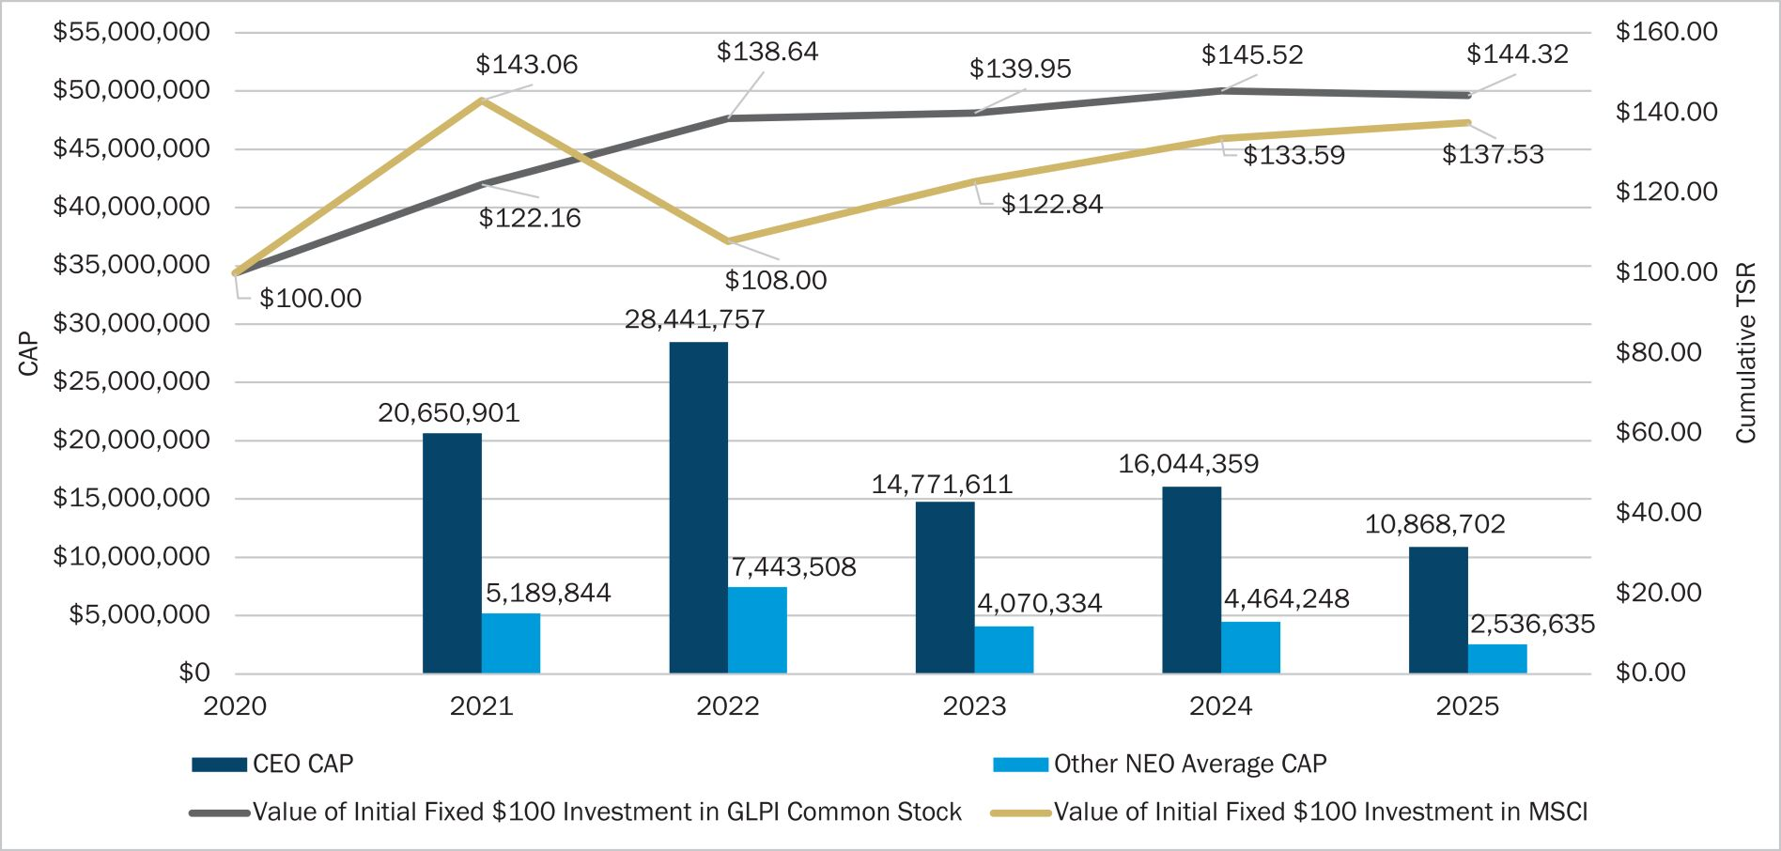

Compensation Actually Paid (CAP) vs. Net Income Attributable to Common Shareholders

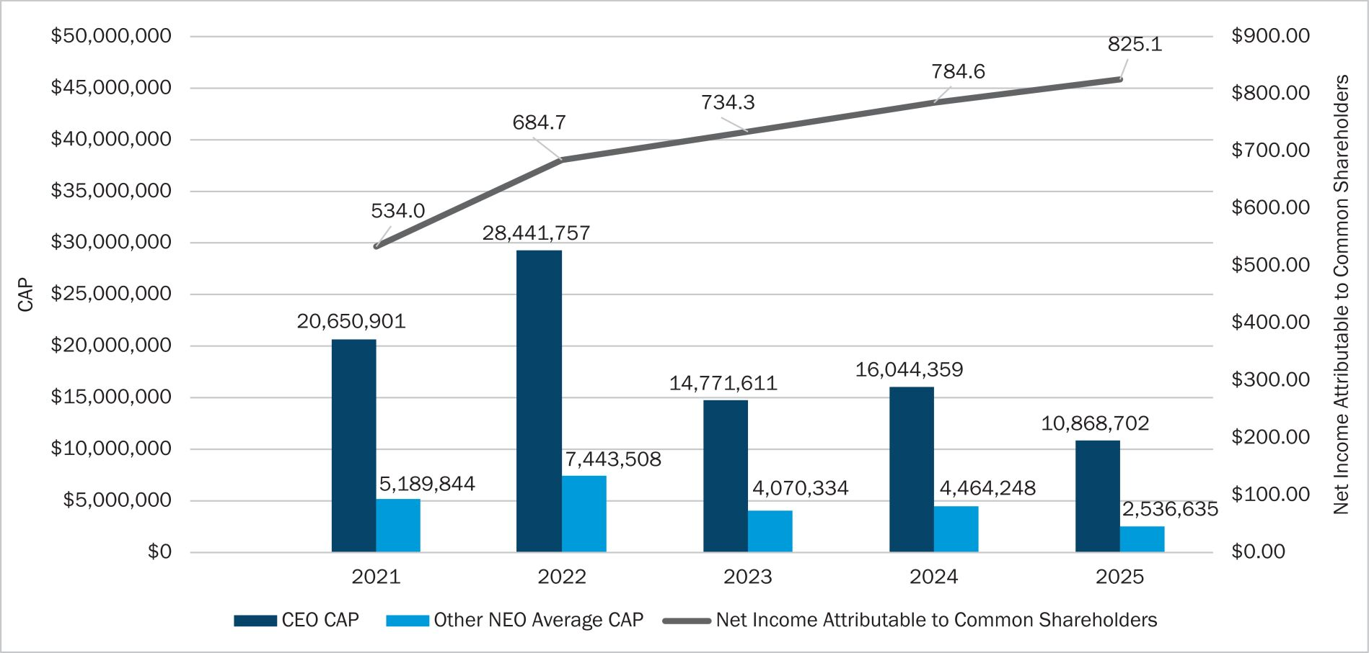

Gaming and Leisure Properties, Inc. |  | 2026 Proxy Statement  | 49

Table of Contents

Proxy  Summary |  | Board of  Directors |  | Executive  Compensation |  | Audit Committee  Matters |  | Voting  Proposals |  | Other  Matters

Compensation Actually Paid (CAP) vs. AFFO Per Diluted Share

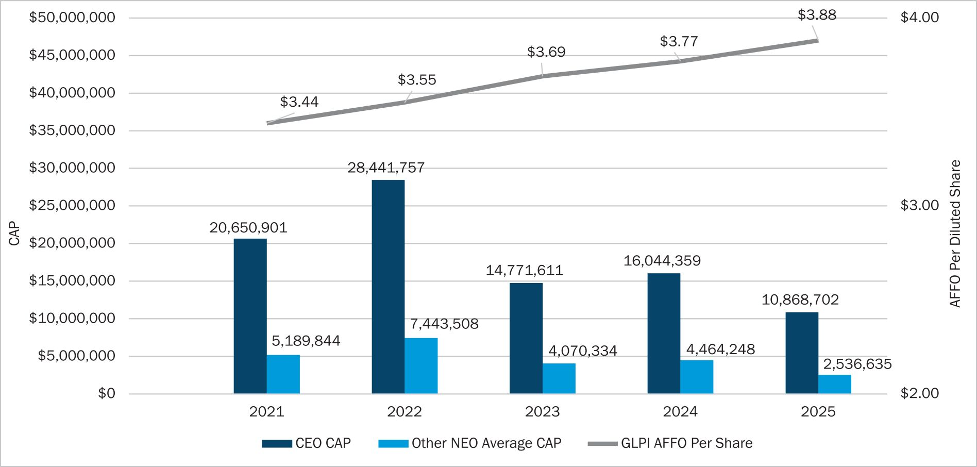

50 |  2026 Proxy Statement |  | Gaming and Leisure Properties, Inc.

Table of Contents

Proxy  Summary |  | Board of  Directors |  | Executive  Compensation |  | Audit Committee  Matters |  | Voting  Proposals |  | Other  Matters

2025 Grants of Plan-Based Awards
The following table sets forth certain information regarding grants of plan-based awards to the NEOs in 2025:

 |  |  |  |  |  |  |  |  |  |  |  | Estimated future payouts  under non-equity incentive  plan awards |  |  |  |  |  |  |  |  |  |  |  |  |  |  | Estimated future payouts  under equity incentive plan  awards – Performance-Based  Awards |  |  |  |  |  |  |  |  |  |  |  |  |  |  | All Other Stock Awards –  Service-Based Awards
Name |  | Grant Date |  |  |  |  | Grant  Board  Approval  Date |  |  |  |  | Threshold  (#)(1) |  |  |  |  | Target  (#)(1) |  |  |  |  | Maximum  (#)(1) |  |  |  |  | Threshold  (#)(2) |  |  |  |  | Target  (#)(2) |  |  |  |  | Maximum  (#)(2) |  |  |  |  | Number of  Securities  Underlying  Stock  Awards  (#)(3) |  |  |  |  | Grant Date  Fair Value of  Stock  Awards  ($)(4)
Peter M. Carlino
Annual Performance Cash |  |  |  |  |  |  |  |  |  |  |  |  |  | $ 904,234 |  |  |  | $ | 1,808,468 |  |  |  | $ | 3,616,936
Service-Based Awards |  |  |  | 1/2/2025 |  |  |  |  | 12/16/2024 |  |  |  |  |  |  |  |  |  |  |  |  |  |  |  |  |  |  |  |  |  |  |  |  |  |  |  |  |  |  |  |  |  |  | 55,000 |  |  |  |  | 2,648,800
Performance—Based Awards—MSCI US REIT Index |  |  |  | 1/2/2025 |  |  |  |  | 12/16/2024 |  |  |  |  |  |  |  |  |  |  |  |  |  |  |  |  |  |  |  | — |  |  |  |  | 55,000 |  |  |  |  | 110,000 |  |  |  |  |  |  |  |  |  | 3,003,000
Performance—Based Awards—Triple-Net REIT Group |  |  |  | 1/2/2025 |  |  |  |  | 12/16/2024 |  |  |  |  |  |  |  |  |  |  |  |  |  |  |  |  |  |  |  | — |  |  |  |  | 55,000 |  |  |  |  | 110,000 |  |  |  |  |  |  |  |  |  | 2,949,100
Brandon J. Moore
Annual Performance Cash |  |  |  |  |  |  |  |  |  |  |  |  | $ | 325,000 |  |  |  | $ | 650,000 |  |  |  |  | $1,300,000
Service-Based Awards |  |  |  | 1/2/2025 |  |  |  |  | 12/16/2024 |  |  |  |  |  |  |  |  |  |  |  |  |  |  |  |  |  |  |  |  |  |  |  |  |  |  |  |  |  |  |  |  |  |  | 26,000 |  |  |  |  | 1,252,160
Performance—Based Awards—MSCI US REIT Index |  |  |  | 1/2/2025 |  |  |  |  | 12/16/2024 |  |  |  |  |  |  |  |  |  |  |  |  |  |  |  |  |  |  |  | — |  |  |  |  | 26,000 |  |  |  |  | 52,000 |  |  |  |  |  |  |  |  |  | 1,444,560
Performance—Based Awards—Triple-Net REIT Group |  |  |  | 1/2/2025 |  |  |  |  | 12/16/2024 |  |  |  |  |  |  |  |  |  |  |  |  |  |  |  |  |  |  |  | — |  |  |  |  | 26,000 |  |  |  |  | 52,000 |  |  |  |  |  |  |  |  |  | 1,419,600
Desiree A. Burke
Annual Performance Cash |  |  |  |  |  |  |  |  |  |  |  |  | $ | 225,000 |  |  |  | $ | 450,000 |  |  |  | $ | 900,000
Service-Based Awards |  |  |  | 1/2/2025 |  |  |  |  | 12/16/2024 |  |  |  |  |  |  |  |  |  |  |  |  |  |  |  |  |  |  |  |  |  |  |  |  |  |  |  |  |  |  |  |  |  |  | 18,000 |  |  |  |  | 866,880
Performance—Based Awards—MSCI US REIT Index |  |  |  | 1/2/2025 |  |  |  |  | 12/16/2024 |  |  |  |  |  |  |  |  |  |  |  |  |  |  |  |  |  |  |  | — |  |  |  |  | 18,000 |  |  |  |  | 36,000 |  |  |  |  |  |  |  |  |  | 1,000,080
Performance—Based Awards—Triple-Net REIT Group |  |  |  | 1/2/2025 |  |  |  |  | 12/16/2024 |  |  |  |  |  |  |  |  |  |  |  |  |  |  |  |  |  |  |  | — |  |  |  |  | 18,000 |  |  |  |  | 36,000 |  |  |  |  |  |  |  |  |  | 982,800
Matthew J. Demchyk(5)
Annual Performance Cash |  |  |  |  |  |  |  |  |  |  |  |  | $ | 172,500 |  |  |  | $ | 345,000 |  |  |  | $ | 690,000
Service-Based Awards |  |  |  | 1/2/2025 |  |  |  |  | 12/16/2024 |  |  |  |  |  |  |  |  |  |  |  |  |  |  |  |  |  |  |  |  |  |  |  |  |  |  |  |  |  |  |  |  |  |  | 15,000 |  |  |  |  | 722,400
Performance—Based Awards—MSCI US REIT Index |  |  |  | 1/2/2025 |  |  |  |  | 12/16/2024 |  |  |  |  |  |  |  |  |  |  |  |  |  |  |  |  |  |  |  | — |  |  |  |  | 15,000 |  |  |  |  | 30,000 |  |  |  |  |  |  |  |  |  | 819,000
Performance—Based Awards—Triple-Net REIT Group |  |  |  | 1/2/2025 |  |  |  |  | 12/16/2024 |  |  |  |  |  |  |  |  |  |  |  |  |  |  |  |  |  |  |  | — |  |  |  |  | 15,000 |  |  |  |  | 30,000 |  |  |  |  |  |  |  |  |  | 804,300
Steven L. Ladany
Annual Performance Cash |  |  |  |  |  |  |  |  |  |  |  |  | $ | 172,500 |  |  |  | $ | 345,000 |  |  |  | $ | 690,000
Service-Based Awards |  |  |  | 1/2/2025 |  |  |  |  | 12/16/2024 |  |  |  |  |  |  |  |  |  |  |  |  |  |  |  |  |  |  |  |  |  |  |  |  |  |  |  |  |  |  |  |  |  |  | 15,000 |  |  |  |  | 722,400
Performance—Based Awards—MSCI US REIT Index |  |  |  | 1/2/2025 |  |  |  |  | 12/16/2024 |  |  |  |  |  |  |  |  |  |  |  |  |  |  |  |  |  |  |  | — |  |  |  |  | 15,000 |  |  |  |  | 30,000 |  |  |  |  |  |  |  |  |  | 819,000
Performance—Based Awards—Triple-Net REIT Group |  |  |  | 1/2/2025 |  |  |  |  | 12/16/2024 |  |  |  |  |  |  |  |  |  |  |  |  |  |  |  |  |  |  |  | — |  |  |  |  | 15,000 |  |  |  |  | 30,000 |  |  |  |  |  |  |  |  |  | 804,300

(1) | Awards represent annual performance-based cash award opportunity, at the threshold, target, and maximum level. Actual annual performance-based cash awards earned for 2025 are included in the Non-Equity Incentive Plan Compensation column of the Summary Compensation Table.

(2) | Represent performance-based awards with cliff vesting at the end of the performance period beginning on January 1, 2025 and ending on December 31, 2027. The number of awards vested at the end of the performance period can range from zero to a maximum of 200% of target, depending on the level of achievement of the performance goals measured against the return of the companies included in the MSCI US REIT Index or in the triple-net REIT group set forth by the Company over the measurement period. In the event of a change-in-control, awards vest immediately at target level or, if greater, the actual level of achievement as of the date of the change-in-control. For more information on the Company’s performance-based awards, see the Overview of 2025 Compensation section of the Compensation Discussion and Analysis included in this Proxy Statement.

(3) | Represent service-based awards granted to the NEOs as part of their annual compensation. All grants have vesting over three years, 33.33% on the first anniversary of the date of grant and 33.33% on each succeeding anniversary.

(4) | Represents the aggregate grant date fair value of awards under ASC 718. Generally, the aggregate grant date fair value is the amount the Company would expense in its financial statements over the award’s vesting period. The Company utilized a third party valuation firm to measure the fair value of the performance-based awards at grant date using the Monte Carlo model. Additional information regarding the calculation of the grant date fair value is included in footnote 2 to the Company’s audited financial statements in the Company’s Annual Report on Form 10-K for the year ended December 31, 2025.

(5) | In accordance with Mr. Demchyk’s Separation Agreement, all 2025 grants were cancelled.

Gaming and Leisure Properties, Inc. |  | 2026 Proxy Statement | 51

Table of Contents

Proxy  Summary |  | Board of  Directors |  | Executive  Compensation |  | Audit Committee  Matters |  | Voting  Proposals |  | Other  Matters

Outstanding 2025 Restricted Stock Awards at Fiscal Year-End
The following table sets forth information concerning restricted stock awards outstanding as of December 31, 2025 and which have been reported in the appropriate period in the Summary Compensation Table when granted:

 |  |  |  |  |  |  | Service-Based Awards |  |  |  |  |  |  |  |  |  | Performance-Based Awards
Name(1) |  | Restricted  Stock Award  Grant Date |  |  |  |  | Number of  Shares or  Units Held  that Have  Not Vested  (#)(4) |  |  |  |  | Market  Value of  Service-Based  Awards Held  that Have  Not Vested  ($)(5) |  |  |  |  | Number of  Unearned  Shares or  Units Held  that Have  Not Vested  (#)(6) |  |  |  |  | Market  Value of  Performance-  Based  Awards Held  that Have  Not Vested  ($)(7)
Peter M. Carlino |  |  |  | 1/3/2023 |  |  |  |  | 18,333 |  |  |  |  | 819,302
 |  |  |  | 1/3/2023 | (2) |  |  |  |  |  |  |  |  |  |  |  |  |  | 55,000 |  |  |  |  | 2,968,900
 |  |  |  | 1/3/2023 | (3) |  |  |  |  |  |  |  |  |  |  |  |  |  | 55,000 |  |  |  |  | 2,968,900
 |  |  |  | 1/2/2024 |  |  |  |  | 36,666 |  |  |  |  | 1,638,604
 |  |  |  | 1/2/2024 | (2) |  |  |  |  |  |  |  |  |  |  |  |  |  | 55,000 |  |  |  |  | 2,795,650
 |  |  |  | 1/2/2024 | (3) |  |  |  |  |  |  |  |  |  |  |  |  |  | 55,000 |  |  |  |  | 2,795,650
 |  |  |  | 1/2/2025 |  |  |  |  | 55,000 |  |  |  |  | 2,457,950
 |  |  |  | 1/2/2025 | (2) |  |  |  |  |  |  |  |  |  |  |  |  |  | 55,000 |  |  |  |  | 2,628,450
 |  |  |  | 1/2/2025 | (3) |  |  |  |  |  |  |  |  |  |  |  |  |  | 55,000 |  |  |  |  | 2,628,450
Brandon J. Moore |  |  |  | 1/3/2023 |  |  |  |  | 7,333 |  |  |  |  | 327,712
 |  |  |  | 1/3/2023 | (2) |  |  |  |  |  |  |  |  |  |  |  |  |  | 22,000 |  |  |  |  | 1,187,560
 |  |  |  | 1/3/2023 | (3) |  |  |  |  |  |  |  |  |  |  |  |  |  | 22,000 |  |  |  |  | 1,187,560
 |  |  |  | 1/2/2024 |  |  |  |  | 14,666 |  |  |  |  | 655,424
 |  |  |  | 1/2/2024 | (2) |  |  |  |  |  |  |  |  |  |  |  |  |  | 22,000 |  |  |  |  | 1,118,260
 |  |  |  | 1/2/2024 | (3) |  |  |  |  |  |  |  |  |  |  |  |  |  | 22,000 |  |  |  |  | 1,118,260
 |  |  |  | 1/2/2025 |  |  |  |  | 26,000 |  |  |  |  | 1,161,940
 |  |  |  | 1/2/2025 | (2) |  |  |  |  |  |  |  |  |  |  |  |  |  | 26,000 |  |  |  |  | 1,242,540
 |  |  |  | 1/2/2025 | (3) |  |  |  |  |  |  |  |  |  |  |  |  |  | 26,000 |  |  |  |  | 1,242,540
Desiree A. Burke |  |  |  | 1/3/2023 |  |  |  |  | 6,000 |  |  |  |  | 268,140
 |  |  |  | 1/3/2023 | (2) |  |  |  |  |  |  |  |  |  |  |  |  |  | 18,000 |  |  |  |  | 971,640
 |  |  |  | 1/3/2023 | (3) |  |  |  |  |  |  |  |  |  |  |  |  |  | 18,000 |  |  |  |  | 971,640
 |  |  |  | 1/2/2024 |  |  |  |  | 12,000 |  |  |  |  | 536,280
 |  |  |  | 1/2/2024 | (2) |  |  |  |  |  |  |  |  |  |  |  |  |  | 18,000 |  |  |  |  | 914,940
 |  |  |  | 1/2/2024 | (3) |  |  |  |  |  |  |  |  |  |  |  |  |  | 18,000 |  |  |  |  | 914,940
 |  |  |  | 1/2/2025 |  |  |  |  | 18,000 |  |  |  |  | 804,420
 |  |  |  | 1/2/2025 | (2) |  |  |  |  |  |  |  |  |  |  |  |  |  | 18,000 |  |  |  |  | 860,220
 |  |  |  | 1/2/2025 | (3) |  |  |  |  |  |  |  |  |  |  |  |  |  | 18,000 |  |  |  |  | 860,220
Steven L. Ladany |  |  |  | 1/3/2023 |  |  |  |  | 5,000 |  |  |  |  | 223,450
 |  |  |  | 1/3/2023 | (2) |  |  |  |  |  |  |  |  |  |  |  |  |  | 15,000 |  |  |  |  | 809,700
 |  |  |  | 1/3/2023 | (3) |  |  |  |  |  |  |  |  |  |  |  |  |  | 15,000 |  |  |  |  | 809,700
 |  |  |  | 1/2/2024 |  |  |  |  | 10,000 |  |  |  |  | 446,900
 |  |  |  | 1/2/2024 | (2) |  |  |  |  |  |  |  |  |  |  |  |  |  | 15,000 |  |  |  |  | 762,450
 |  |  |  | 1/2/2024 | (3) |  |  |  |  |  |  |  |  |  |  |  |  |  | 15,000 |  |  |  |  | 762,450
 |  |  |  | 1/2/2025 |  |  |  |  | 15,000 |  |  |  |  | 670,350
 |  |  |  | 1/2/2025 | (2) |  |  |  |  |  |  |  |  |  |  |  |  |  | 15,000 |  |  |  |  | 716,850
 |  |  |  | 1/2/2025 | (3) |  |  |  |  |  |  |  |  |  |  |  |  |  | 15,000 |  |  |  |  | 716,850

(1) | As of December 31, 2025, Mr. Demchyk did not have any outstanding awards.

(2) | Performance-based awards based on the Company’s performance ranking among the US MSCI REIT Index.

(3) | Performance-based awards based on the Company’s performance ranking among the triple-net REIT peers.

(4) | Represents service-based awards with forfeiture provisions that lapse 33.33% on each of the first, second, and third anniversary of the date of grant. In the event of a change-in-control, the forfeiture restrictions lapse immediately.

(5) | Calculated based on the Company’s common stock closing price of $44.69 on December 31, 2025, which was the last trading day of 2025. Dividends are payable on service-based awards to the same extent and on the same date that dividends are paid on GLPI common stock.

52 | 2026 Proxy Statement |  | Gaming and Leisure Properties, Inc.

Table of Contents

Proxy  Summary |  | Board of  Directors |  | Executive  Compensation |  | Audit Committee  Matters |  | Voting  Proposals |  | Other  Matters

(6) | The amount of performance-based awards to vest at the end of the performance period can range from zero to the maximum as described in the Long-term Performance-based Awards section of the Overview of 2025 Compensation section of the Compensation Discussion and Analysis included in this Proxy Statement. The forfeiture provisions on the performance-based awards granted lapse at the end of their three-year measurement period. In the event of a change-in-control, awards vest immediately at target level or, if greater, the actual level of achievement as of the date of the change-in-control, annualized for the entire performance period. As of December 31, 2025, the market value of unearned shares and units is based upon performance to date plus the relevant prior performance. As a result, all awards are valued at target.

(7) | Calculated based on the Company’s common stock closing price of $44.69 on December 31, 2025, which was the last trading day of 2025, plus dividends declared during the applicable performance period as of December 31, 2025. During the three-year performance period, holders of LTIP Units are entitled to receive a partial distribution on each unit equal to 10% of the regular dividend payable on a share of GLPI common stock. Following the completion of the three-year performance period, GLPI will make a “catch-up” cash payment on the LTIP Units that are ultimately earned, if any, in an amount equal to the regular and special distribution declared during the performance period on an equal number of shares of GLPI common stock, less the distributions actually paid to holders of LTIP Units during the performance period on all of the awarded LTIP Units. Holders of equity-based performance awards receive dividends upon vesting on shares that are ultimately earned in an amount equal to the regular and special distribution declared during the performance period on an equal number of shares of GLPI common stock.
2025 Restricted Stock Awards Vested
The following table sets forth information concerning restricted stock awards vested during fiscal 2025:

 |  | Restricted Stock Awards
Name |  | Number of  Awards  Acquired on  Vesting (#) |  |  |  |  | Value  Realized on  Vesting  ($)(1)
Peter M. Carlino |  |  |  | 308,419 |  |  |  |  | 14,839,809
Brandon J. Moore |  |  |  | 114,092 |  |  |  |  | 5,489,211
Desiree A. Burke |  |  |  | 91,540 |  |  |  |  | 4,404,147
Matthew J. Demchyk |  |  |  | 84,570 |  |  |  |  | 4,068,991
Steven L. Ladany |  |  |  | 84,570 |  |  |  |  | 4,068,991

(1) | The value realized for vested awards is calculated based on the closing price of the Company’s common stock on the day prior to vesting for awards, not the grant date fair value disclosed elsewhere in this Proxy Statement. Includes performance share dividends, which are paid at vesting in Company common stock.
2025 Nonqualified Deferred Compensation
The following table sets forth information concerning nonqualified deferred compensation of the NEOs:

Name |  | Amount  Previously  Reported  ($) |  |  |  |  | Executive  Contributions  in Last  Fiscal Year  ($)(1) |  |  |  |  | Company  Contributions  in Last  Fiscal Year  ($)(2) |  |  |  |  | Aggregate  Earnings in  Last  Fiscal Year  ($)(3) |  |  |  |  | Aggregate  Withdrawals/  Distributions  ($) |  |  |  |  | Aggregate  Balance at  Last Fiscal  Year End  ($)
Peter M. Carlino |  |  |  | 34,005,233 |  |  |  |  | 497,329 |  |  |  |  | 248,664 |  |  |  |  | 4,629,210 |  |  |  |  | — |  |  |  |  | 39,380,436
Brandon J. Moore |  |  |  | 1,151,916 |  |  |  |  | 152,500 |  |  |  |  | 76,250 |  |  |  |  | 183,773 |  |  |  |  | — |  |  |  |  | 1,564,439
Desiree A. Burke |  |  |  | 1,560,535 |  |  |  |  | 128,906 |  |  |  |  | 64,453 |  |  |  |  | 303,577 |  |  |  |  | (133,425 | ) |  |  |  | 1,924,046
Matthew J. Demchyk |  |  |  | 605,845 |  |  |  |  | 89,168 |  |  |  |  | 44,584 |  |  |  |  | 168,590 |  |  |  |  | — |  |  |  |  | 908,187
Steven L. Ladany |  |  |  | 797,151 |  |  |  |  | 102,437 |  |  |  |  | 51,219 |  |  |  |  | 161,784 |  |  |  |  | (96,460 | ) |  |  |  | 1,016,131

(1) | For each NEO, the executive’s contribution is included in the NEO’s salary and/or non-equity executive compensation for 2025, as reported in the Summary Compensation Table.

(2) | For each NEO, the Company’s contribution is included in the NEO’s other compensation for 2025, as reported in the Summary Compensation Table.

(3) | Amounts reflect the change in account value during 2025. No amounts are reported in the Summary Compensation Table because earnings were not above market or preferential.

Gaming and Leisure Properties, Inc. |  | 2026 Proxy Statement | 53

Table of Contents

Proxy  Summary |  | Board of  Directors |  | Executive  Compensation |  | Audit Committee  Matters |  | Voting  Proposals |  | Other  Matters

Gaming and Leisure Properties, Inc. Deferred Compensation Plan
Pursuant to the Company’s Deferred Compensation Plan, as amended, management and certain other highly compensated employees selected by the committee administering the plan (the “Plan Committee”) may elect to defer, on a pre-tax basis, a percentage of his or her salary and/or bonus. The minimum amount deferrable is $3,000 and the maximum is 90% of his or her base annual salary and/or bonus. Generally, deferral elections must be made before the beginning of the year in which compensation will be earned. The Company’s contributions under the plan are equal to 50% of the participant’s deferral for the first 10% of the salary and/or bonus deferred, subject to a maximum annual Company contribution equal to 5% of the participant’s salary and/or bonus. With the approval of the Board of Directors, the Company is also permitted to make discretionary contributions. Participants are always 100% vested in their own contributions, but Company contributions vest 20% per year of service with the Company. Therefore, employees with five or more years of service are fully vested in Company contributions under the plan. However, for employees with less than five years of service, all Company contributions become immediately and fully vested upon death, retirement (on or after age 65) or a change in control of the Company, as defined in the Deferred Compensation Plan. The Plan Committee may accelerate vesting of the Company’s contributions if a participant terminates his or her employment because of disability. The Plan Committee may also accelerate vesting in the event of an involuntary termination of employment pursuant to the same section of the Company’s Deferred Compensation Plan.
Subject to the exceptions discussed below, participants in the Deferred Compensation Plan, or their beneficiaries, receive distributions upon retirement, death, termination or change in control. Participants can elect to receive distributions following retirement or death in the form of a lump sum payment or annual installments. Distributions following retirement can be deferred for at least five years.
For purposes of the Deferred Compensation Plan, termination of employment as a result of a disability will be considered retirement. Distributions following termination of employment other than as a result of retirement or death will be in the form of a lump sum payment. Participants can also elect to receive a scheduled distribution with respect to an annual deferral amount, which is payable in a lump sum at the beginning of a designated subsequent calendar year, subject to certain limitations. In the event of an unforeseeable financial emergency and with the approval of the Plan Committee, a participant can suspend deferrals or receive a partial and/or full payout under the plan. Certain specified employees have a six-month delay imposed upon distributions pursuant to a separation from service, as required by the final Code section 409A regulations. In the event of a change in control (as defined under the Deferred Compensation Plan), the Company will accelerate installment payments that are in pay status by paying the account balance in lump sum and will distribute the account balances of all active participants in a lump sum; provided, however, that no distributions (or accelerations of installments) will occur unless the transaction qualifies as a “change-of-control event” under Code section 409A.
Participants in the Deferred Compensation Plan may notionally invest deferred amounts, including Company contributions, in mutual funds selected by the Plan Committee. Participants may change their investment elections at any time.

54 | 2026 Proxy Statement |  | Gaming and Leisure Properties, Inc.

Table of Contents

Proxy  Summary |  | Board of  Directors |  | Executive  Compensation |  | Audit Committee  Matters |  | Voting  Proposals |  | Other  Matters

Potential Payments Upon Termination or Change-in-Control
The NEOs are entitled to accelerated vesting of restricted stock awards under the Company’s Executive Change-in-Control and Severance Plan upon a change in control and, under certain circumstances, in the event of termination. The Executive Change in Control and Severance Plan is more fully described under Employment Agreements and Severance Plan in this Proxy Statement. The information below describes and quantifies compensation that would become payable and which is accelerated assuming that such change-in-control or termination was effective December 31, 2025.

Executive Payments |  | Termination  without  Cause  by Company  ($)(4) |  |  |  |  | Termination  Upon Death  ($)(5) |  |  |  |  | Termination  upon  Disability  ($)(5) |  |  |  |  | Change-in-  Control  ($)(6) |  |  |  |  | Change-in-  Control  Termination  without  Cause  ($)(6)
Peter M. Carlino
Cash Severance Benefit(1) |  |  |  | 10,197,748 |  |  |  |  | 5,098,874 |  |  |  |  | 5,098,874 |  |  |  |  | — |  |  |  |  | 15,296,622
Benefit Continuation(2) |  |  |  | 646 |  |  |  |  | 646 |  |  |  |  | 646 |  |  |  |  | — |  |  |  |  | 861
Service-Based Awards(3) |  |  |  | 4,915,856 |  |  |  |  | 4,915,856 |  |  |  |  | 4,915,856 |  |  |  |  | — |  |  |  |  | 4,915,856
Performance-Based Awards(7) |  |  |  | 9,001,784 |  |  |  |  | 13,183,437 |  |  |  |  | 13,183,437 |  |  |  |  | 16,786,000 |  |  |  |  | 16,786,000
Total |  |  | $ | 24,116,034 |  |  |  | $ | 23,198,813 |  |  |  | $ | 23,198,813 |  |  |  | $ | 16,786,000 |  |  |  | $ | 36,999,339
Brandon J. Moore
Cash Severance Benefit(1) |  |  |  | 2,417,709 |  |  |  |  | 1,611,806 |  |  |  |  | 1,611,806 |  |  |  |  | — |  |  |  |  | 3,223,612
Benefit Continuation(2) |  |  |  | 43,794 |  |  |  |  | 43,794 |  |  |  |  | 43,794 |  |  |  |  | — |  |  |  |  | 58,392
Service-Based Awards(3) |  |  |  | 2,145,076 |  |  |  |  | 2,145,076 |  |  |  |  | 2,145,076 |  |  |  |  | — |  |  |  |  | 2,145,076
Performance-Based Awards(7) |  |  |  | 3,699,097 |  |  |  |  | 5,568,526 |  |  |  |  | 5,568,526 |  |  |  |  | 7,096,720 |  |  |  |  | 7,096,720
Total |  |  | $ | 8,305,676 |  |  |  | $ | 9,369,202 |  |  |  | $ | 9,369,202 |  |  |  | $ | 7,096,720 |  |  |  | $ | 12,523,800
Desiree A. Burke
Cash Severance Benefit(1) |  |  |  | 2,022,657 |  |  |  |  | 1,348,438 |  |  |  |  | 1,348,438 |  |  |  |  | — |  |  |  |  | 2,696,876
Benefit Continuation(2) |  |  |  | 43,794 |  |  |  |  | 43,794 |  |  |  |  | 43,794 |  |  |  |  | — |  |  |  |  | 58,392
Service-Based Awards(3) |  |  |  | 1,608,840 |  |  |  |  | 1,608,840 |  |  |  |  | 1,608,840 |  |  |  |  | — |  |  |  |  | 1,608,840
Performance-Based Awards(7) |  |  |  | 2,946,037 |  |  |  |  | 4,314,579 |  |  |  |  | 4,314,579 |  |  |  |  | 5,493,600 |  |  |  |  | 5,493,600
Total |  |  | $ | 6,621,328 |  |  |  | $ | 7,315,651 |  |  |  | $ | 7,315,651 |  |  |  | $ | 5,493,600 |  |  |  | $ | 9,857,708
Matthew J. Demchyk
Cash Severance Benefit |  |  |  | 6,250,000 |  |  |  |  | — |  |  |  |  | — |  |  |  |  | — |  |  |  |  | —
Benefit Continuation |  |  |  | 66,959 |  |  |  |  | — |  |  |  |  | — |  |  |  |  | — |  |  |  |  | —
Service-Based Awards |  |  |  | — |  |  |  |  | — |  |  |  |  | — |  |  |  |  | — |  |  |  |  | —
Performance-Based Awards |  |  |  | — |  |  |  |  | — |  |  |  |  | — |  |  |  |  | — |  |  |  |  | —
Total(8) |  |  | $ | 6,316,959 |  |  |  | $ | — |  |  |  | $ | — |  |  |  | $ | — |  |  |  | $ | —
Steven L. Ladany
Cash Severance Benefit(1) |  |  |  | 1,589,375 |  |  |  |  | 1,059,583 |  |  |  |  | 1,059,583 |  |  |  |  | — |  |  |  |  | 2,119,166
Benefit Continuation(2) |  |  |  | 43,794 |  |  |  |  | 43,794 |  |  |  |  | 43,794 |  |  |  |  | — |  |  |  |  | 58,392
Service-Based Awards(3) |  |  |  | 1,340,700 |  |  |  |  | 1,340,700 |  |  |  |  | 1,340,700 |  |  |  |  | — |  |  |  |  | 1,340,700
Performance-Based Awards(7) |  |  |  | 2,455,031 |  |  |  |  | 3,595,482 |  |  |  |  | 3,595,482 |  |  |  |  | 4,578,000 |  |  |  |  | 4,578,000
Total |  |  | $ | 5,428,900 |  |  |  | $ | 6,039,559 |  |  |  | $ | 6,039,559 |  |  |  | $ | 4,578,000 |  |  |  | $ | 8,096,258

(1) | Basis for cash severance benefit is 2025 salary and assumes it is an eligible termination as defined under the Company’s Executive Change-in-Control and Severance Plan and includes 2025 salary plus average bonus from the prior three years.

(2) | Represents employer cost of medical and dental coverage.

(3) | Service-based award values were computed based on the Company’s common stock closing price of $44.69 on December 31, 2025, which was the last trading day of 2025. Restrictions on awards will immediately lapse in the event of termination as a result of termination without cause, death, disability or change in control termination without cause.

Gaming and Leisure Properties, Inc. |  | 2026 Proxy Statement | 55

Table of Contents

Proxy  Summary |  | Board of  Directors |  | Executive  Compensation |  | Audit Committee  Matters |  | Voting  Proposals |  | Other  Matters

(4) | Performance-based award values, in the event of termination without cause by the Company, were computed based on the Company’s TSR as compared to the MSCI US REIT Index and in the triple-net REIT group achieved as of December 31, 2025, shown on the table below, and then multiplied by a fraction, the numerator of which equals the number of days during such performance period that such award holder was actively employed by the Company, and the denominator of which equals the total days in the applicable performance period if terminated at December 31, 2025.

Grant |  | Performance at  December 31, 2025  (% of maximum)
2023—US MSCI REIT Index |  |  |  | 38.2 | %
2023—Triple-NET REIT peers |  |  |  | 40.9 | %
2024—US MSCI REIT Index |  |  |  | 42.9 | %
2024—Triple-NET REIT peers |  |  |  | 36.3 | %
2025—US MSCI REIT Index |  |  |  | 50.0 | %
2025—Triple-NET REIT peers |  |  |  | 27.2 | %

(5) | Performance-based award values, in the event of termination as a result of death or disability, were computed based on the Company’s TSR as compared to the MSCI US REIT Index and in the triple-net REIT group achieved as of December 31, 2025, shown on the table above in footnote 4. The award is determined at the end of the applicable performance period as if such award holder was still employed at the time of the applicable performance period.

(6) | Performance-based award values, in the event of change-in-control, were computed based on the Company’s TSR as compared to the MSCI US REIT Index and in the triple-net REIT group achieved as of December 31, 2025. Performance shall be deemed to have been achieved at target level or, if greater, the actual level of achievement as of the date of the change-in-control. As of December 31, 2025, the performance-based award achievement level by award is detailed in the table of footnote 4. All grants were completed at target because the actual level of achievement was at or below target.

(7) | All performance-based award values were computed based on the Company’s common stock closing price of $44.69 on December 31, 2025, which was the last trading day of 2025, plus applicable dividends.

(8) | Mr. Demchyk separated from the Company effective August 1, 2025 pursuant to the Separation Agreement dated as of July 18, 2025 between Mr. Demchyk and the Company (the “Separation Agreement”) filed on a Current Report on Form 8-K with the SEC on July 18, 2025. The values set forth in this table reflect the value of the benefits provided in accordance with the Separation Agreement. $3.3 million of this value was paid in 2025.
CEO Pay Ratio
In 2025, the compensation of Mr. Carlino, our Chairman and CEO, was approximately 39 times the median pay of our employees resulting in a 39:1 pay ratio.
We identified our median employee by examining 2025 federal taxable wages for all employees, excluding Mr. Carlino, who were employed by the Company as of December 31, 2025, the last day of our payroll year. We included all of our employees in this process, whether employed on a full-time or part-time basis. We did not make any assumptions or estimates with respect to total compensation.
After identifying the median employee based on federal taxable wages, we calculated total compensation in 2025 for such employee using the same methodology we use for our NEOs as set forth above in the Summary Compensation Table for 2025.

 |  | Peter M. Carlino |  |  |  |  | Median Employee
Total compensation |  |  | $ | 14,054,918 |  |  |  | $ | 359,967
Pay Ratio |  |  |  |  |  |  |  |  | 39.1
We believe that the ratio of the CEO compensation to that of the median employee is a reasonable estimate calculated in a manner consistent with Item 402(u) of Regulation S-K. Given the different methodologies that various public companies will use to determine an estimate of their pay ratio, the estimated ratio reported above should not be used as a basis for comparison between companies.

56 | 2026 Proxy Statement |  | Gaming and Leisure Properties, Inc.

Table of Contents

Proxy  Summary |  | Board of  Directors |  | Executive  Compensation |  | Audit Committee  Matters |  | Voting  Proposals |  | Other  Matters

AUDIT AND COMPLIANCE COMMITTEE REPORT
The Audit and Compliance Committee of the Board of Directors assists the Board of Directors in performing its oversight responsibilities for our financial reporting process and audit process as more fully described in the Company’s Audit and Compliance Committee Charter. Management has the primary responsibility for the financial statements and the reporting process. Our independent registered public accounting firm is responsible for performing an independent audit of our consolidated financial statements in accordance with the auditing standards of the Public Company Accounting Oversight Board (“PCAOB”) (United States) and to issue a report thereon.
In the performance of its oversight function, the Audit and Compliance Committee reviewed and discussed our audited financial statements for the fiscal year ended December 31, 2025, with management and with our independent registered public accounting firm. In addition, the Audit and Compliance Committee discussed with our independent registered public accounting firm the matters required to be discussed by the SEC and PCAOB Accounting Standard No. 1301, Communications with Audit Committees, which includes, among other items, matters related to the conduct of the audit of our financial statements. The Audit and Compliance Committee has also received and reviewed the written disclosures and the letter from our independent registered public accounting firm required by the applicable requirements of the PCAOB regarding the accounting firm’s communications with the Audit and Compliance Committee concerning independence and has discussed with our independent registered public accounting firm that firm’s independence and considered whether the non-audit services provided by the independent registered public accounting firm, if any, are compatible with maintaining its independence.
Based on the review and discussions with management and our independent registered public accounting firm described above, the Audit and Compliance Committee recommended to the Board of Directors that the audited financial statements be included in our Annual Report on Form 10-K for the year ended December 31, 2025, filed with the SEC.
Audit and Compliance Committee
Carol “Lili” Lynton, Chair
Earl C. Shanks
E. Scott Urdang
The foregoing report of the Audit and Compliance Committee does not constitute soliciting material and shall not be deemed filed, incorporated by reference into or a part of any other filing by the Company (including any future filings) under the Securities Act or the Exchange Act, except to the extent the Company specifically incorporates such report by reference therein.

Gaming and Leisure Properties, Inc. |  | 2026 Proxy Statement | 57

Table of Contents

Proxy  Summary |  | Board of  Directors |  | Executive  Compensation |  | Audit Committee  Matters |  | Voting  Proposals |  | Other  Matters

CERTAIN RELATIONSHIPS AND RELATED PERSON TRANSACTIONS
Related Person Transactions
There are no reportable related person transactions.
Indemnification of Directors and Officers
Our charter and bylaws contain indemnification provisions for the benefit of our directors and officers.
Review and Approval of Transactions with Related Persons
Pursuant to the terms of its charter, the Audit and Compliance Committee reviews and pre-approves all conflicts of interest and related person transactions. For the purposes of the Audit and Compliance Committee’s review, related person transactions are transactions, arrangements or relationships that are required to be disclosed pursuant to SEC Regulation S-K, Item 404, including those where the Company is a participant and in which an executive officer, a director or an owner of 5% or greater of the Company’s common stock (or any immediate family member of the foregoing persons) has a direct or indirect material interest. Our Code of Business Conduct has a broad definition of conflict of interest, which includes related person transactions, and requires employees to report potential conflicts to the Company’s Deputy General Counsel. The Deputy General Counsel may, if appropriate, consult with members of the legal and finance staffs to determine whether the proposed transaction represents a conflict of interest or a related person transaction that must be presented to the Audit and Compliance Committee.
For transactions determined to require Audit and Compliance Committee review, the Deputy General Counsel shall collaborate with members of the finance staff to prepare and present the transaction to the Audit and Compliance Committee. An Audit and Compliance Committee member shall not participate in the review of transactions in which he or she or his or her immediate family member has an interest. The Audit and Compliance Committee shall only approve related person transactions that are in, or are not inconsistent with, the best interests of the Company based on a review of (i) the benefits to the Company of the transaction and (ii) the terms of the transaction and the terms available to or from unrelated third parties, as applicable.
Conflict of Interest Policies
As described above, our Code of Business Conduct seeks to identify and mitigate conflicts of interest between our directors, officers and employees, including our Chief Executive Officer and other executive officers, on the one hand, and the Company on the other hand, in accordance with applicable rules and regulations of the SEC and Nasdaq. Waivers of and amendments to our Code of Business Conduct are required to be disclosed in accordance with SEC and Nasdaq requirements. In addition, we adopted Corporate Governance Guidelines to assist our Board of Directors in the exercise of its responsibilities and to serve our interests and those of our shareholders. Our Code of Business Conduct is available on our website www.glpropinc.com, under the “Investors” section. The information on our website shall not be deemed incorporated by reference in this Proxy Statement.

58 | 2026 Proxy Statement |  | Gaming and Leisure Properties, Inc.

Table of Contents

Proxy  Summary |  | Board of  Directors |  | Executive  Compensation |  | Audit Committee  Matters |  | Voting  Proposals |  | Other  Matters

SECURITY OWNERSHIP OF CERTAIN BENEFICIAL OWNERS AND MANAGEMENT
The following table contains information about the beneficial ownership of our common stock as of April 2, 2026 by:

 | ● |  | each person, or group of persons, who beneficially owns more than 5% of our capital stock

 | ● |  | each NEO in the Summary Compensation Table

 | ● |  | each of our current directors, and

 | ● |  | all current directors and executive officers as a group
Beneficial ownership and percentage ownership are determined in accordance with the rules and regulations of the SEC and include voting or investment power with respect to shares of stock. This information does not necessarily indicate beneficial ownership for any other purpose. In computing the number of shares beneficially owned by a person and the percentage ownership of that person, shares of common stock subject to restrictions, options or warrants held by that person that are currently exercisable, or exercisable within 60 days of April 2, 2026, are deemed outstanding. Such shares, however, are not deemed outstanding for the purposes of computing the percentage ownership of any other person. Except as indicated in the footnotes to the following table or pursuant to applicable community property laws, each shareholder named in the table has sole voting and investment power with respect to the shares set forth opposite such shareholder’s name. Our calculation of the percentage of beneficial ownership is based on 283,420,826 shares of common stock outstanding on April 2, 2026.
The number of shares of our common stock outstanding as of April 2, 2026 does not include 8,581,163 common units of limited partnership in GLP Capital, L.P., our operating partnership (“OP Units”), held by unaffiliated third parties that were issued and outstanding on April 2, 2026, representing approximately 3.0% of the total issued and outstanding OP Units, or any LTIP Units then issued and outstanding. A holder of OP Units, other than the Company, generally has the right to require the operating partnership to redeem all or a portion of the OP Units held by the holder in exchange for a cash payment based on the market value of our common stock at the time of redemption; however, the operating partnership’s obligation to pay the cash amount is subject to the prior right of the Company to acquire such OP Units in exchange for either the cash amount or shares of our common stock. Following vesting and upon the occurrence of certain events, LTIP Units will be converted into OP Units and the holders will be entitled to exercise the redemption right described above. Holders of OP Units and LTIP Units do not vote on matters submitted for a vote of holders of our common stock.
Unless otherwise indicated in the footnotes, the address of each of the beneficial owners named below is: c/o Gaming and Leisure Properties, Inc., 845 Berkshire Blvd., Suite 200, Wyomissing, Pennsylvania 19610.

 |  | GLPI Common Stock
Name and Address of Beneficial Owner |  | Shares |  |  |  | %
Peter M. Carlino(1)(2) |  |  | 10,795,408 |  |  |  | 3.809 | %
Michael C. Borofsky(3) |  |  | 4,476 |  |  |  | *
Debra Martin Chase(4) |  |  | 11,862 |  |  |  | *
Carol “Lili” Lynton(5) |  |  | 34,181 |  |  |  | *
Joseph W. Marshall, III(6) |  |  | 93,672 |  |  |  | *
James B. Perry(7) |  |  | 44,623 |  |  |  | *
Earl C. Shanks(8) |  |  | 97,259 |  |  |  | *
E. Scott Urdang(9) |  |  | 130,429 |  |  |  | *
Desiree Burke(10) |  |  | 128,352 |  |  |  | *
Brandon J. Moore(11) |  |  | 257,874 |  |  |  | *
Steven L. Ladany(12) |  |  | 57,886 |  |  |  | *
All executive officers and directors as a group (11 persons) |  |  | 11,656,022 |  |  |  | 4.113 | %
5% Shareholders Not Listed Above
BlackRock, Inc.(13) |  |  | 31,392,216 |  |  |  | 11.076 | %

* | Less than 1%

Gaming and Leisure Properties, Inc. |  | 2026 Proxy Statement | 59

Table of Contents

Proxy  Summary |  | Board of  Directors |  | Executive  Compensation |  | Audit Committee  Matters |  | Voting  Proposals |  | Other  Matters

Notes to Security Ownership of Principal Shareholders and Management Table

(1) | The number of shares in the table includes: (a) 4,708,917 shares owned by the Carlino Family Trust and the Residuary Trust, each described in footnote 2 below, as to which Peter M. Carlino has sole voting power for the election of directors and certain other matters and shared investment power and shared voting power with respect to certain matters; (b) 28,683 shares owned by his wife, Marshia W. Carlino, (c) 6,039,475 shares jointly-owned with his wife Marshia W. Carlino; and (d) 18,333 shares of restricted stock under which Mr. Carlino has voting rights but his disposition rights are currently restricted. Excludes 110,000 service-based LTIP Units held by Mr. Carlino, 18,334 of which are vested, the remainder of which are unvested and not convertible into OP Units in the next 60 days.

(2) | 4,321,356 shares of our common stock are owned by an irrevocable trust, which we refer to as the Carlino Family Trust, among Peter D. Carlino (who passed away in November 2013), his eight children and the former spouse of one of his children, as settlors, and certain trustees, as to which Peter M. Carlino has sole voting power for the election of directors and certain other matters. 387,561 shares are owned by a residuary trust (the “Residuary Trust”) for the benefit of Peter D. Carlino and his children. Peter M. Carlino, David E. Carlino and Richard J. Carlino have shared investment power and shared voting power with respect to certain matters for the Carlino Family Trust and for the Residuary Trust. The Carlino Family Trust has pledged an aggregate of 1,195,741 shares as security for loans to the trust and for the benefit of trust beneficiaries.

(3) | Includes 4,476 shares of restricted stock under which Mr. Borofsky has voting rights but his disposition rights are currently restricted.

(4) | Includes 4,476 shares of restricted stock under which Ms. Chase has voting rights but her disposition rights are currently restricted.

(5) | Includes 7,385 shares of restricted stock under which Ms. Lynton has voting rights but her disposition rights are currently restricted.

(6) | Includes 8,840 shares of restricted stock under which Mr. Marshall has voting rights but his disposition rights are currently restricted.

(7) | Includes 4,476 shares of restricted stock under which Mr. Perry has voting rights but his disposition rights are currently restricted.

(8) | Includes 4,476 shares of restricted stock under which Mr. Shanks has voting rights but his disposition rights are currently restricted.

(9) | Includes 4,476 shares of restricted stock under which Mr. Urdang has voting rights but his disposition rights are currently restricted. Mr. Urdang has pledged an aggregate of 10,000 shares as security for loans.

(10) | Includes 36,000 shares of restricted stock under which Ms. Burke has voting rights but her disposition rights are currently restricted.

(11) | Includes 2,935 shares owned by Mr. Moore’s daughter and 24,666 shares of restricted stock under which Mr. Moore has voting rights but his disposition rights are currently restricted. Excludes 26,000 service-based LTIP Units held by Mr. Moore, none of which are vested and convertible into OP Units in the next 60 days.

(12) | Includes 5,000 shares of restricted stock under which Mr. Ladany has voting rights but his disposition rights are currently restricted. Excludes 30,000 service-based LTIP Units held by Mr. Ladany, 5,000 of which are vested, the remainder of which are unvested and not convertible into OP Units in the next 60 days.

(13) | According to its Schedule 13G/A filed with the SEC on January 23, 2024, BlackRock, Inc. possesses sole voting power with respect to 29,745,186 shares and shared voting power with respect to 0 shares and possesses sole dispositive power with respect to 31,392,216 shares and shared dispositive power with respect to 0 shares. The address of BlackRock, Inc. is 50 Hudson Yards, New York, NY 10001.

60 | 2026 Proxy Statement |  | Gaming and Leisure Properties, Inc.

Table of Contents

Proxy  Summary |  | Board of  Directors |  | Executive  Compensation |  | Audit Committee  Matters |  | Voting  Proposals |  | Other  Matters

EQUITY COMPENSATION PLAN INFORMATION
Equity Compensation Plan Information Table

December 31, 2025 |  | (a) |  |  |  | (b) |  |  |  | (c)
Plan Category |  | Number of  securities  to be issued  upon exercise  of outstanding  options, warrants  and rights |  |  |  | Weighted-  average  exercise price  of outstanding  options, warrants  and rights ($) |  |  |  | Number of  securities  remaining  available for  future issuance  under equity  compensation  plans (excluding  securities reflected  in column (a))
Equity compensation plans approved by shareholders |  |  | — |  |  |  | — |  |  |  | 4,988,607

Gaming and Leisure Properties, Inc. |  | 2026 Proxy Statement | 61

Table of Contents

Proxy  Summary |  | Board of  Directors |  | Executive  Compensation |  | Audit Committee  Matters |  | Voting  Proposals |  | Other  Matters

DELINQUENT SECTION 16(a) REPORT
Section 16(a) of the Exchange Act requires the Company’s officers, directors and persons who own more than 10% of a registered class of our equity securities to file reports of ownership and changes in ownership of our common stock and any other equity securities of the Company with the SEC. Such officers, directors and shareholders are required by SEC regulations to furnish us with copies of all such reports that they file. Based solely on a review of copies of reports filed with the SEC and of written representations by officers, directors, and greater than 10% shareholders, we believe that during 2025 all officers, directors, and greater than 10% shareholders subject to the reporting requirements of Section 16(a) filed the required reports on a timely basis.

62 | 2026 Proxy Statement |  | Gaming and Leisure Properties, Inc.

Table of Contents

Proxy  Summary |  | Board of  Directors |  | Executive  Compensation |  | Audit Committee  Matters |  | Voting  Proposals |  | Other  Matters

PROPOSAL 2 – RATIFICATION OF INDEPENDENT REGISTERED PUBLIC ACCOUNTING FIRM
The Audit and Compliance Committee has selected Deloitte & Touche LLP as the Company’s independent registered public accounting firm for the fiscal year ending December 31, 2026, and the shareholders are asked to ratify this selection. Deloitte & Touche LLP has served as the Company’s independent registered public accounting firm since September 2016. All audit and non-audit services provided by Deloitte & Touche LLP are approved by the Audit and Compliance Committee. Deloitte & Touche LLP has advised the Company that it has no direct or material indirect interest in the Company or its affiliates. Representatives of Deloitte & Touche LLP are expected to participate in the Annual Meeting, will have the opportunity to make a statement if they desire to do so and are expected to be available to respond to appropriate questions.
A description of aggregate fees for professional services performed in relation to fiscal 2025 and fiscal 2024 is as follows:

 |  | Fiscal 2025 |  |  |  | Fiscal 2024
Audit Fees(1) |  | $ | 1,341,895 |  |  | $ | 1,185,000
Audit-Related Fees |  |  | — |  |  |  | —
Tax Fees |  |  | — |  |  |  | —
Total Fees |  | $ | 1,341,895 |  |  | $ | 1,185,000

(1) | Audit fees include fees associated with the annual audit, reviews of the Company’s quarterly reports on Form 10-Q, comfort letters, and consents.
Audit and Compliance Committee Pre-Approval Policies and Procedures
Under our Audit and Compliance Committee’s charter, the Audit and Compliance Committee must pre-approve all audit and other permissible non-audit services proposed to be performed by our independent registered public accounting firm. The Audit and Compliance Committee is also responsible for approving, in advance, all requests by management for permissible non-audit services to be provided to us by the independent registered public accounting firm. If the Audit and Compliance Committee delegates pre-approval authority to one or more of its members, the member would be required to report any pre-approval decisions to the Audit and Compliance Committee at its next scheduled meeting. All of the fees paid to the Company’s independent auditor described above were pre-approved by the Audit and Compliance Committee.
Required Vote
The affirmative vote of a majority of votes cast is required to ratify the selection of Deloitte & Touche LLP as our independent registered public accounting firm for the fiscal year ending December 31, 2026. However, the vote is not binding on the Audit and Compliance Committee. The Board of Directors and the Audit and Compliance Committee value the opinions of our shareholders and, to the extent there is any significant vote against the ratification of the selection of Deloitte & Touche LLP as our independent registered public accounting firm, we will consider our shareholders’ concerns but may nevertheless retain Deloitte & Touche LLP.

Our Board of Directors unanimously recommends a vote FOR the ratification of the selection of
Deloitte & Touche LLP as the Company’s independent registered public accounting firm for the
fiscal year ending December 31, 2026.

Gaming and Leisure Properties, Inc. |  | 2026 Proxy Statement | 63

Table of Contents

Proxy  Summary |  | Board of  Directors |  | Executive  Compensation |  | Audit Committee  Matters |  | Voting  Proposals |  | Other  Matters

PROPOSAL 3 – ADVISORY (NON-BINDING) VOTE TO APPROVE THE COMPANY’S EXECUTIVE COMPENSATION
The Dodd-Frank Wall Street Reform and Consumer Protection Act of 2010 (the “Dodd-Frank Act”) enables our shareholders to vote to approve, on an advisory (non-binding) basis, the compensation of our NEOs as disclosed in this Proxy Statement in accordance with the SEC’s rules. Currently, this vote is conducted every year. The next vote will occur at the 2027 Annual Meeting of Shareholders.
As described in detail under the heading Executive Compensation, our executive compensation is designed to reward executive performance that contributes to our success while encouraging behavior that is in our shareholders’ long-term best interests. We also seek to attract, motivate, reward and retain the management talent required to achieve our corporate objectives and increase shareholder value. At the core of our executive compensation program is our “pay for performance” philosophy that links competitive levels of compensation to achievements of our overall strategy and business goals, as well as predetermined objectives. We believe our compensation program is strongly aligned with the interests of our shareholders and sound corporate governance principles and is deserving of shareholder support. At the 2025 Annual Meeting of Shareholders, approximately 96% of the voted shares approved such advisory vote.
We urge you to read the Compensation Discussion and Analysis section and compensation tables and narrative discussion in this Proxy Statement for additional details on our executive compensation, including our NEO compensation, philosophy, and objectives and the compensation of the NEOs.
We are asking our shareholders to again indicate their support for our NEOs’ compensation as described in this Proxy Statement. This proposal, commonly known as a “say-on-pay” proposal, gives our shareholders the opportunity to express their views on our NEOs’ compensation. This vote is not intended to address any specific item of compensation, but rather the overall compensation of our NEOs and the philosophy, policies and practices described in this Proxy Statement.
In accordance with the requirements of Section 14A of the Exchange Act (which was added by the Dodd-Frank Act) and the related rules of the SEC, our Board will request your advisory vote on the following resolution at the Annual Meeting:
RESOLVED, that the compensation paid to the named executive officers, as disclosed in this Proxy Statement pursuant to the SEC’s executive compensation disclosure rules (which disclosure includes the Compensation Discussion and Analysis, the compensation tables and the narrative discussion that accompanies the compensation tables), is hereby approved.
The say-on-pay vote is advisory, and therefore not binding on the Company, the Compensation Committee or our Board. Our Board and our Compensation Committee value the opinions of our shareholders and, to the extent there is any significant vote against the NEOs’ compensation as disclosed in this Proxy Statement, we will consider our shareholders’ concerns and the Compensation Committee will evaluate whether any actions are necessary to address those concerns.
Required Vote
The affirmative vote of a majority of votes cast is required to approve the Company’s executive compensation on a non-binding advisory basis.

Our Board of Directors unanimously recommends a vote FOR the approval of the
compensation of the named executive officers as disclosed in this Proxy Statement.

64 | 2026 Proxy Statement |  | Gaming and Leisure Properties, Inc.

Table of Contents

Proxy  Summary |  | Board of  Directors |  | Executive  Compensation |  | Audit Committee  Matters |  | Voting  Proposals |  | Other  Matters

FREQUENTLY ASKED QUESTIONS
When and where will the Annual Meeting take place?
The Annual Meeting will be held on June 4, 2026, at 10:00 a.m. Eastern Daylight Time, in-person at the Company’s offices located at 845 Berkshire Blvd., Suite 200, Wyomissing, Pennsylvania 19610.
Why did I receive only a Notice of Internet Availability of Proxy Materials?
As permitted by the SEC, the Company is furnishing to shareholders its notice of the Annual Meeting (the “Notice”), this Proxy Statement and the 2025 Annual Report primarily over the Internet. On or about April 24, 2026, we will mail to each of our shareholders (other than those who previously requested electronic delivery or to whom we are mailing a paper copy) a Notice of Internet Availability of Proxy Materials (the “Notice of Internet Availability”) containing instructions on how to access and review the proxy materials via the Internet and how to submit a proxy electronically using the Internet. The Notice of Internet Availability also contains instructions on how to receive, free of charge, paper copies of the proxy materials. If you received the Notice of Internet Availability, you will not receive a paper copy of the proxy materials unless you request one.
We believe the delivery options that we have chosen will allow us to provide our shareholders with the proxy materials they need, while minimizing the cost of the delivery of the materials and the environmental impact of printing and mailing printed copies.
What is the purpose of the Annual Meeting and the Proxy Materials?
We are providing these proxy materials in connection with the solicitation by our Board of Directors of proxies to be voted at the Annual Meeting and any adjournments or postponements of the Annual Meeting.
At the Annual Meeting, you will be asked to vote on the following matters:

 | ● |  | a proposal to elect eight (8) directors to hold office until the 2027 Annual Meeting of Shareholders and until their respective successors have been duly elected and qualified (Proposal No. 1);

 | ● |  | a proposal to ratify the appointment of Deloitte & Touche LLP as our independent registered public accounting firm for the current fiscal year (Proposal No. 2);

 | ● |  | a proposal to approve, on a non-binding advisory basis, the Company’s executive compensation (Proposal No. 3); and

 | ● |  | any other business that may properly come before the Annual Meeting or any adjournment or postponement thereof.
What are the voting recommendations of the Board of Directors on these matters?
The Board of Directors recommends that you vote your shares as follows:

 | ● |  | FOR the election of each of the nominees as directors to the Board of Directors (Proposal No. 1);

 | ● |  | FOR the ratification of the appointment of Deloitte & Touche LLP as our independent registered public accounting firm for the current fiscal year (Proposal No. 2); and

 | ● |  | FOR the approval, on a non-binding advisory basis, of the Company’s executive compensation (Proposal No. 3).
Who is entitled to vote at the Annual Meeting?
The record date for the Annual Meeting is April 2, 2026. You have one vote for each share of our common stock that you owned at the close of business on the record date, provided that on the record date those shares were either held directly in your name as the shareholder of record or were held for you as the beneficial owner through a bank, broker, or other intermediary. As of that date, there were 283,420,826 shares of common stock entitled to vote. There is no other class of voting securities outstanding.
What is the difference between holding shares as a shareholder of record and as a beneficial owner?
Most of our shareholders hold their shares through a bank, broker, or other intermediary (that is, in “street name”) rather than directly in their own name. As summarized below, there are some distinctions between shares held of record and those owned beneficially.

Gaming and Leisure Properties, Inc. |  | 2026 Proxy Statement | 65

Table of Contents

Proxy  Summary |  | Board of  Directors |  | Executive  Compensation |  | Audit Committee  Matters |  | Voting  Proposals |  | Other  Matters

Shareholder of Record. If your shares are registered directly in your name with our transfer agent, Continental Stock Transfer, you are considered to be the shareholder of record with respect to those shares, and we have sent the Notice of Internet Availability directly to you. As a shareholder of record, you have the right to grant your voting proxy directly to us or to vote at the Annual Meeting.
Beneficial Owner. If your shares are held in a stock brokerage account or by a bank or other nominee, you are considered to be the beneficial owner of shares held in “street name,” and the Notice of Internet Availability has been forwarded to you by your bank, broker, or intermediary (which is considered to be the shareholder of record with respect to those shares). As a beneficial owner, you have the right to direct your bank, broker, or intermediary on how to vote and are also invited to attend the Annual Meeting, but should follow the instructions below for attending the Annual Meeting. Your bank, broker, or intermediary has sent you a voting instruction card for you to use in directing the bank, broker, or intermediary regarding how to vote your shares.
What options are available to me to vote my shares?
Whether you hold shares directly as the shareholder of record or through a bank, broker, or other intermediary, your shares may be voted at the Annual Meeting by following any of the voting options available to you below:
You may vote via the Internet.

 | ● |  | If you received a Notice of Internet Availability by mail, you can submit your proxy or voting instructions over the Internet by following the instructions provided in the Notice of Internet Availability.

 | ● |  | If you received a Notice of Internet Availability or proxy materials by email, you may submit your proxy or voting instructions over the Internet by following the instructions included in the email.

 | ● |  | If you received a printed set of the proxy materials by mail, including a paper copy of the proxy card or voting instruction form, you may submit your proxy or voting instructions over the Internet by following the instructions on the proxy card or voting instruction form.
You may vote via the telephone.

 | ● |  | If you are a shareholder of record, you can submit your proxy by calling the telephone number specified on the paper copy of the proxy card you received if you received a printed set of the proxy materials. You must have the control number that appears on your proxy card available when submitting your proxy over the telephone.

 | ● |  | Most shareholders who hold their shares in street name may submit voting instructions by calling the number specified on the paper copy of the voting instruction form provided by their bank, broker, or other intermediary. Those shareholders should check the voting instruction form for telephone voting availability.
You may vote by mail. If you received a printed set of the proxy materials, you can submit your proxy or voting instructions by completing and signing the separate proxy card or voting instruction form you received and mailing it in the accompanying prepaid and addressed envelope.
You may vote in person at the Annual Meeting. All shareholders of record may vote in person at the Annual Meeting. Written ballots will be passed out to anyone who wants to vote at the Annual Meeting. However, if you are the beneficial owner of shares held in street name through a bank, broker, or other intermediary, you may not vote your shares at the Annual Meeting unless you obtain a legal proxy from the bank, broker, or other intermediary that holds your shares, giving you the right to vote the shares at the Annual Meeting. You must bring the legal proxy with you to vote your shares at the Annual Meeting.
If you plan to attend the Annual Meeting in-person, we recommend that you submit your proxy or voting instructions in advance to authorize the voting of your shares at the Annual Meeting to ensure that your vote will be counted if you later are unable to attend.
What if I do not vote for some of the items listed on my proxy card or voting instruction card?
If you properly return your proxy card in the enclosed envelope but do not mark selections, your shares will be voted in accordance with the recommendations of our Board of Directors. If you indicate a choice with respect to any matter to be acted upon on your proxy card, your shares will be voted in accordance with your instructions.
If you are a beneficial owner and hold your shares in street name through a bank, broker, or other intermediary and do not give voting instructions to the bank, broker, or intermediary, the bank, broker, or other intermediary, as applicable, will determine if it has the discretionary authority to vote on the particular matter. Under applicable rules, brokers have the discretion to vote on routine matters, such as, the ratification of the selection of accounting firms, but do not have discretion to vote on non-routine matters, including the uncontested election of directors. As a result, if you are a beneficial owner and hold your shares in street name, but do

66 | 2026 Proxy Statement |  | Gaming and Leisure Properties, Inc.

Table of Contents

Proxy  Summary |  | Board of  Directors |  | Executive  Compensation |  | Audit Committee  Matters |  | Voting  Proposals |  | Other  Matters

not give your bank, broker, or other intermediary instructions on how to vote your shares with respect to the following matters, no votes will be cast on your behalf regarding: the election of directors (Proposal No. 1) and the non-binding advisory vote on the Company’s executive compensation (Proposal No. 3).
If you do not provide voting instructions to your broker, and your broker indicates on its proxy card that it does not have discretionary authority to vote on a particular proposal, your shares will be considered to be “broker non-votes” with regard to that matter. Proxy cards that reflect a broker non-vote with respect to at least one proposal to be considered at the Annual Meeting (so long as they do not apply to all proposals to be considered) will be considered to be represented for purposes of determining a quorum but generally will not be considered to be entitled to vote with respect to that proposal. Broker non-votes are not counted in the tabulation of the voting results with respect to proposals that require a majority of the votes cast.
How is a quorum determined?
The presence, in person or by proxy, of shareholders entitled to cast at least a majority of the votes that all shareholders are entitled to cast at the Annual Meeting constitutes a quorum at the Annual Meeting; provided, however, that shares owned, directly or indirectly, by the Company and controlled, directly or indirectly, by the Board of Directors will not be counted in determining the total number of outstanding shares for quorum purposes. Abstentions, broker votes and broker non-votes (only when accompanied by broker votes with respect to at least one matter at the meeting) are considered present and entitled to vote for purposes of establishing a quorum for the transaction of business at the Annual Meeting. If a quorum is not present by attendance at the Annual Meeting or represented by proxy, the shareholders present by attendance at the Annual Meeting or by proxy may adjourn the Annual Meeting, until a quorum is present. If a new record date is fixed for the adjourned meeting, we will provide notice of the adjourned meeting to each shareholder of record entitled to vote at the rescheduled meeting.
What vote is required to approve each proposal at the Annual Meeting?

Proposal |  |  |  | Vote Required |  | Broker  Discretionary  Voting Allowed
Proposal No. 1 |  | Election of Directors |  | Majority of Votes Cast |  | No
Proposal No. 2 |  | Ratification of Appointment of Independent Registered Public Accounting Firm |  | Majority of Votes Cast |  | Yes
Proposal No. 3 |  | Non-Binding Advisory Vote to Approve Executive Compensation |  | Majority of Votes Cast |  | No
With respect to Proposal No. 1, you may vote FOR, AGAINST or ABSTAIN your vote on each nominee. Each nominee receiving a majority of votes cast FOR will be elected. A properly executed proxy marked ABSTAIN with respect to the election of a director or directors will not be voted with respect to such director or directors. Proxies may not be voted more than once for any one director.
With respect to Proposal Nos. 2 and 3, you may vote FOR, AGAINST or ABSTAIN. If you abstain from voting on Proposal Nos. 2 or 3, your shares will be counted as present and entitled to vote on that matter for purposes of establishing a quorum, but will not be counted for purposes of determining the number of votes cast.
Can I change my vote or revoke my proxy?
Yes. Any shareholder of record has the power to change or revoke a previously submitted proxy at any time before it is voted at the Annual Meeting by:

 | ● |  | submitting to our Corporate Secretary, before the voting at the Annual Meeting, a written notice of revocation bearing a later date than the proxy being revoked,

 | ● |  | timely delivery of a valid, later-dated proxy (only the last proxy submitted by a shareholder by Internet, telephone or mail will be counted), or

 | ● |  | voting during the Annual Meeting (participation in-person will not by itself constitute a revocation of a proxy) by following the instructions set forth under “What options are available to me to vote my shares? – You may vote in person at the Annual Meeting.” set forth above.

Gaming and Leisure Properties, Inc. |  | 2026 Proxy Statement | 67

Table of Contents

Proxy  Summary |  | Board of  Directors |  | Executive  Compensation |  | Audit Committee  Matters |  | Voting  Proposals |  | Other  Matters

For shares held in street name, you may revoke any previous voting instructions by submitting new voting instructions to the bank, broker, or intermediary holding your shares by the deadline for voting specified in the voting instructions provided by your bank, broker, or intermediary. Alternatively, you may revoke any previous voting instructions by voting during the Annual Meeting in accordance with the instructions set forth above.
Are there other matters to be voted on at the Annual Meeting?
We do not know of any matters that may come before the Annual Meeting other than Proposal Nos. 1 through 3 included herein. If any other matters are properly presented at the Annual Meeting, the persons named as proxies on the enclosed proxy card intend to vote or otherwise act in accordance with their judgment on the matter.
Is a list of shareholders available?
The names of shareholders of record entitled to vote at the Annual Meeting will be available for review by shareholders during the Annual Meeting.
Where can I find the voting results?
Preliminary voting results will be announced at the Annual Meeting, and final voting results will be reported in a Current Report on Form 8-K, which we will file with the SEC within four (4) business days following the Annual Meeting.
Who is soliciting proxies, how are they being solicited, and who pays the cost?
The solicitation of proxies is being made on behalf of our Board of Directors and we will bear the costs of the solicitation. This solicitation is being made by mail and through the Internet, but also may be made by telephone or in person. We have engaged Alliance Advisors, LLC to aid in the solicitation of proxies and to verify records relating to the solicitation for an estimated fee of $10,000. All costs of such solicitation of proxies will be borne by us. We will reimburse brokerage firms and other custodians, nominees and fiduciaries for their reasonable out-of-pocket expenses for sending proxy materials to shareholders and obtaining their votes.
How do I gain access to the Annual Meeting?
The Company’s Annual Meeting will be held in-person. Only shareholders who owned common stock as of the close of business on April 2, 2026 will be entitled to attend and participate in the Annual Meeting. The Annual Meeting will begin at 10:00 a.m. Eastern Daylight Time at 845 Berkshire Blvd., Suite 200, Wyomissing, PA 19610.
Please note that if you attend the Annual Meeting in person, you may be asked to present valid picture identification, such as, a driver’s license or passport. If you are a shareholder holding stock in brokerage accounts or by a bank or other intermediary, you may be required to show a brokerage statement or account statement reflecting your stock ownership as of the record date, but in order to vote your shares at the Annual Meeting, you must obtain a “legal proxy” from the bank, brokerage firm or other intermediary that holds your shares. Cameras, recording devices and other electronic devices will not be permitted at the Annual Meeting.

68 | 2026 Proxy Statement |  | Gaming and Leisure Properties, Inc.

Table of Contents

Proxy  Summary |  | Board of  Directors |  | Executive  Compensation |  | Audit Committee  Matters |  | Voting  Proposals |  | Other  Matters

OTHER MATTERS
Our Board of Directors does not presently intend to bring any other business before the Annual Meeting, and, so far as is known to our Board, no matters are to be brought before the Annual Meeting except as specified in the Notice of Annual Meeting. As to any business that may properly come before the Annual Meeting, however, it is intended that proxies, in the form enclosed, will be voted in respect thereof in accordance with the judgment of the persons voting such proxies.
SHAREHOLDER PROPOSALS AND DIRECTOR NOMINATIONS FOR 2027 ANNUAL MEETING OF SHAREHOLDERS
Shareholder proposals submitted to us pursuant to Rule 14a-8 promulgated under the Exchange Act for inclusion in our Proxy Statement and form of proxy for our 2027 Annual Meeting of Shareholders must be received by us no later than December 25, 2026 and must comply with the requirements of the proxy rules promulgated by the SEC.
In accordance with our amended and restated bylaws, for a proposal of a shareholder to be raised from the floor and presented at our 2027 Annual Meeting of Shareholders, other than a shareholder proposal intended to be included in our Proxy Statement and submitted pursuant to Rule 14a-8 promulgated under the Exchange Act, a shareholder’s notice must be hand-delivered or mailed by certified or registered mail, return receipt requested, to our principal executive offices, together with all supporting documentation required by our amended and restated bylaws, not prior to January 5, 2027 nor later than February 4, 2027. Shareholder proposals should be addressed to Gaming and Leisure Properties, Inc., 845 Berkshire Boulevard, Suite 200, Wyomissing, PA 19610, Attention: Secretary.
In addition to satisfying the foregoing advance notice requirements, to comply with the universal proxy rules under the Exchange Act, shareholders who intend to solicit proxies in support of director nominees other than the Company’s nominees must provide notice that sets forth the information required by Rule 14a-19 under the Exchange Act, including a statement that they will solicit the holders of shares representing at least 67% of the voting power of shares entitled to vote on the election of directors. Please note that the notice deadline under Rule 14a-19 is the same as the applicable notice period under the advance notice provisions of our amended and restated bylaws described above.
ANNUAL REPORT TO SHAREHOLDERS
Our 2025 Annual Report has been posted, and is available without charge, on our corporate website at www.glpropinc.com. The information on our website shall not be deemed incorporated by reference in this Proxy Statement. For shareholders receiving a Notice of Internet Availability, such notice will contain instructions on how to request a printed copy of our 2025 Annual Report. For shareholders receiving a printed copy of this Proxy Statement, a copy of our 2025 Annual Report has also been provided to you. In addition, we will provide, without charge, a copy of our 2025 Annual Report (including the financial statements and the financial statement schedules but excluding the exhibits thereto) to any shareholder of record or beneficial owner of our common stock. Requests can be made by writing to Gaming and Leisure Properties, Inc., 845 Berkshire Boulevard, Suite 200, Wyomissing, PA 19610, Attention: Secretary.
DELIVERY OF DOCUMENTS TO SHAREHOLDERS SHARING AN ADDRESS
We have adopted a procedure, approved by the SEC, called “householding.” Under this procedure, shareholders of record who have the same address and last name and did not receive a Notice of Internet Availability or otherwise receive their proxy materials electronically will receive only one copy of this Proxy Statement and the 2025 Annual Report, unless we are notified that one or more of these shareholders wishes to continue receiving individual copies. This procedure will reduce our printing costs and postage fees.
If you are eligible for householding, but you and other shareholder(s) of record with whom you share an address currently receive multiple copies of this Proxy Statement and the 2025 Annual Report, or if you hold our stock in more than one account, and in either case you wish to receive only a single copy of each of these documents for your household, please contact us by telephone at 610.401.2900 or in writing at 845 Berkshire Boulevard, Suite 200, Wyomissing, Pennsylvania 19610, Attention: Secretary. If you

Gaming and Leisure Properties, Inc. |  | 2026 Proxy Statement | 69

Table of Contents

Proxy  Summary |  | Board of  Directors |  | Executive  Compensation |  | Audit Committee  Matters |  | Voting  Proposals |  | Other  Matters

participate in householding and wish to receive a separate copy of this Proxy Statement and the 2025 Annual Report, or if you do not wish to continue to participate in householding and prefer to receive separate copies of these documents in the future, please contact us as indicated above, and we will deliver separate copies promptly.
If your shares are held in street name through a broker, bank or other intermediary, please contact your broker, bank or nominee directly if you have questions, require additional copies of this Proxy Statement or the 2025 Annual Report or wish to receive a single copy of such materials in the future for all beneficial owners of shares of the Company’s common stock sharing an address.

70 | 2026 Proxy Statement |  | Gaming and Leisure Properties, Inc.

Table of Contents
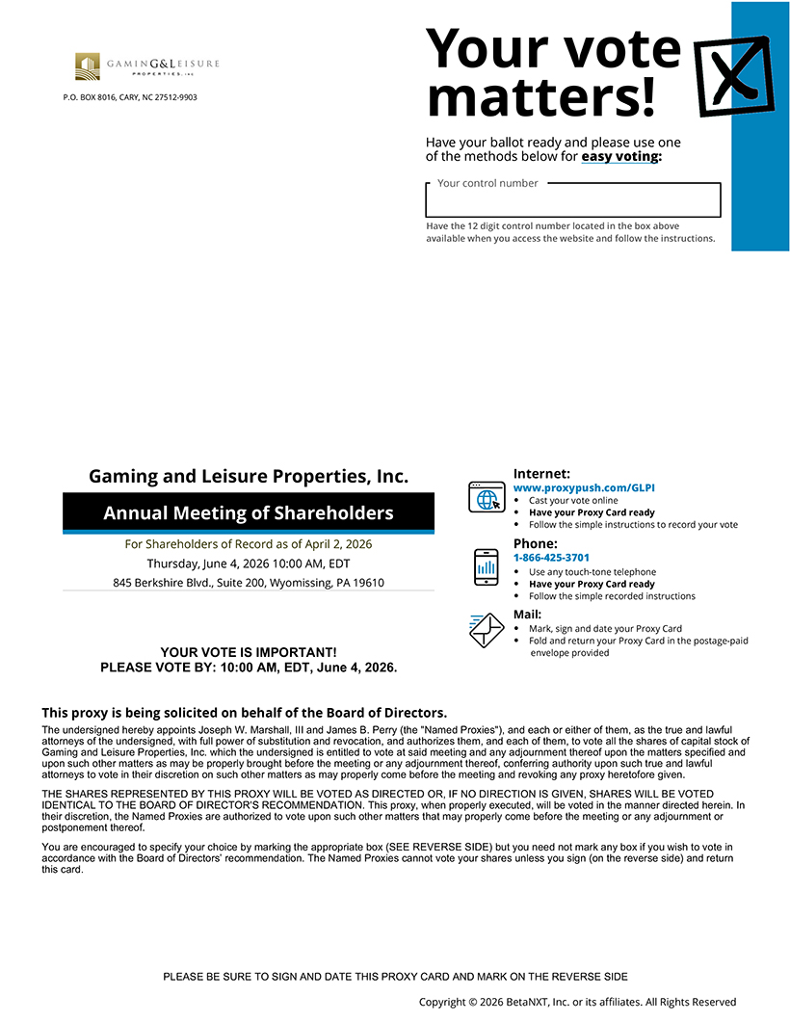
styleIPC Your vote P.O. BOX 8016, CARY, NC 27512-9903 matters! Have your ballot ready and please use one of the methods below for easy voting: Your control number [ Have the 12 digit control number located in the box above available when you access the website and follow the instructions. Gaming and Leisure Properties, Inc. Internet: www.proxypush.com/GLPI • Cast your vote online Annual Meeting of Shareholders • Have your Proxy Card ready • Follow the simple instructions to record your vote For Shareholders of Record as of April 2, 2026 Phone: Thursday, June 4, 2026 10:00 AM, EDT 1-866-425-3701 845 Berkshire Blvd., Suite 200, Wyomissing, PA 19610 • Use any touch-tone telephone • Have your Proxy Card ready • Follow the simple recorded instructions Mail: • • Mark, sign and date your Proxy Card Fold and return your Proxy Card in the postage-paid YOUR VOTE IS IMPORTANT! envelope provided PLEASE VOTE BY: 10:00 AM, EDT, June 4, 2026. This proxy is being solicited on behalf of the Board of Directors. The undersigned hereby appoints Joseph W. Marshall, III and James B. Perry (the “Named Proxies”), and each or either of them, as the true and lawful attorneys of the undersigned, with full power of substitution and revocation, and authorizes them, and each of them, to vote all the shares of capital stock of Gaming and Leisure Properties, Inc. which the undersigned is entitled to vote at said meeting and any adjournment thereof upon the matters specified and upon such other matters as may be properly brought before the meeting or any adjournment thereof, conferring authority upon such true and lawful attorneys to vote in their discretion on such other matters as may properly come before the meeting and revoking any proxy heretofore given. THE SHARES REPRESENTED BY THIS PROXY WILL BE VOTED AS DIRECTED OR, IF NO DIRECTION IS GIVEN, SHARES WILL BE VOTED IDENTICAL TO THE BOARD OF DIRECTOR’S RECOMMENDATION. This proxy, when properly executed, will be voted in the manner directed herein. In their discretion, the Named Proxies are authorized to vote upon such other matters that may properly come before the meeting or any adjournment or postponement thereof. You are encouraged to specify your choice by marking the appropriate box (SEE REVERSE SIDE) but you need not mark any box if you wish to vote in accordance with the Board of Directors’ recommendation. The Named Proxies cannot vote your shares unless you sign (on the reverse side) and return this card. PLEASE BE SURE TO SIGN AND DATE THIS PROXY CARD AND MARK ON THE REVERSE SIDE Copyright © 2026 BetaNXT, Inc. or its affiliates. All Rights Reserved

Table of Contents
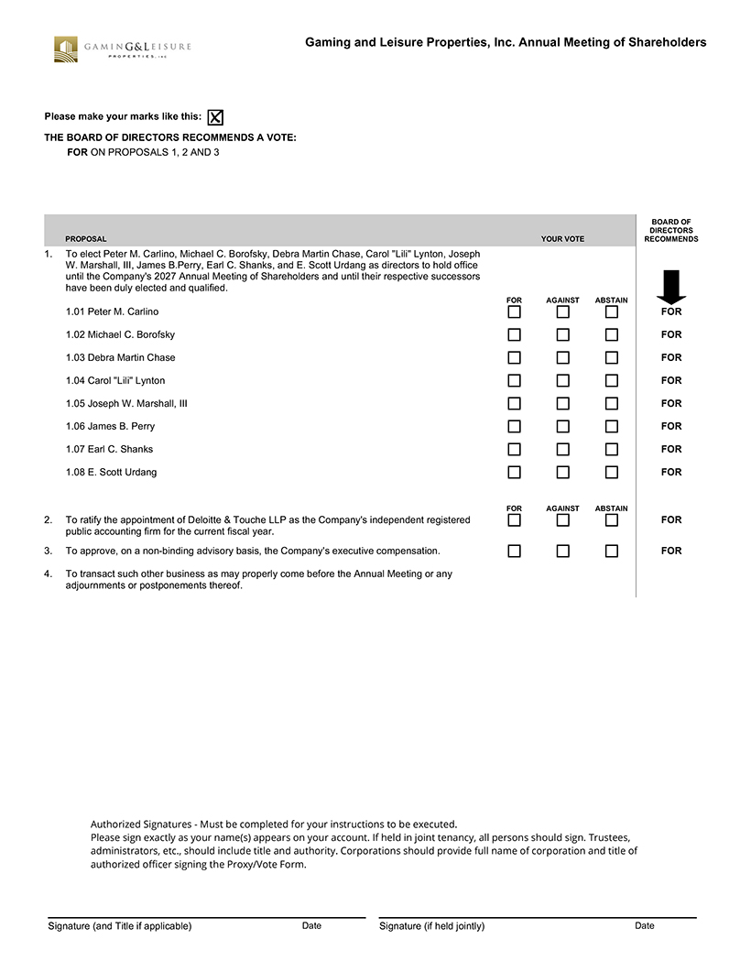
Gaming and Leisure Properties, Inc. Annual Meeting of Shareholders GAM I N G&L EISURE ~ ,. .. O,.El! T lt:S ., -c Please make your marks like this: THE BOARD OF DIRECTORS RECOMMENDS A VOTE: FOR ON PROPOSALS 1, 2 AND 3 BOARD OF DIRECTORS PROPOSAL YOUR VOTE RECOMMENDS 1. To elect Peter M. Carlino, Michael C. Borofsky, Debra Martin Chase, Carol “Lili” Lynton, Joseph W. Marshall, III, James B.Perry, Earl C. Shanks, and E. Scott Urdang as directors to hold office until the Company’s 2027 Annual Meeting of Shareholders and until their respective successors have been duly elected and qualified. FOR AGAINST ABSTAIN 1.01 Peter M. Carlino FOR #P2# #P2# #P2# • 1.02 Michael C. Borofsky FOR #P3# #P3# #P3# 1.03 Debra Martin Chase FOR #P4# #P4# #P4# 1.04 Carol “Lili” Lynton FOR #P5# #P5# #P5# 1.05 Joseph W. Marshall, III FOR #P6# #P6# #P6# 1.06 James B. Perry FOR #P7# #P7# #P7# 1.07 Earl C. Shanks FOR #P8# #P8# #P8# 1.08 E. Scott Urdang FOR #P9# #P9# #P9# FOR AGAINST ABSTAIN 2. To ratify the appointment of Deloitte & Touche LLP as the Company’s independent registered FOR public accounting firm for the current fiscal year. #P10# #P10# #P10# 3. To approve, on a non-binding advisory basis, the Company’s executive compensation. FOR #P11# #P11# #P11# 4. To transact such other business as may properly come before the Annual Meeting or any adjournments or postponements thereof. Authorized Signatures—Must be completed for your instructions to be executed. Please sign exactly as your name(s) appears on your account. If held in joint tenancy, all persons should sign. Trustees, administrators, etc., should include title and authority. Corporations should provide full name of corporation and title of authorized officer signing the Proxy/Vote Form. Signature (and Title if applicable) Date Signature (if held jointly) Date

