UNITED STATES
SECURITIES AND EXCHANGE COMMISSION
Washington, D.C. 20549
SCHEDULE 14A
Proxy Statement Pursuant to Section 14(a) of
the Securities Exchange Act of 1934 (Amendment No. )

Filed by the Registrant ☒
Filed by a Party other than the Registrant ☐
Check the appropriate box:
☐ |  | Preliminary Proxy Statement
☐ |  | Confidential, for Use of the Commission Only (as permitted by Rule 14a-6(e)(2))
☐ |  | Definitive Proxy Statement
☒ |  | Definitive Additional Materials
☐ |  | Soliciting Material under §240.14a-12

Gaming and Leisure Properties, Inc.
(Name of Registrant as Specified In Its Charter)
(Name of Person(s) Filing Proxy Statement, if other than the Registrant)
Payment of Filing Fee (Check the appropriate box):
☒ |  | No fee required.
☐ |  | Fee computed on table in exhibit required by Item 25(b) per Exchange Act Rules 14a-6(i)(1) and 0-11.
☐ |  | Fee paid previously with preliminary materials.

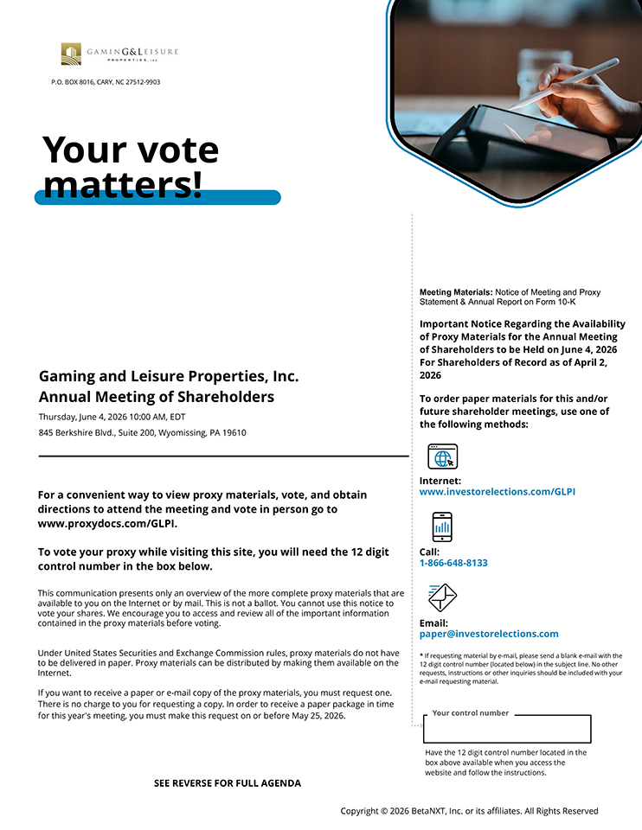
P.O. BOX 8016, CARY, NC 27512-9903 Gaming and Leisure Properties, Inc. Annual Meeting of Shareholders Thursday, June 4, 2026 10:00 AM, EDT 845 Berkshire Blvd., Suite 200, Wyomissing, PA 19610 For a convenient way to view proxy materials, vote, and obtain directions to attend the meeting and vote in person go to www.proxydocs.com/GLPI. To vote your proxy while visiting this site, you will need the 12 digit control number in the box below. This communication presents only an overview of the more complete proxy materials that are available to you on the Internet or by mail. This is not a ballot. You cannot use this notice to vote your shares. We encourage you to access and review all of the important information contained in the proxy materials before voting. Under United States Securities and Exchange Commission rules, proxy materials do not have to be delivered in paper. Proxy materials can be distributed by making them available on the Internet. If you want to receive a paper or e-mail copy of the proxy materials, you must request one. There is no charge to you for requesting a copy. In order to receive a paper package in time for this year’s meeting, you must make this request on or before May 25, 2026. SEE REVERSE FOR FULL AGENDA Meeting Materials: Notice of Meeting and Proxy Statement & Annual Report on Form 10-K Important Notice Regarding the Availability of Proxy Materials for the Annual Meeting of Shareholders to be Held on June 4, 2026 For Shareholders of Record as of April 2, 2026 To order paper materials for this and/or future shareholder meetings, use one of the following methods: Internet: www.investorelections.com/GLPI Call: 1-866-648-8133 Email: paper@investorelections.com * If requesting material by e-mail, please send a blank e-mail with the 12 digit control number (located below) in the subject line. No other requests, instructions or other inquiries should be included with your e-mail requesting material. Your control number Have the 12 digit control number located in the box above available when you access the website and follow the instructions. Copyright © 2026 BetaNXT, Inc. or its affiliates. All Rights Reserved

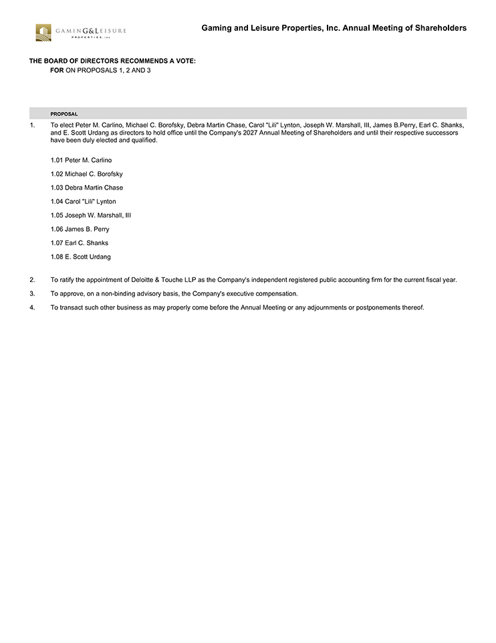
Gaming and Leisure Properties, Inc. Annual Meeting of Shareholders THE BOARD OF DIRECTORS RECOMMENDS A VOTE: FOR ON PROPOSALS 1, 2 AND 3 PROPOSAL 1. To elect Peter M. Carlino, Michael C. Borofsky, Debra Martin Chase, Carol “Lili” Lynton, Joseph W. Marshall, III, James B.Perry, Earl C. Shanks, and E. Scott Urdang as directors to hold office until the Company’s 2027 Annual Meeting of Shareholders and until their respective successors have been duly elected and qualified. 1.01 Peter M. Carlino 1.02 Michael C. Borofsky 1.03 Debra Martin Chase 1.04 Carol “Lili” Lynton 1.05 Joseph W. Marshall, III 1.06 James B. Perry 1.07 Earl C. Shanks 1.08 E. Scott Urdang 2. To ratify the appointment of Deloitte & Touche LLP as the Company’s independent registered public accounting firm for the current fiscal year. 3. To approve, on a non-binding advisory basis, the Company’s executive compensation. 4. To transact such other business as may properly come before the Annual Meeting or any adjournments or postponements thereof.

